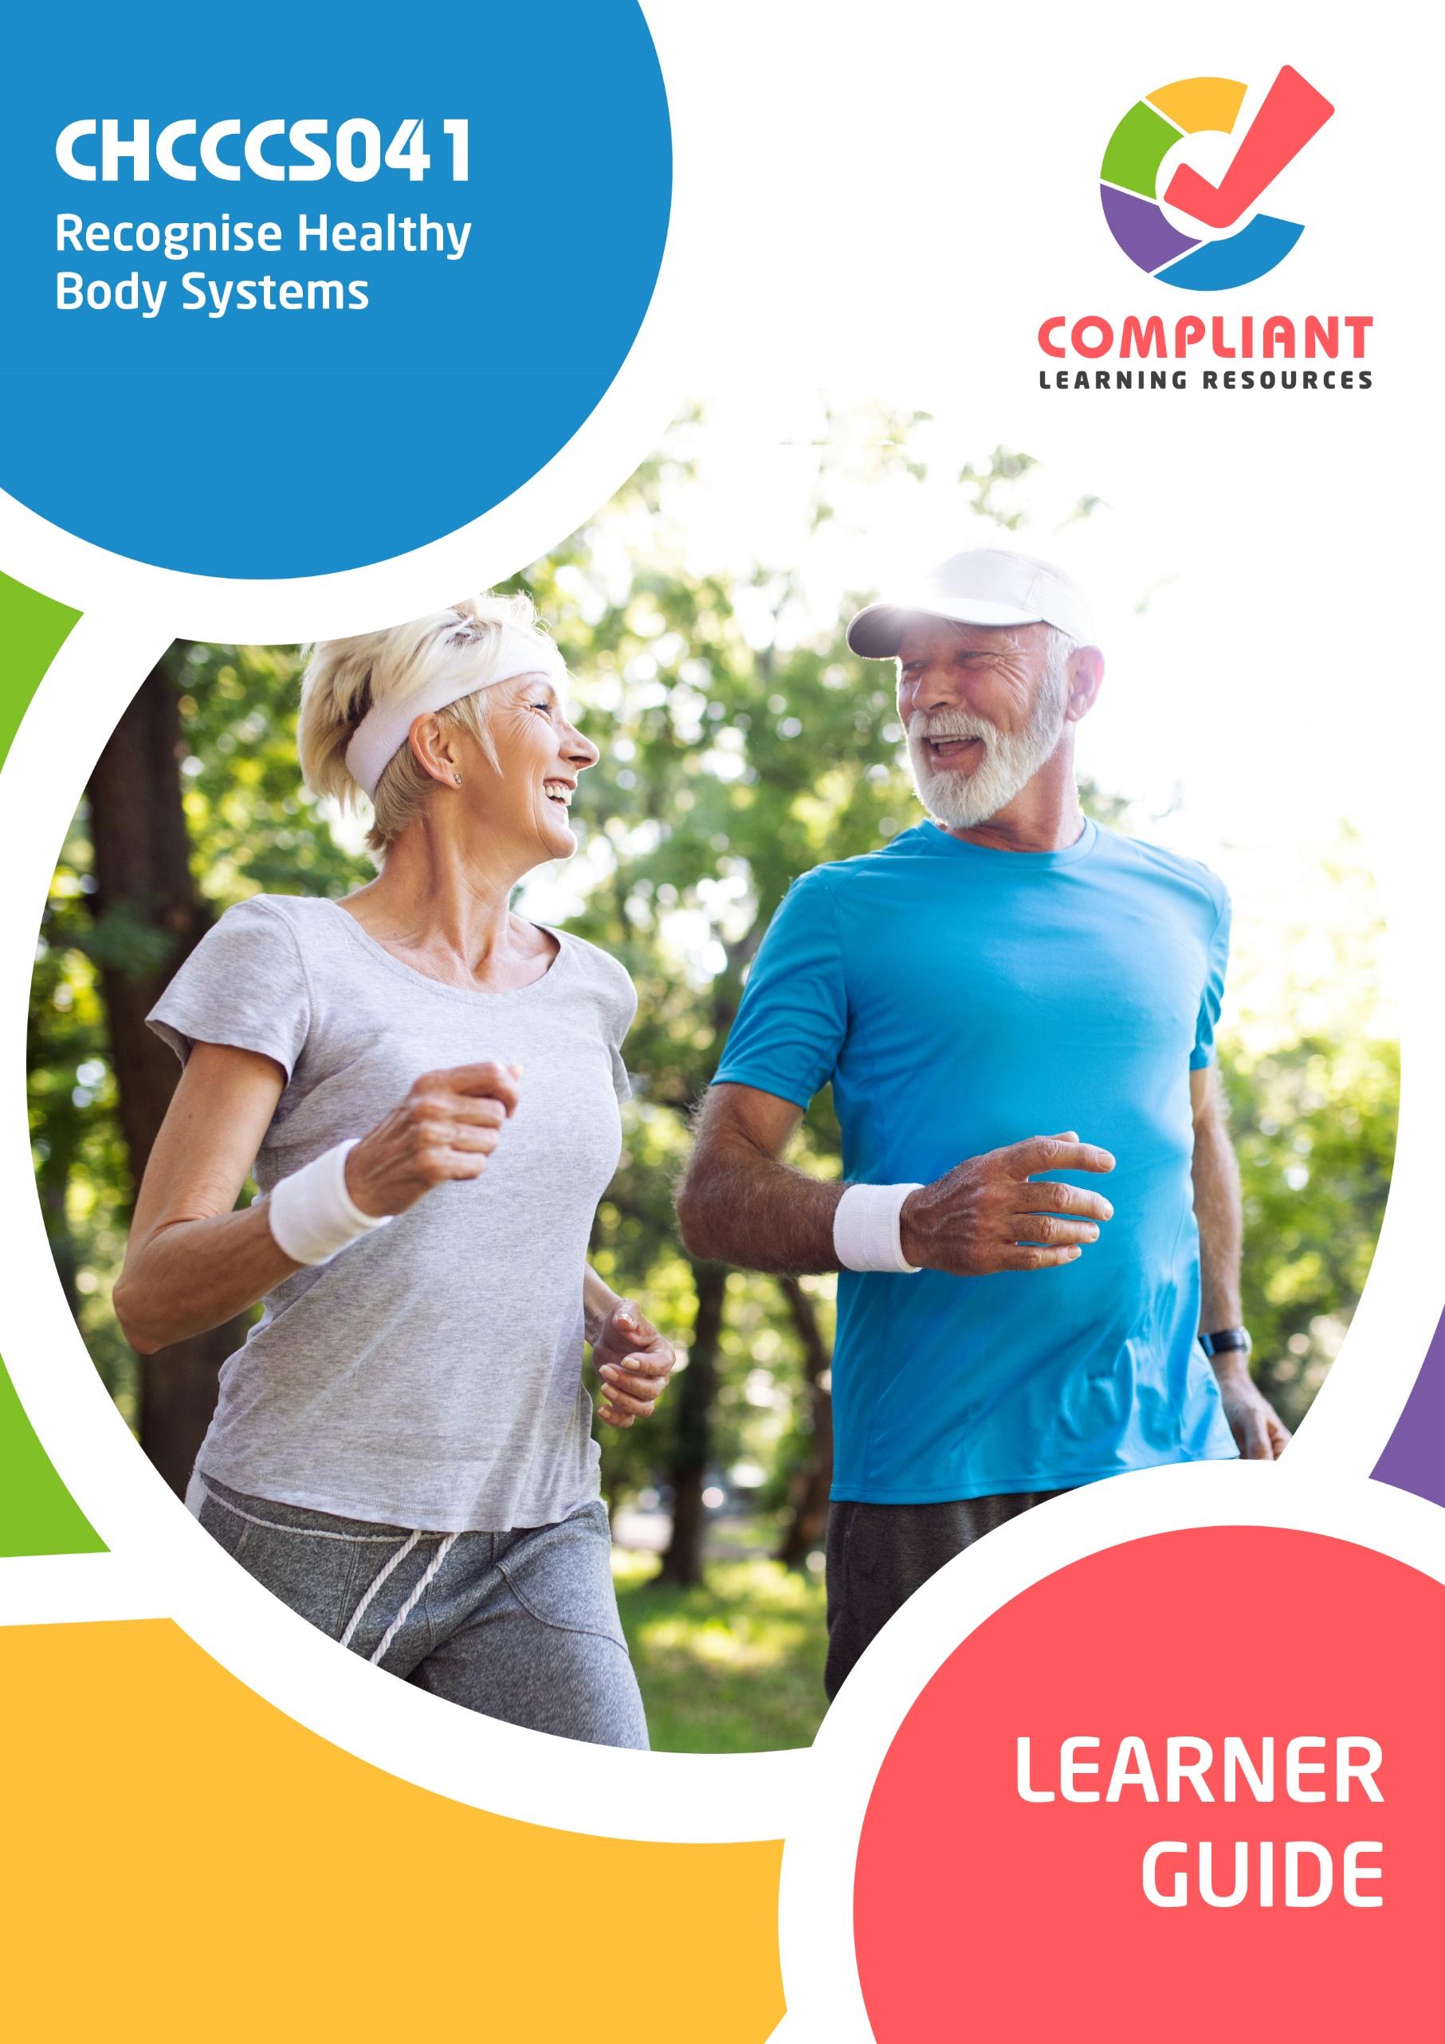

**Copyright**

This document was developed by Compliant Learning Resources.

© 2023 Compliant Learning Resources.

All rights reserved.

No part of this publication may be reproduced, stored in a retrieval system, or transmitted in any form or by any means, electronic, mechanical, photocopying, recording or otherwise without the prior written permission of Compliant Learning Resources.

**Version Control & Document History**

|  |  |  |
| --- | --- | --- |
| **Date** | **Summary of Modifications** | **Version** |
| 13 January 2023 | Version 1.0 released for publishing | 1.0 |
| 14 April 2023 | Version 1.1 endorsed for use  Minor revisions for improved readability | 1.1 |
| 22 August 2023 | Version 1.2 endorsed for use  Fixed wording issues | 1.2 |

# Table of Contents

This Learner Guide 5

Introduction 13

I. Work With Information About the Human Body 14

1.1 Interpret Health Terms Relevant to the Major Body Systems 19

1.1.1 Cardiovascular System 23

1.1.2 Respiratory System 27

1.1.3 Musculoskeletal System 28

1.1.4 Endocrine System 31

1.1.5 Digestive System 33

1.1.6 Urinary System 36

1.1.7 Reproductive System 41

1.1.8 Integumentary System 43

1.1.9 Lymphatic System 44

1.1.10 Immune System 46

1.1.11 Nervous System 48

1.1.12 Senses of the Body 52

1.2 Interpret Information Relevant to the Interrelationship of Body Structures 57

1.2.1 Interrelated Major Organ Systems and Relevant Common Body System Issues 58

1.2.2 Common Body System Issues 69

1.2.3 Common Diseases That Affect Body System Functioning 73

1.2.4 Pain and Discomfort 87

1.2.5 Procedures to Follow for Monitoring and Reporting Pain 93

II. Recognise and Promote Ways to Support Healthy Functioning of the Body 96

2.1 Review Factors for Healthy Body Maintenance 98

2.2 Evaluate How Body Systems Affect Health Functioning 108

2.2.1 Body Regulation 108

2.2.2 Protection From Infection 113

2.2.3 Physical Activities 116

2.3 Share Information About Healthy Body Functioning 119

2.4 Identify and Report Changes in the Person’s Health Status 126

2.4.1 Changes in the Client’s Health Status and Physical Condition 127

2.4.2 Reporting to Supervisor or Health Professional 138

References 141

# This Learner Guide

**CHCCCS041 - Recognise healthy body systems (Release 1)**

This unit describes the performance outcomes, skills and knowledge required to work with basic information about healthy body systems and the impacts of ageing and disability. It includes recognising and reporting any changes in healthy bodies involving people who are ageing or living with disability. Any identified issues of concern to be reported to the supervisor or professional health staff.

This unit applies to workers across a range of community services contexts.

The skills in this unit must be applied in accordance with Commonwealth and State/Territory legislation, Australian standards and industry codes of practice.

No occupational licensing, certification or specific legislative requirements apply to this unit at the time of publication.

**A complete copy of the above unit of competency can be downloaded from the TGA website:**

<https://training.gov.au/Training/Details/CHCCCS041>

**About This Unit of Study Introduction**

As a worker, a trainee, or a future worker, you want to enjoy your work and become known as a valuable team member. This unit of competency will help you acquire the knowledge and skills to work effectively as an individual and in groups. It will give you the basis to contribute to the goals of the organisation which employs you.

It is essential that you begin your training by becoming familiar with the industry standards to which organisations must conform.

**This Learner Guide Covers**

Recognise healthy body systems

1. Work with information about the human body
2. Recognise and promote ways to support healthy functioning of the body

**Learning Program**

As you progress through this unit of study, you will develop skills in locating and understanding an organisation’s policies and procedures. You will build up a sound knowledge of the industry standards within which organisations must operate. You will become more aware of the effect that your own skills in dealing with people have on your success or otherwise in the workplace. Knowledge of your skills and capabilities will help you make informed choices about your further study and career options.

**Additional Learning Support**

To obtain additional support you may:

* Search for other resources. You may find books, journals, videos and other materials which provide additional information about topics in this unit.
* Search for other resources in your local library. Most libraries keep information about government departments and other organisations, services and programs. The librarian should be able to help you locate such resources.
* Contact information services such as Infolink, Equal Opportunity Commission, Commissioner of Workplace Agreements, Union organisations, and public relations and information services provided by various government departments. Many of these services are listed in the telephone directory.
* Contact your facilitator.

**Facilitation**

Your training organisation will provide you with a facilitator. Your facilitator will play an active role in supporting your learning. Your facilitator will help you at any time during working hours to assist with:

* How and when to make contact
* What you need to do to complete this unit of study
* What support will be provided.

Here are some of the things your facilitator may do to make your study easier:

* Give you a clear visual timetable of events for the semester or term in which you are enrolled, including any deadlines for assessments
* Provide you with online webinar times and availability
* Use ‘action sheets’ to remind you about tasks you need to complete, and updates on websites
* Make themselves available by telephone for support discussion and provide you with industry updates by email where applicable
* Keep in touch with you during your studies

**Flexible Learning**

Studying to become a competent worker is an interesting and exciting thing to do. You will learn about current issues in this area. You will establish relationships with other students, fellow workers, and clients. You will learn about your own ideas, attitudes, and values. You will also have fun. (Most of the time!)

At other times, studying can seem overwhelming and impossibly demanding, particularly when you have an assignment to do and you aren’t sure how to tackle it, your family and friends want you to spend time with them, or a movie you want to see is on television.

Sometimes being a student can be hard.

Here are some ideas to help you through the hard times. To study effectively, you need space, resources, and time.

**Space**

Try to set up a place at home or at work where you can:

* Keep your study materials
* Be reasonably quiet and free from interruptions
* Be reasonably comfortable, with good lighting, seating, and a flat surface for writing.

If it is impossible for you to set up a study space, perhaps you could use your local library. You will not be able to store your study materials there, but you will have a quiet place, a desk and chair, and easy access to the other facilities.

**Study Resources**

The most basic resources you will need are:

* A chair
* A desk or table
* A computer with Internet access
* A reading lamp or good light
* A folder or file to keep your notes and study materials together
* Materials to record information (pen and paper or notebooks, or a computer and printer)
* Reference materials, including a dictionary

Do not forget that other people can be valuable study resources. Your fellow workers, work supervisor, other students, your facilitator, your local librarian, and workers in this area can also help you.

**Time**

It is important to plan your study time. Work out a time that suits you and plan around it. Most people find that studying, in short, concentrated blocks of time (an hour or two) at regular intervals (daily, every second day, once a week) is more effective than trying to cram a lot of learning into a whole day. You need time to ‘digest’ the information in one section before you move on to the next, and everyone needs regular breaks from study to avoid overload. Be realistic in allocating time for study. Look at what is required for the unit and look at your other commitments.

Make up a study timetable and stick to it. Build in ‘deadlines’ and set yourself goals for completing study tasks. Allow time for reading and completing activities. Remember that it is the quality of the time you spend studying rather than the quantity that is important.

**Study Strategies**

Different people have different learning ‘styles’. Some people learn best by listening or repeating things out loud. Some learn best by ‘doing’, some by reading and making notes. Assess your own learning style and try to identify any barriers to learning which might affect you. Are you easily distracted? Are you afraid you will fail? Are you taking study too seriously? Not seriously enough? Do you have supportive friends and family? Here are some ideas for effective study strategies:

1. **Make notes.** This often helps you to remember new or unfamiliar information. Do not worry about spelling or neatness, as long as you can read your own notes. Keep your notes with the rest of your study materials and add to them as you go. Use pictures and diagrams if this helps.
2. **Underline keywords** when you are reading the materials in this Learner Guide. (Do not underline things in other people’s books.) This also helps you to remember important points.
3. **Talk to other people** (fellow workers, fellow students, friends, family, or your facilitator) about what you are learning. As well as help you to clarify and understand new ideas, talking also gives you a chance to find out extra information and to get fresh ideas and different points of view.



**Using This Learner Guide**

A Learner Guide is just that, a guide to help you learn. A Learner Guide is not a textbook. Your Learner Guide will:

1. Describe the skills you need to demonstrate to achieve competency for this unit.
2. Provide information and knowledge to help you develop your skills.
3. Provide you with structured learning activities to help you absorb knowledge and information and practice your skills.
4. Direct you to other sources of additional knowledge and information about topics for this unit.

**How to Get the Most Out of Your Learner Guide**

Some sections are quite long and cover complex ideas and information. If you come across anything you do not understand:

1. Talk to your facilitator.
2. Research the area using the books and materials listed under Resources.
3. Discuss the issue with other people (your workplace supervisor, fellow workers, fellow students).
4. Try to relate the information presented in this Learner Guide to your own experience and to what you already know.
5. Ask yourself questions as you go. For example, ‘Have I seen this happening anywhere?’ ‘Could this apply to me?’ ‘What if...’ This will help you to ‘make sense’ of new material, and to build on your existing knowledge.
6. Talk to people about your study. Talking is a great way to reinforce what you are learning.
7. Make notes.
8. Work through the activities. Even if you are tempted to skip some activities, do them anyway. They are there for a reason, and even if you already have the knowledge or skills relating to a particular activity, doing them will help to reinforce what you already know. If you do not understand an activity, think carefully about the way the questions or instructions are phrased. Read the section again to see if you can make sense of it. If you are still confused, contact your facilitator or discuss the activity with other students, fellow workers or with your workplace supervisor.

**Additional Research, Reading, and Note-Taking**

If you are using the additional references and resources suggested in the Learner Guide to take your knowledge a step further, there are a few simple things to keep in mind to make this kind of research easier.

Always make a note of the author’s name, the title of the book or article, the edition, when it was published, where it was published, and the name of the publisher. This includes online articles. If you are taking notes about specific ideas or information, you will need to put the page number as well. This is called the reference information. You will need this for some assessment tasks, and it will help you to find the book again if you need to.

Keep your notes short and to the point. Relate your notes to the material in your Learner Guide. Put things into your own words. This will give you a better understanding of the material.

Start off with a question you want answered when you are exploring additional resource materials. This will structure your reading and save you time.

# Introduction

The World Health Organization (WHO) defines health as the ‘state of complete physical, mental, and social well-being, and not merely the absence of disease or infirmity’. A healthy body is not one without diseases or infirmities. A healthy body pertains to various body systems functioning at their best.

As someone who works in community services, you must possess factual knowledge about the human body and the practices related to body systems. This is so you can support your clients who are ageing or with disability in maintaining their health. Service delivery to clients who are ageing or with disability will greatly differ from that outside this spectrum. Age and disability are two of the many factors affecting the overall function and makeup of the body system. Knowing how they impact a healthy body will make a difference in delivering quality service in your field of work.

For example, a community service worker with in-depth knowledge of frontotemporal dementia can better support a client with dementia than those unfamiliar with the condition. They will be more accommodating of the client’s outbursts because they know that this type of dementia manifests in personality changes rather than memory loss.

While it is true that the condition of a person’s body will differ from one individual to another, the basic information that includes references to the anatomy and physiology of the body remains the same.

|  |  |
| --- | --- |
| **Anatomy** | **Physiology** |
| *Anatomy* is the study of the human body, which deals with structures like muscles, bones and interior organs.  For example, the heart's anatomy means the structure of the heart and its chambers, arteries, veins, and valves. | *Physiology* is the study of the human body that deals with the functions of different organs like digestion, respiration, reproduction and osmoregulation.  For example, the physiology of the heart means how the pumping of the blood is done by the heart. |

In other words, anatomy is the analysis of an organism and how it is organised internally and externally. In contrast, physiology is focused more on how organs function. Nonetheless, anatomy and physiology are closely related concepts normally studied together to provide better support to your clients who are ageing or with disability.

In this Learner Guide, you will learn how to:

* Work with information about the human body
* Recognise and promote ways to support healthy functioning of the body

# I. Work With Information About the Human Body

The human body comprises various organs with different functions. To effectively work with information about it, you must first understand its basic makeup from the body systems' fundamental structure, functions, interactions and associated components. Anatomy and physiology can help you understand the following:

As someone who works in community services, you must also know the human body's theoretical concepts and practical functionalities. The following are just some scenarios wherein you can practice your practical knowledge and skills about the human body.

* **Emergency**

Without medical professionals on the scene, a life-threatening health emergency can be avoided or eased if you have extensive knowledge about human body information. In case of a client choking, knowing exactly where the critical spot is between their rib cage and their navel will help you easily locate where to press on their abdomen to perform back blows and chest thrusts.

* **Health monitoring**

Understanding body systems information will help you track the health status of your clients. This information helps assess, evaluate, diagnose and track a patient’s health. Changes in your client’s health will be more evident if you know which specific aspects to observe.

* **Quick analysis**

Making prompt but correct decisions is crucial, especially in industries where a person's health is at stake. Quickly examining a client’s health condition can significantly impact their overall health and, ultimately, their life.

Not having the appropriate skills and knowledge about the fundamentals of the human body can lead to consequences such as overlooked severe signs and symptoms and sometimes even death. This is not impossible, especially if you relayed incorrect information about the location or the function of body systems or interpreted medical advice inaccurately.

**Levels of Organisation of the Human Body**

To gain knowledge of important information about body systems, you must first refresh your mind with the basic makeup of the body from the simplest level to the most complex. The level of the basic organisation of a human body system can be categorised into the following:

All living things, including humans, are made up of cells. The cell is the basic unit of all living things. Its basic functions include metabolism and reproduction.

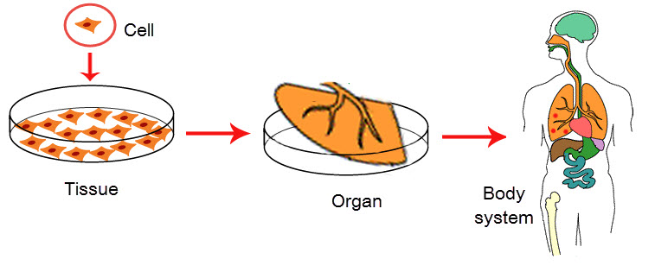

There are different types of cells with various functions. These functions include the following:

* Providing structure for the body
* Taking in nutrients from food
* Converting those nutrients into energy
* Carrying out specialised functions
* Holding the body’s genetic code and being able to duplicate themselves

Our bodies are made up of trillions of cells. They group to form tissues, which carry out a particular task in an organism. The following are the five basic functions of tissues:

A group of tissues form organs that perform specific functions in the human body. Overall, organ systems comprise organs such as the respiratory system.

The cells’ unique function serves a larger purpose in the organisation of the organs in the body. The eleven organ systems in the human body are as follows:

Below are the different functions of the different organ systems.

|  |  |
| --- | --- |
| **Organ System** | **Function** |
| Cardiovascular system | The cardiovascular system transports blood from the heart to other body parts. |
| Respiratory system | The respiratory system brings oxygen in and carbon dioxide out. |
| Musculoskeletal system | The musculoskeletal system facilitates movement and locomotion. |
| Endocrine system | The endocrine system secretes hormones into the circulatory system. |
| Digestive system | The digestive system breaks down food into energy. |
| Urinary or renal system | The urinary system removes liquid waste from the blood to keep a stable balance of salts and other substances in the blood. |
| Female reproductive system | The female reproductive system produces, transports and sustains egg cells. It also nurtures the developing offspring. |
| Male reproductive system | The male reproductive system produces, transports, and sustains sperm cells. |
| Integumentary system | The integumentary system serves as a barrier to protect the inside of the body from environmental elements, such as bacteria, pollution, and UV rays from the sun. |
| Lymphatic system | The lymphatic system transports fluid containing infection-fighting white blood cells throughout the body. |
| Immune system | The immune system provides the body protection from infections or diseases. |
| Nervous system | The nervous system carries information from the brain to other body parts. |

As a support worker, this Learner Guide will help equip you with the basic knowledge needed to cater to older people and people with disability. *Older people* include those aged 65 and over (Australian Institute of Health and Welfare, 2018), while *people with disability* are those who may have any of the following types of disability:

|  |  |  |
| --- | --- | --- |
| **Type of Disability** | **Description** | |
| Physical disability | These are disabilities that may temporarily or permanently affect a person’s physical capacity and mobility. | |
| Cognitive disability | These conditions affect the ability to perform one or more mental tasks. These include but are not limited to problems with reading text, memory, problem-solving, and staying focused (attention span). | |
| Intellectual disability | It is a developmental disorder characterised by intelligence limitations and difficulty with daily living skills. |
| Psychosocial disability | It is a disability that may arise from a mental health issue (NSW Ministry of Health, 2018). It results from someone with a mental health condition interacting with a social environment that may present barriers to their inclusion and participation. | |
| Hearing impairment | This interferes with a person’s ability to hear and, in severe cases, prevents a person from hearing and distinguishing sounds. | |
| Vision impairment | It includes communication disorders and impairments involving hearing, fluency, and the ability to articulate words. | |

Hearing impairment and vision impairment are known as sensory disabilities. A sensory disability refers to the impairments of the senses, such as tasting, hearing, smelling, touching and seeing. This disability greatly affects how your client interacts with the world, as people naturally rely on their senses to engage with others.

This chapter of the Learner Guide will cover how to:

* Interpret health terms relevant to the major body systems
* Interpret information relevant to the interrelationship of body structures

## Interpret Health Terms Relevant to the Major Body Systems



In community services, the usage and interpretation of specific vocabulary relevant to health and the body are part of standard service delivery.

When speaking to your clients or patients, you use health-related terminology to explain different body-related facts. You also interpret medical advice from professionals to your clients or patients whenever needed.

In short, using health-related terminologies and abbreviations relevant to body systems will help you in performing tasks in your work role, such as the following:

* Interpreting medical advice to the client given by the doctor
* Recognising changes in the physical, psychological and mental condition of the client and or patient
* Reporting indicators of body system issues
* Interpreting content to implement in clients’ individualised plans
* Taking note of clients’ health conditions accurately

The common documents containing health-related terminologies and abbreviations that you will be interpreting may include the following:

* Doctor’s prescriptions
* Client’s individualised care plans
* Client’s medical documents with information regarding the following:
* Previous hospitalisations
* Previous surgeries
* Allergies
* Medications
* Client’s medical history
* Client’s family history of illnesses

You must access other documents to interpret the client’s needs properly. What is important is that you have a thorough knowledge of the common terminologies and abbreviations used in your practice.

Listed on the next page are the common terms and abbreviations you will often see in the documents mentioned above.



**Medical Terminology**

Before you continue learning about various body systems' structure, function and location, you must first consider the anatomical terminologies below since many are recurring terms used in different body systems. Knowing these terms will make it easier for you to understand body systems-related topics in this subchapter. Some important terminologies include the following:

* **Planes of the body**

The following describes the location of structures in the body as a whole. They commonly describe medical images captured by CAT scans and MRIs.

|  |  |
| --- | --- |
| **Terminology** | **Description** |
| Sagittal plane (lateral plane) | A vertical plane from front to back divides the body into right and left sides |
| Median plane | A sagittal plane through the middle of the body that divides it or any of its parts into right and left halves |
| Coronal plane (frontal plane) | A vertical plane that divides the body into anterior and posterior portions from side to side |
| Axial plane (transverse plane) | A horizontal plane that divides the body into upper and lower parts |

* **Other basic medical terminologies**

Below are other helpful general medical abbreviations and terms that are commonly seen in a client’s medical documents and profile.

| **Terminology** | **Explanation** |
| --- | --- |
| Abrasion | A wound caused by superficial damage to the skin and no deeper than the epidermis |
| Cardi- or cardio- | The heart or pertaining to the heart |
| Cephalgia | The medical term for headache; pain anywhere in the region of the head or neck |

|  |  |
| --- | --- |
| **Terminology** | **Explanation** |
| Contusion | Also called a bruise, a type of hematoma of tissue where the capillaries and venules are damaged by trauma |
| Febrile | Having or showing symptoms of a fever |
| Pathogen | Infectious agents (or anything that can produce a disease), such as viruses, bacterium and fungus |

**Medical Abbreviations**

Various abbreviations can reveal a variety of information. Below are commonly used medical abbreviations that often appear in medical documents relevant to the body system. They are often abbreviated to make it easier for medical professionals to express a condition, state or treatment. Your job is to relay the accurate description of what each of the following means should your client be unfamiliar with them.

You must also remember that some abbreviations have more than one meaning, whether or not listed below. In these cases, you must interpret the abbreviations according to the context in which they are used.

| **Medical Abbreviation** | **What does it stand for?** | **What is this?** |
| --- | --- | --- |
| CBC | Complete blood count | A blood test used to assess overall health and detect a wide range of disorders |
| UTI | Urinary tract infection | Infection of one or more organs in the urinary tract |
| Dx | Diagnosis | The process of identifying a disease based on signs, symptoms and tests |
| Px | Prognosis | Prediction of the outcome of a disease |
| URI | Upper respiratory infection | Also referred to as the common cold |

Now that you know all about the common terminologies and abbreviations generally associated with the body, you can explore the terminologies relevant to the structure, function, and location of specific organ systems in the body.

In the following sections, you will be reading about the structure, function and location of the major organ systems in the body. The important terminologies you will need to familiarise yourself with, and other basic information for each organ system will be described in the following pages.

### **1.1.1 Cardiovascular System**

The cardiovascular system is responsible for the following:

* Transporting oxygen, blood cells, water and nutrients around the body
* Picking up waste and transporting them to organs to be removed

The common terminologies that you will encounter when talking about the cardiovascular system comprise the following body organs and parts:

The succeeding pages will detail where they are located in your body, how they are structured and how they function.

**Heart**

* Behind the breastbone, located between the lungs and in the middle of the chest
* The heart is as big as your fist and tilts slightly to the left
* Divided into four chambers
* Pumps out blood throughout the body

The heart has many parts which help it perform its vital function. Some of the pivotal parts of the heart include the blood vessels. They are tubes through which blood circulates, each having a different function.

**Blood Vessels**

They include the following:

Other important terminologies to remember regarding the structure, location and function of the parts of the heart can be seen in the photo below.

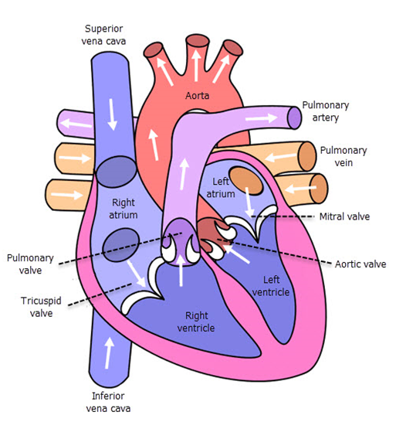

The arrows in the photo indicate how the blood is transported to and from the central pumping station, the heart.

**Blood**

In a more detailed discussion, blood is considered the essential fluid that circulates in the heart, arteries, veins, and capillaries. It gives nourishment and oxygen to and removes waste products from all body parts. The blood cells include the following:

Blood is pumped from the heart to other body parts through blood circulation. The process of blood circulation is as follows:

1. Deoxygenated blood from the body goes to the heart through the inferior and superior vena cava.
2. Blood then moves through the right atrium into the right ventricle and to the lungs through the pulmonary artery, where carbon dioxide is exchanged for oxygen.
3. Oxygenated blood comes back from the lungs through the pulmonary vein into the left atrium and the left ventricle.
4. Blood leaves the heart through the aorta to other parts of the body.
5. Oxygenated blood is delivered to body cells through arteries and then capillaries.
6. Blood returns to the heart through capillaries. Then veins to the inferior and superior vena cava.

|  |  |
| --- | --- |
|  | **Further Reading**  Various websites cover many more terminologies commonly associated with the circulatory system. One of them is Visible Body, a website of a group of anatomy enthusiasts whose mission is to make studying the human body interactive for learners. To access the website, click the link below.  [Glossary of the Circulatory System](https://www.visiblebody.com/learn/circulatory/glossary) |

**Cardiovascular-Related Challenges**

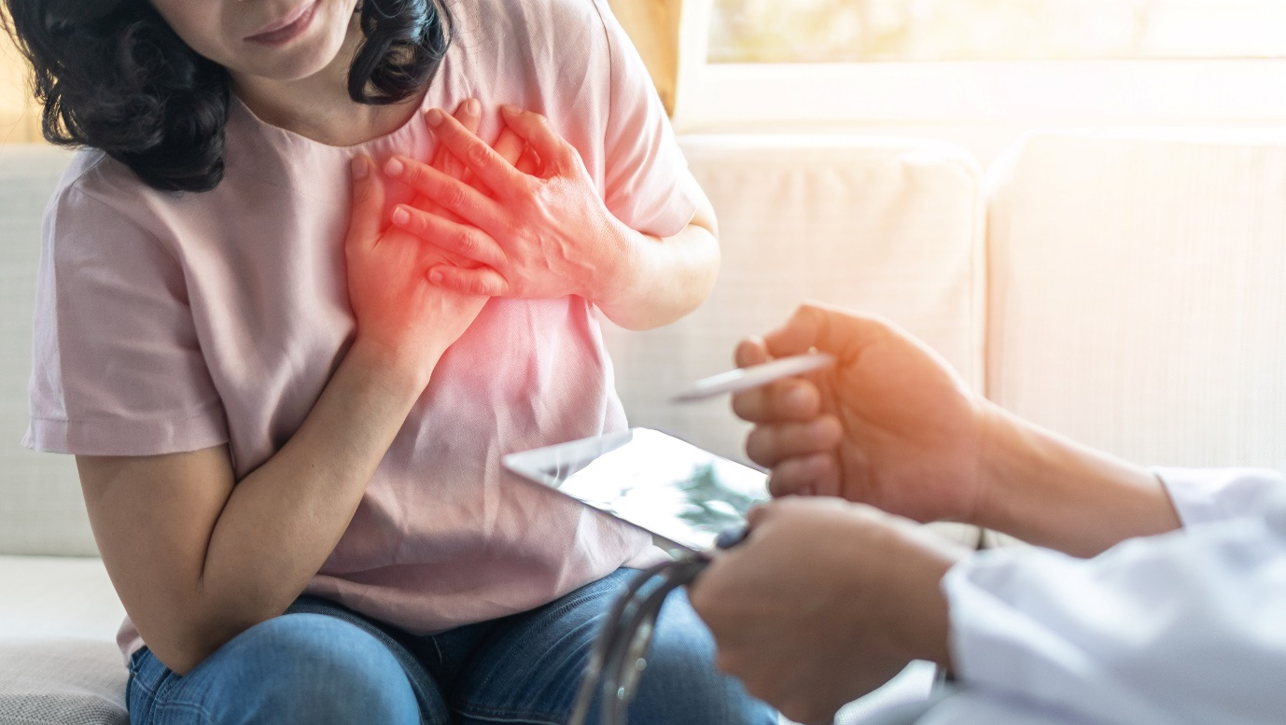

Older people and people with disability often experience various complications and challenges concerning the heart. According to the Victorian Government’s Better Health Channel, cardiovascular diseases are Australia's leading cause of death, with 41,849 reported deaths in 2018 alone.

There are many factors why clients who are ageing and with disability are more prone to cardiovascular diseases. The most common examples include the following:

* **Lack of physical activity (idleness) –** Limitations in movement due to their condition are often the number one cause of why people with disability cannot stay active. Older people also struggle to maintain the exercise needed to stimulate cardiovascular activity and improve heart health. Common heart complications that can be triggered due to lack of physical activity include the build-up of fat in the chambers and valves of the heart, which may lead to heart failure.
* **Ageing –** The natural ageing process affects the tissues, developing a more rigid tissue wall around the heart. As such, an older person’s heart during physical activity or times of stress will no longer beat as efficiently as it would in the similar situation when they were still young.

These changes in the arteries cause the systolic blood pressure to rise while the diastolic blood pressure declines. This is normally true, especially if your clients are 60 and above. Hypertension is one of the most common heart conditions associated with ageing.

### **1.1.2 Respiratory System**

The respiratory system is responsible for bringing oxygen in and carbon dioxide out through the lungs, nose and mouth. Oxygen is brought into the blood through inhalation in the lungs, and carbon dioxide is brought out through exhalation.

Air is inhaled through the nose and into the lungs through the following process:

1. Air is breathed in through the nose, warmed and humidified, and dust is trapped.
2. Air then goes down the trachea and into the right and left bronchi. Then, it travels down to the right and left lungs.
3. In the alveoli, oxygen is then exchanged for carbon dioxide.
4. Capillaries surrounding the alveoli sac are where oxygen is exchanged for carbon dioxide.
5. The diaphragm assists with breathing by drawing air into the lungs (inhalation) and releasing (exhalation) air into the lungs.

Other important terminologies to remember regarding the structure, location and function of the parts of the respiratory system can be seen in the photo below.

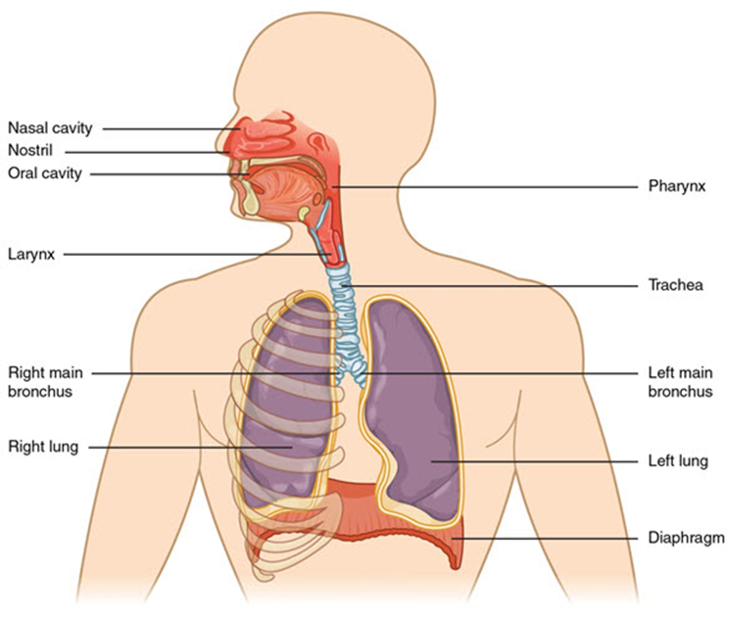

|  |  |
| --- | --- |
|  | **Further Reading**  Various websites cover many more terminologies commonly associated with the respiratory system. One of them is Visible Body, a website of a group of anatomy enthusiasts whose mission is to make studying the human body engaging and interactive for learners. To access their website, follow the link below.  [Glossary of the Respiratory System](https://www.visiblebody.com/learn/respiratory/glossary) |

### **1.1.3 Musculoskeletal System**

The musculoskeletal system is mainly responsible for giving structure and providing the body with the right blood cells. The muscular system facilitates movement and locomotion.

The musculoskeletal system consists of bone, muscle, joints, cartilage, ligaments (bind bone to bone) and tendons (bind muscle to bone). It has the following functions:

Important terminologies to remember regarding the structure and location of the skeletal system parts can be seen in the photo below.

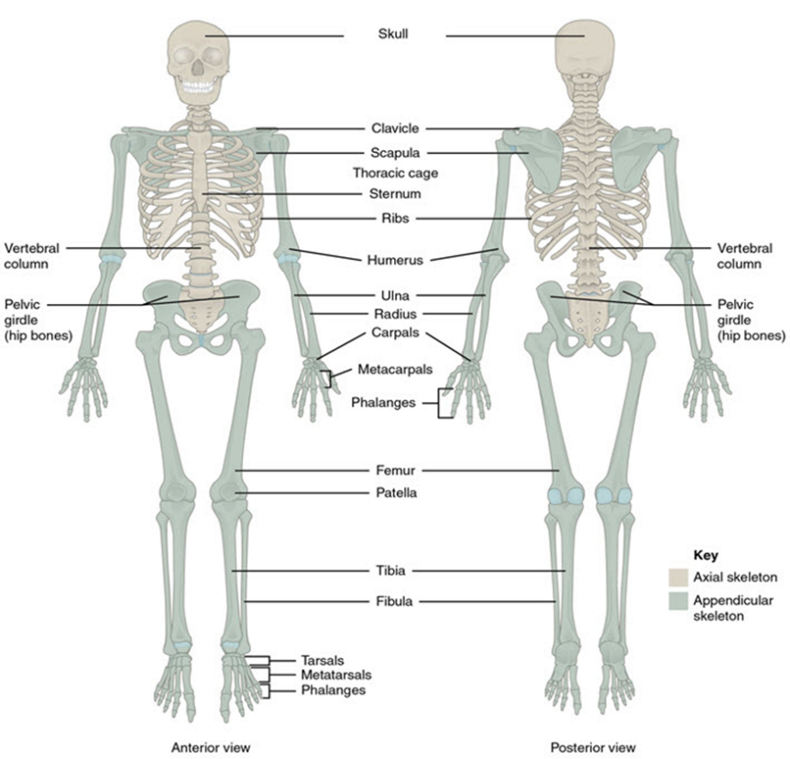

There are also different muscle types, and these are as follows:

* **Skeletal muscles** support movement and are voluntary (meaning they are moved with our conscious awareness).
* **Cardiac muscles** contract and relax the heart to help pump blood around the body. They are involuntary (meaning they function without conscious awareness).
* **Smooth muscles** are located in organs such as the intestine (peristalsis) and blood vessels. They are involuntary (meaning they function without conscious awareness).

Important terminologies to keep in mind regarding the structure and location of the parts of the different muscle types can be seen in the photo below.

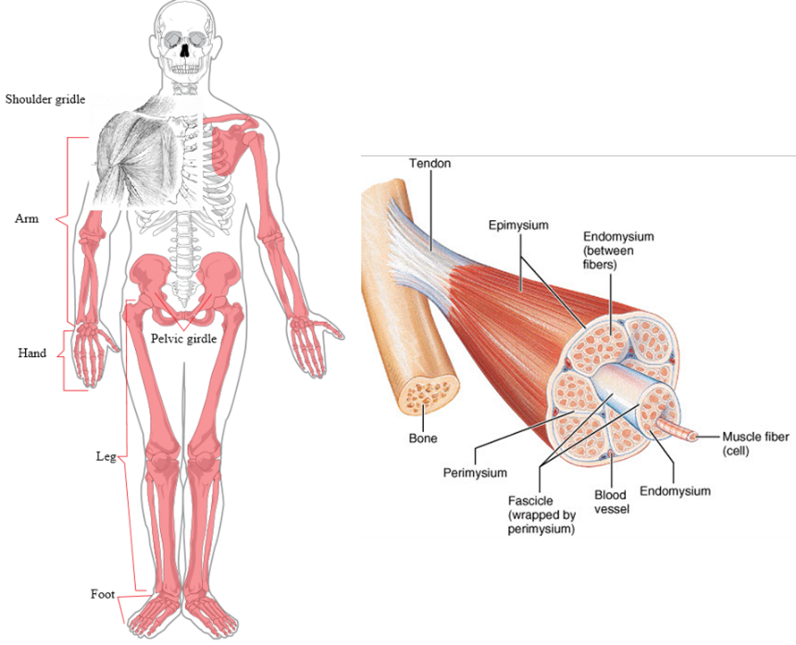

|  |  |
| --- | --- |
|  | **Further Reading**  Various websites cover many more terminologies commonly associated with the muscular and skeletal systems. One of them is Visible Body, a website of a group of anatomy enthusiasts whose mission is to make studying the human body engaging and interactive for learners. To access their website, follow the link below.  [Glossary of the Muscular System](https://www.visiblebody.com/learn/muscular/glossary?msclkid=373cff14d0d911ec99425d77c070ef5e)  [Glossary of the Skeletal System](https://www.visiblebody.com/learn/skeleton/glossary?msclkid=42d3e00ed0d911ec8aa1a463fb20d3e7) |

### **1.1.4 Endocrine System**

The function of the endocrine system is to regulate growth, moods, digestion, metabolism, tissue function, and reproduction.

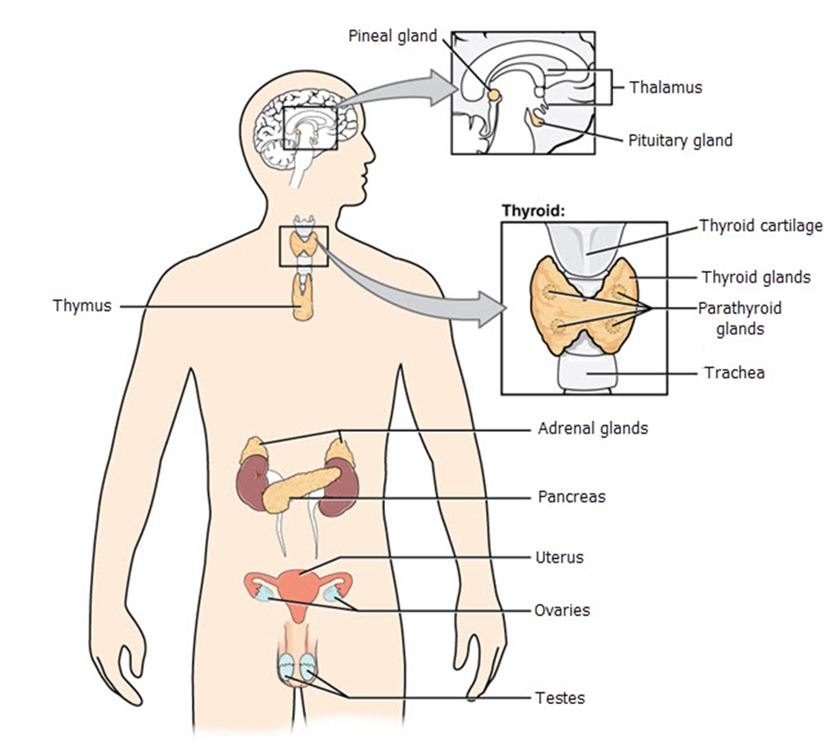

The endocrine system secretes hormones transported to the organs via the circulatory system. Below is a discussion about glands and their hormones and functions.

* The **pituitary gland** is connected to the hypothalamus, which is another gland that oversees many functions in the body. The pituitary gland releases the following hormones:
* *Thyroid stimulation hormone* stimulates metabolism, which is a chemical process within cells.
* *Antidiuretic hormone* acts on the kidneys to stimulate water reabsorption if there is a reduction in blood volume. Therefore, less water is excreted in the urine.
* *Oxytocin* facilitates contractions during childbirth.
* *Prolactin* stimulates breast milk production.
* *Endorphins* act on the nervous system to produce a feeling of well-being and an analgesic effect.
* The **thyroid gland** releases thyroxine, a hormone for homeostasis (maintaining internal stability) and metabolism.

Below are other important terminologies that you will encounter in the endocrine system.

**Impacts of Ageing and Disability**

As people age, the endocrine system changes due to decreased hormone production. Endocrine function normally declines with age because hormone receptors become less sensitive.

In women, menopause is usually when estrogen levels decline. In men, testosterone levels normally decrease gradually. Due to the decrease in growth hormone levels, there may also be decreased muscle mass and strength in an individual. We can also associate the loss of normal sleep-wake cycles with an aging client's decline in melatonin levels.

|  |  |
| --- | --- |
|  | **Further Reading**  Various websites cover many more terminologies commonly associated with the endocrine system. One of them is Visible Body, a website of a group of anatomy enthusiasts whose mission is to make studying the human body engaging and interactive for learners. To access their website, follow the link below.  [Glossary of the Endocrine System](https://www.visiblebody.com/learn/endocrine/glossary) |

### **1.1.5 Digestive System**

After food is taken via the mouth to the stomach, our digestive system breaks food down into simple substances to be absorbed into the bloodstream via the intestines. These simple forms become energy used by the body to aid in our growth and for fuel and repair.

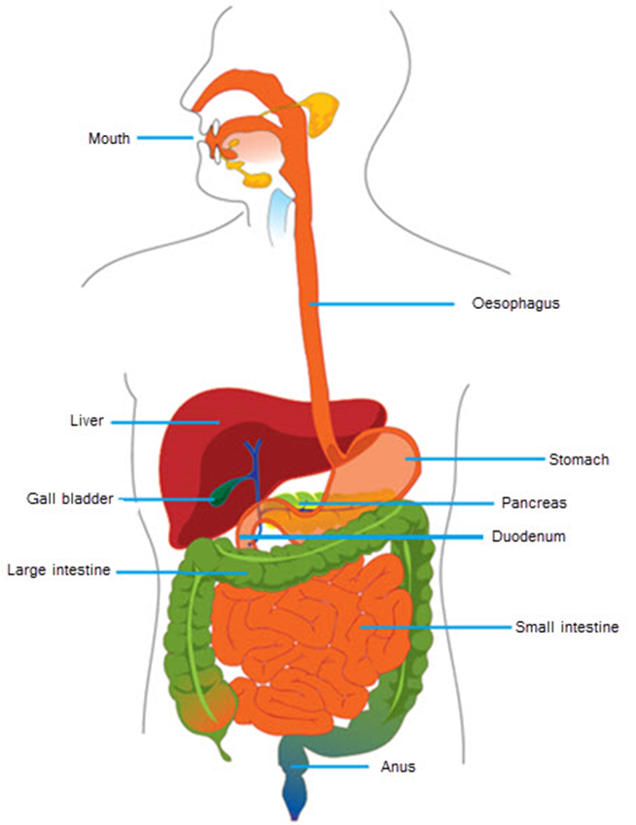

Digestion of food occurs through the following process:

1. The food begins the breakdown process in the mouth by grounding food by teeth and saliva (moistens and contains amylase).
2. Food is then passed to the stomach via the oesophagus from muscular contraction (peristalsis). The *epiglottis* is made up of cartilage. When a person is swallowing food, it will fold backwards and cover the larynx, so food does not go into the lungs.
3. In the stomach, food is churned, broken down further, and mixed with gastric acids (hydrochloric acid and pepsin).
4. As the food passes through the duodenum and before it reaches the small intestine, it is mixed with more digestive enzymes from the pancreas (lipase, amylases and proteases) and bile from the liver.
5. Nutrients and water are absorbed via the villi in the small intestine into the bloodstream.
6. The by-product of this process runs through the large intestine, where bacteria further break it down. Water and nutrients are absorbed in the bloodstream.
7. The indigestible substances are then eliminated via the anus.

Enzymes in the digestive system include the following:

* **Hydrochloric acid and pepsin** help to break proteins into amino acids.
* **Bile** helps to emulsify fats and fat-soluble vitamins.
* **Lipase**helps to break fats into fatty acids.
* **Amylase** helps to break carbohydrates (starch) into maltose.
* **Maltase** helps to convert maltose to glucose.
* **Protease** helps to break proteins into amino acids.

|  |  |
| --- | --- |
|  | **Further Reading**  Various websites cover many more terminologies commonly associated with the digestive system. One of them is Visible Body, a website of a group of anatomy enthusiasts whose mission is to make studying the human body engaging and interactive for learners. To access their website, follow the link below.  [Glossary of the Digestive System](https://www.visiblebody.com/learn/digestive/glossary) |

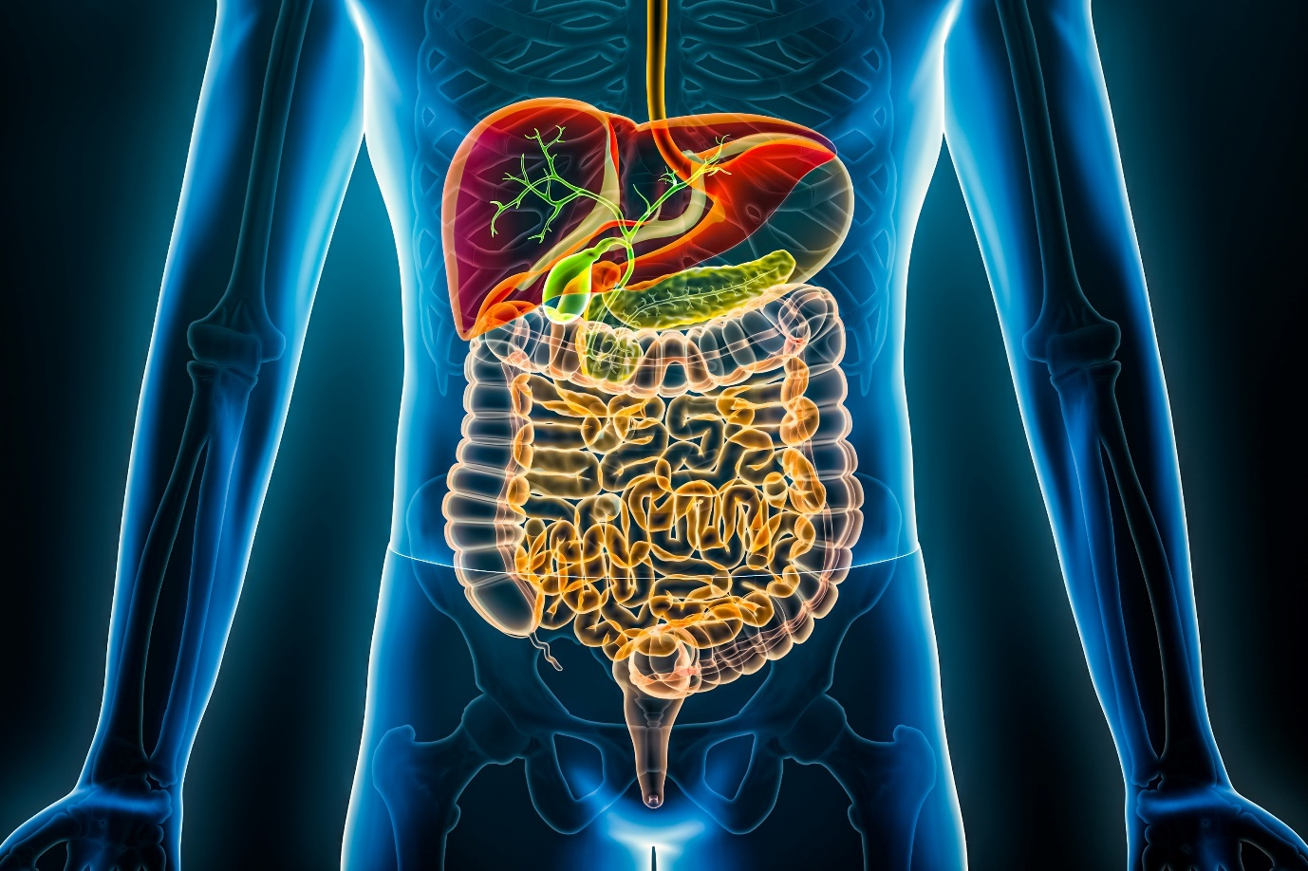

### **1.1.6 Urinary System**

The urinary system, also known as the renal system, removes liquid waste from the blood to keep a stable balance of salts and other substances. The removal of liquid waste, specifically toxins, metabolic waste and excess ions, happens in excretion and urination.

Through excretion, liquid waste is separated from the essential substances in the blood. After excretion, the liquid waste is released from the body through urine.

The urinary or renal system consists of four primary organs: the kidney, ureters, bladder and urethra.

* **Kidneys** are bean-shaped organs responsible for liquid waste and urine production excretion.
* The **ureter** is the tube that carries urine from the kidneys to the bladder.
* The **bladder** is the organ that stores urine.
* The **urethra** is the tube through which urine leaves the body.

Of all the organs in the urinary or renal system, the kidneys do most of the work. The main functions of the kidneys are as follows:

* 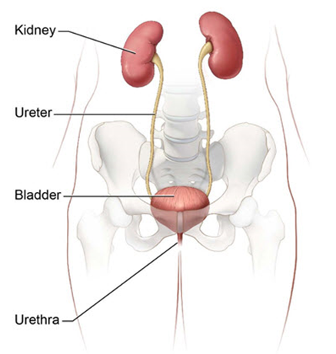**Remove wastes**

The blood enters the kidneys through renal arteries. These arteries branch into tiny capillaries that interacts with the nephrons. *Nephrons* are a network of filtering systems. After filtering of wastes (urine), it is stored in the bladder until they are excreted. Wastes are the by-products of cellular metabolism (e.g. urea which is the by-product of protein metabolism).

* **Maintain homeostasis**

*Homeostasis* is the body’s ability to maintain balance in an environment despite the changes in its external environment. The kidney regulates potassium, sodium and calcium. It will excrete or reabsorb these body elements to maintain normal levels.

* **Regulate pH level**

This is done by excreting excess hydrogen ions (H+). Bicarbonate ions are kept to act as pH buffers.

The kidneys absorb and reabsorb water to help maintain a healthy fluid balance and blood pressure.

* **Produce hormones**
* *Calcitriol* – This is released when there is a low level of calcium. This hormone promotes calcium reabsorption in the small intestine and the kidneys.
* *Erythropoietin* – When blood is filtered through the kidneys, it detects the level of red blood cells (RBC). If RBCs are low, the hormone erythropoietin stimulates the production of red blood cells.

Renin participates in the *renin-angiotensin system (RAS).* For example, if blood pressure drops, the RAS regulates blood pressure and fluid balance by constricting blood vessels and renal sodium retention.

Although the kidneys do most of the work in the urinary or renal system, all the other organs are actively involved in the continuous waste removal process. To better understand how each organ works, refer to the process below.

1. It starts from the digestive system, where the food consumed gets processed. The food's nutrients are taken out, and the waste products are then moved to the bowel and into the blood.
2. 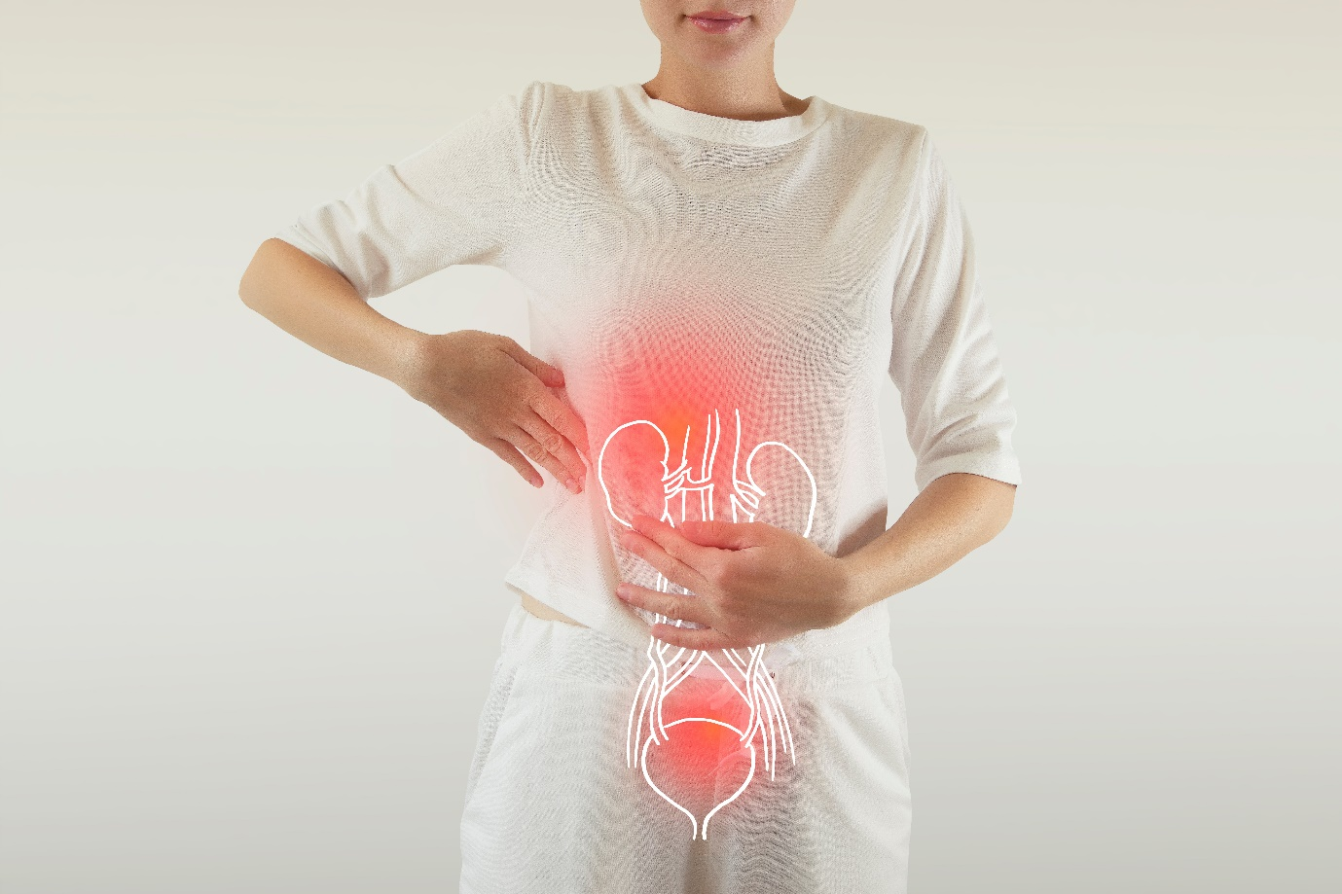The blood then enters the kidneys through the renal arteries. The kidneys filter the blood, further separating nutrients from toxins through its million filtering units called nephrons.
3. After filtering, vitamins, minerals, nutrients, and proteins return to the bloodstream.
4. The waste products, combined with the urine, move through the ureters to the bladder.
5. The bladder will store urine until it reaches its full capacity. When it is full, the nerve endings in the bladder wall send a message to the brain that the urine needs to be released through pee.
6. Urine will leave the body through the urethra while peeing.

As discussed, the urinary system is also known as the renal system. The diagram of the renal system below shows other internal body parts that help the kidneys do their primary function of filtering wastes from the blood.

You may notice that it is similar to the diagram of the urinary system shown on page 35. However, the previous diagram focused more on the parts directly involved in the production and excretion of urine. The one below focuses on other parts that help filter and regulate blood and the excretion of waste through the urine.

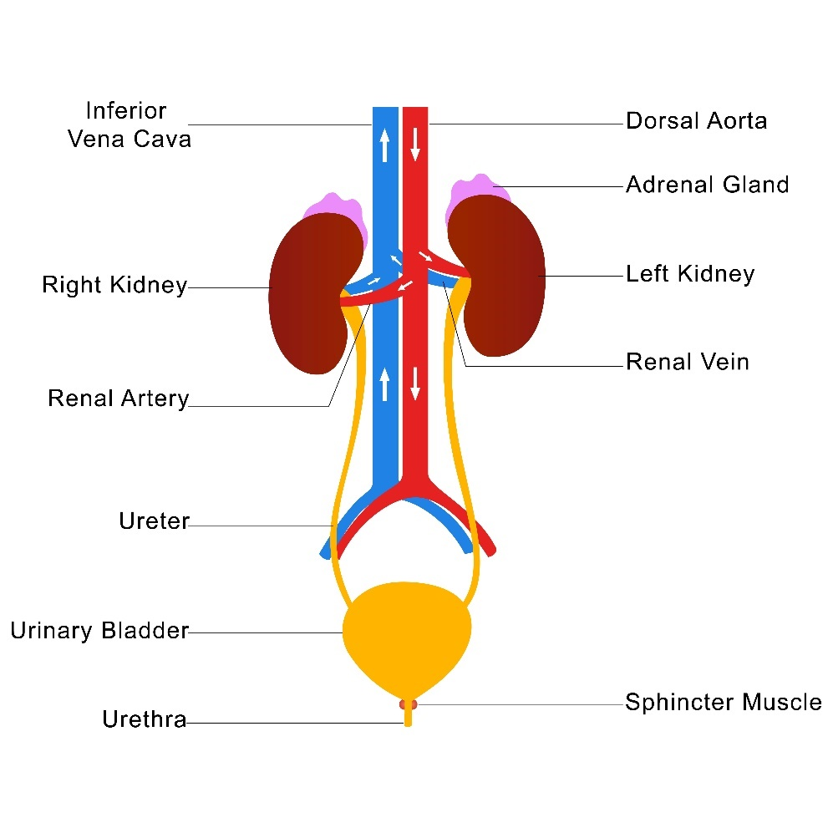

* **Dorsal aorta**

It is the vein that gives rise to many intersegmental arteries. These arteries transfer oxygenated blood to the segmented muscles and form the renal arteries to the kidneys.

* **Inferior vena cava**

It is a part of the largest vein in the body. It carries oxygen-poor blood from the legs, feet and organs in the abdomen and pelvis, which includes the kidneys. The blood will then go to the heart. The blood has a reduced oxygen level after undergoing the filtering process in the kidneys. Through the inferior vena cava, the blood will move back to the heart and then to the lungs until it gets distributed to other body parts.

* **Adrenal gland**

The adrenal glands sit on top of the kidneys and are part of the endocrine system. It works with the kidneys by producing the hormone aldosterone. Aldosterone sends signals to the kidneys to absorb more sodium into the bloodstream and release potassium into the urine. This results in homeostasis or balance in your blood’s pH level where potassium, sodium and water levels are balanced.

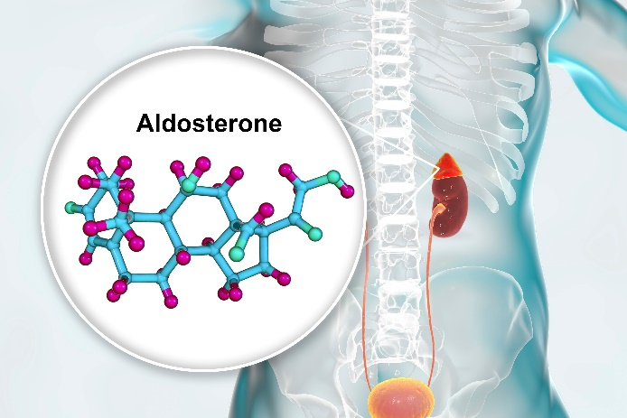

* **Urethral sphincter muscle**

These are the two muscles that encircle the lowest part of the bladder. It controls the exit of urine from the urinary bladder to the urethra. The sphincter muscle contracts to prevent urine from leaving the bladder. When the bladder is full, a message is sent to the brain through the nerves and spinal cord.

When the decision to urinate is made, the sphincter muscle relaxes, allowing urine to flow from the bladder to the urethra.

|  |  |
| --- | --- |
|  | **Further Reading**  Various websites cover many more terminologies commonly associated with the urinary system. One of them is Visible Body, a website of a group of anatomy enthusiasts whose mission is to make studying the human body engaging and interactive for learners. To access their website, follow the link below.  [Glossary of the Urinary System](https://www.visiblebody.com/learn/urinary/glossary) |

|  |
| --- |
| **Multimedia**  Graphical user interface, application  Description automatically generated  To learn more about how the urinary or renal system works, you may click the link below to watch the video.  [Urinary System, Part 1: Crash Course Anatomy & Physiology #38](https://www.youtube.com/watch?v=l128tW1H5a8) |

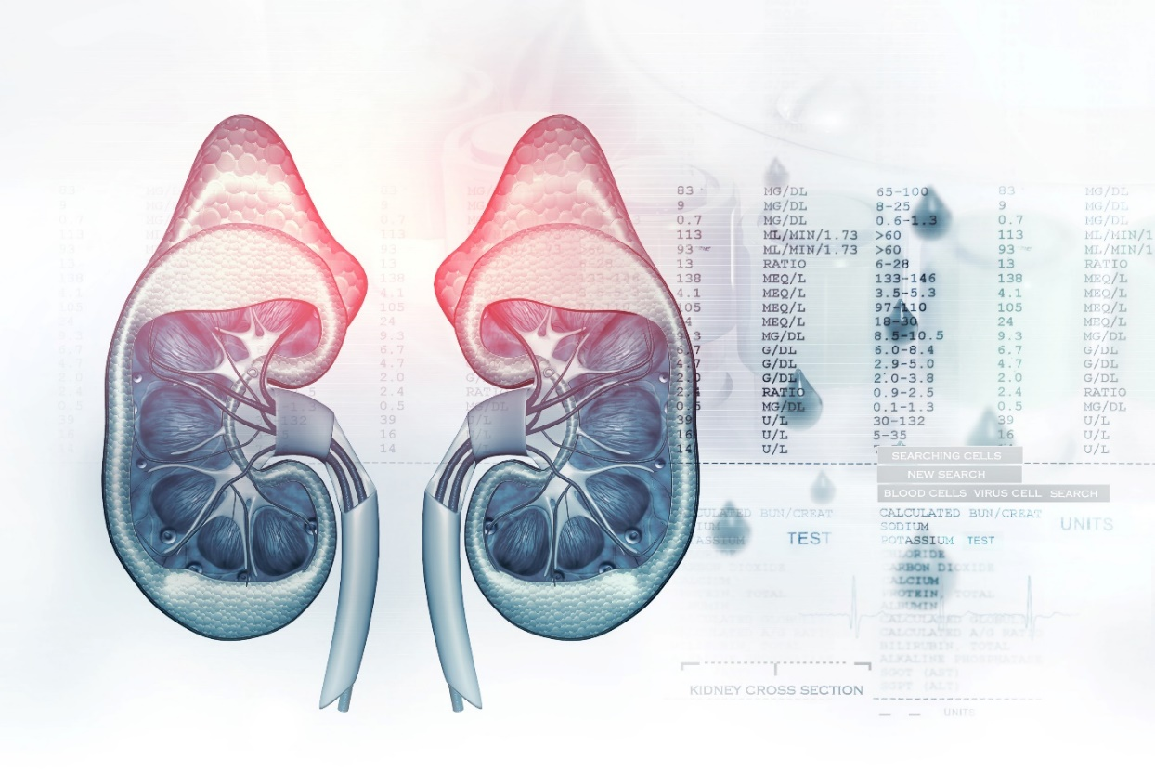

### **1.1.7 Reproductive System**

The reproductive system is essential in the procreation of life. It involves the male and female reproductive systems.

**Male Reproductive System**

The male reproductive system comprises the following parts:

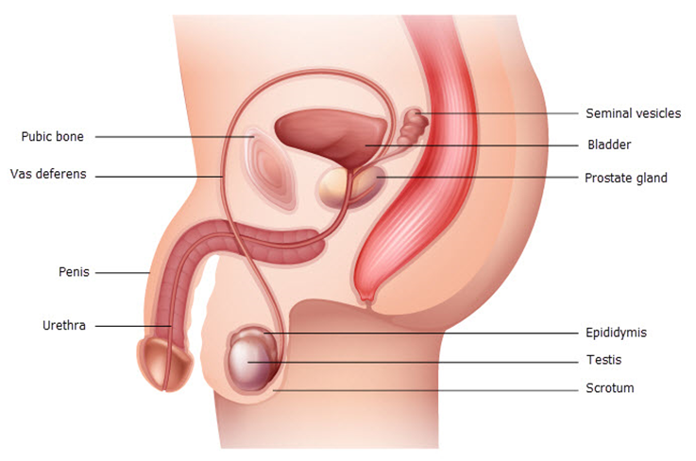

They are normally composed of external and internal organs. The internal organs include the following:

* The **vas deferens** transports mature sperm to the urethra in preparation for ejaculation.
* **Ejaculatory ducts** empty into the urethra.
* The **urethra** carries urine from the bladder to the outside of your body. It also has the function of expelling (ejaculating) semen.
* **Seminal vesicles** are attached to the vas deferens near the base of the bladder. They provide sperms with a source of energy and help with the sperms’ ability to move.
* The **prostate gland** contributes additional fluid to the ejaculate.

The external organs include the following:

* The **penis** is the male organ for sexual intercourse and an important organ that plays a role in secreting urine.
* The **scrotum** holds the testicles (also called testes) and many nerves and blood vessels.
* **Testicles** (testes) are responsible for making testosterone, the primary male sex hormone, and for producing sperm.

**Female Reproductive System**

The female reproductive system is normally composed of external and internal organs. The external organs include the following:

* 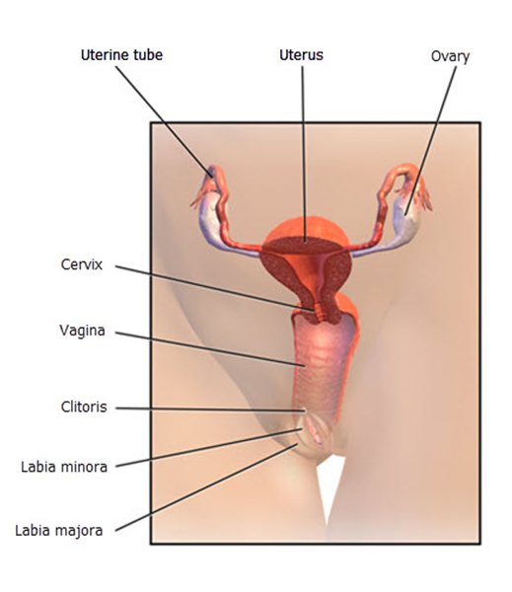The **labia majora** encloses and protects the other external reproductive organs.
* The **labia minora** surrounds the openings to the vagina and urethra.
* The **clitoris** is a sensitive protrusion comparable to the penis in males.

The internal organs include the following:

* The **vagina** is a canal that joins the cervix to the outside of the body.
* The **uterus** is the home of a developing foetus.
* **Ovaries** produce eggs and hormones.
* **Fallopian tubes** are narrow tubes where the fertilisation of an egg (ova) by a sperm occurs typically.

|  |  |
| --- | --- |
|  | **Further Reading**  Various websites cover many more terminologies commonly associated with the reproductive system. One of them is Visible Body, a website of a group of anatomy enthusiasts whose mission is to make studying the human body engaging and interactive for learners. To access their website, follow the link below.  [Glossary of the Reproductive System](https://www.visiblebody.com/learn/reproductive/glossary) |

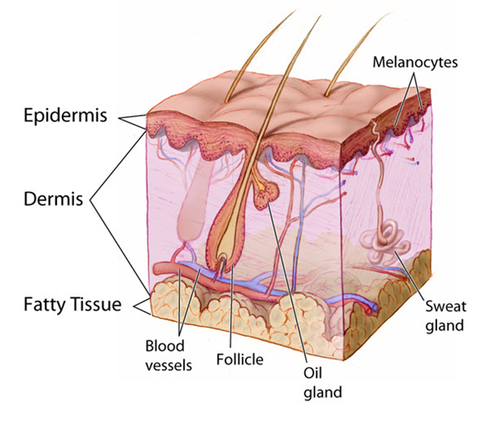

### **1.1.8 Integumentary System**

The integumentary system is mainly responsible for protecting the body's internal parts. It protects against bacteria, pollution, and harmful UV rays from the sun. This is also the body's largest organ and consists of skin, hair, nails and exocrine glands.

The skin has three layers, and these include the following:

* The **epidermis** produces melanin which contributes to skin colour.
* The **dermis** contains nerve endings, hair follicles, sweat glands, sebaceous glands, and blood vessels.
* The **fat layer** serves as protective padding and insulates the body from cold and hot.

The skin’s other functions include:

* Protecting the body from dehydration
* Eliminating waste such as salts, water, urea and lactic acid
* Regulating the temperature by evaporating sweat (when hot) and vasodilation (when cold)
* Protecting the body from infectious microorganisms
* Producing vitamin D
* Signalling the brain for sensations such as pain, touch, pressure, cold and heat

|  |
| --- |
| **Multimedia**  Graphical user interface, application  Description automatically generated  The link below tackles the biggest organ in the human body, the integumentary system. Click the link below to access the video and learn more about the common terminologies used to describe various integumentary components.  [The Integumentary System, Part 1 - Skin Deep: Crash Course Anatomy & Physiology #6](https://www.youtube.com/watch?v=Orumw-PyNjw&t=2s) |

### **1.1.9 Lymphatic System**

The lymphatic system transports fluid containing infection-fighting white blood cells throughout the body. There are lymphatic vessels throughout organs in the body, with lymph nodes located along with the system. The lymphatic system removes excess *interstitial fluid*, drains the fluid into the circulatory system, absorbs fats via the villi in the small intestine, and helps fight infection.

Lymph vessels are located throughout the body and carry clear straw-coloured fluid (lymph) and white blood cells (lymphocytes).

Lymph nodes are round, soft, and located throughout the body, such as the armpit, groin and neck. They contain lymphocytes which filter bacteria, cancer cells, and other foreign substances from the body.

The lymphatic system includes the following:

* The **tonsils** are located at the back of your throat. They contain lymphatic tissue that traps germs before they enter the breathing passage.
* The **spleen** contains white blood cells (WBC), which destroy damaged and old cells.
* The **thymus** helps to produce WBC.
* The **liver** produces a large amount of lymph, which is estimated to be 25–50% of lymph flowing through the thoracic duct.

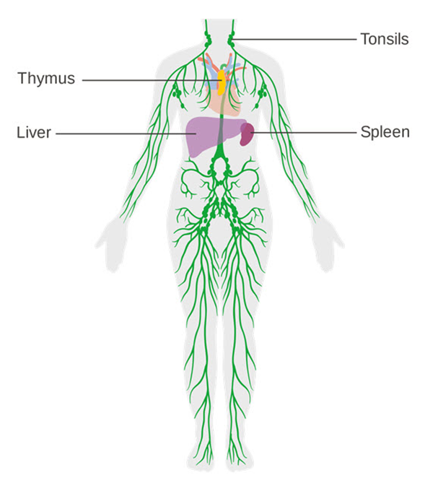The major organs and systems in the lymphatic system that are mainly involved in protecting the body from infections include the following:

* **Keratin**, a protein inside skin cells, makes up the skin cells and sticks together with other proteins to form the epidermis.
* The **epidermis** keeps bacteria and germs from entering the body and causing infections.
* **White blood cells** attach to germs, absorbing them or destroying them. They produce antibodies that latch onto these germs.

The lymphatic system is also a part of the immune system. The immune system provides the body protection from infections and diseases. See Section 1.1.10 for more information on the immune system.

|  |  |
| --- | --- |
|  | **Further Reading**  Various websites cover many more terminologies commonly associated with the lymphatic system. One of them is Visible Body, a website of a group of anatomy enthusiasts whose mission is to make studying the human body engaging and interactive for learners. To access their website, follow the link below.  [Glossary of the Lymphatic System](https://www.visiblebody.com/learn/lymphatic/glossary) |

### **1.1.10 Immune System**

The immune system is pivotal in our overall wellness. It functions in the background and silently waits for any opportunity to protect your body from getting ill. You will not even be aware it is there if all is well. But you will get sick if it stops working correctly. Understanding the immune system's structure and function can help you make informed choices to improve the health and wellness of your clients.

The immune system is mainly responsible for the following:

* Fighting intruders such as bacteria, viruses, parasites or fungi
* Recognising and neutralising harmful substances from our surroundings
* Fighting internal changes within the body that cause illnesses, such as cancer cells

**Organs of the Immune System**

Among the many organs that function in the immune system, a few can be considered pivotal in the overall function of the immune system.

Below are the organs considered pivotal in the operations of the immune system and how they contribute to keeping the body from illnesses.

* **Bone marrow**

This pertains to the spongy substance in the cavities of bones in which blood cells, such as red blood cells, platelets, and white blood cells, are produced.

The bone marrow's white blood cells help fight invading bacteria, viruses or fungi and respond to allergens that invade the body.

* **Lymph nodes**

Lymph nodes are masses of tissue located along lymphatic system pathways, which include the following body parts:

These lymph nodes act as filters for foreign particles in the body, including cancer cells. When the lymph nodes detect toxins or other foreign substances in the lymph, lymphocytes are activated to produce antibodies specific to the toxin or foreign substance. The antibodies then attach to the toxin and are recognised as an intruder for destruction by other immune cells.

* **Thymus gland**

This is located behind the sternum. It also plays a role in producing white blood cells called lymphocytes that help the body fight infection. The T cells, a type of lymphocyte, are trained and programmed in the active years of foetal development until a person’s adolescence. After puberty, the thymus gland gradually performs a less vital role in immune system function.

* **Spleen**

This filters your blood as it breaks down and removes abnormal, old or damaged cells. The spleen also stores healthy red blood cells, platelets, and leukocytes or white blood cells. During infections, the spleen identifies the infection in your blood, signalling the production and release of lymphocytes.

The common diagnoses relevant to the immune system that you will likely encounter in your line of work include the following:

|  |  |
| --- | --- |
|  | **Further Reading**  Below is a link to an explanation of technical terms used in the Australian Immunisation Handbook  [Glossary of technical terms](https://immunisationhandbook.health.gov.au/technical-terms) |

### **1.1.11 Nervous System**

The nervous system communicates with the body with its other parts by carrying information from the brain to the other parts. The nervous system consists of the following:

* The **central nervous system (CNS)** is the body's command centre. It consists of the following:
* **The brain**

The nervous system’s central control point

* **The spinal cord**

Links the brain and the peripheral nervous system (PNS)

* **The retinas of the eyes**

A thin layer of tissue positioned at the back of the eye

* The **peripheral nervous system** **(PNS)** involves nerve cells (neurons) located outside the central nervous system.

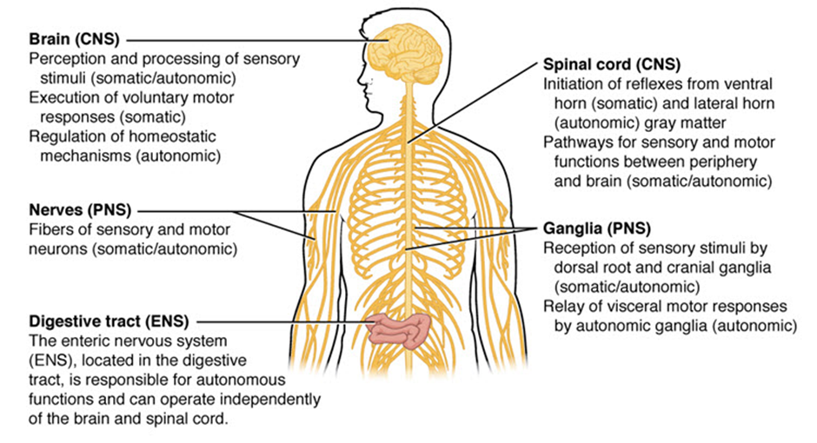

There are different types of neurons (nerve cells), and these include the following:

* **Sensory neurons** detect temperature, pain and pressure.
* **Motor neurons** stimulate the muscles.
* **Interneurons** connect all neurons.

To help you understand how the brain receives and interprets information, take note of the terminologies and functions of the different parts of the nervous system.

A nerve cell is composed of the following parts:

* **Dendrite** – The structure that looks like a branch found at the ends of the neuron that receives signals or information from other neurons
* **Soma** – The body of the cell where the nucleus lies and that controls the cells
* **Nucleus** – The part of the cell that stores DNA, which helps with and controls a cell’s function, growth and reproduction
* **Axon** – The long extension structure from the soma; it works to transmit the information it receives down its body to the dendrites at the end of the neuron
* **Myeline sheath** – The protective sleeve that covers the axon of neurons

Billions of neurons (refer to the diagram below) carry information from one body part to another. The information or messages are transported along the neurons by an electrical current. As it reaches the end of the neuron, a message will jump across to the next neuron via neurotransmitters. This occurs at lightning speed. An example of this process is when your sensory neuron activates when you touch something hot. A message will go to your central nervous system (where information is processed) and to the motor neurons, stimulating your arm muscles to remove your hand.

The *somatic system* (or voluntary nervous system) sends sensory information (e.g. touch, hearing, vision and smell) to the central nervous system. Then a message is sent to motor nerve fibres (e.g. to move muscles).

The *autonomic system* is responsible for involuntary actions like breathing and heart rate.

For example, our breathing rate is determined by central chemoreceptors located in the medulla (brain). The chemoreceptors detectpH levels in the blood. Increased carbon dioxide increases the pH of the blood. The response sends nervous impulses to the diaphragm and intercostal muscles to increase breathing.

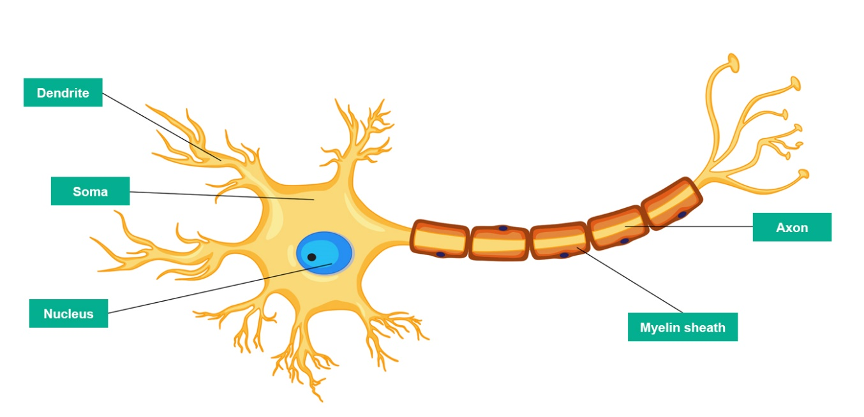

|  |  |
| --- | --- |
|  | **Further Reading**  Various websites cover many more terminologies commonly associated with the nervous system. One of them is Visible Body, a website of a group of anatomy enthusiasts whose mission is to make studying the human body engaging and interactive for learners. To access their website, follow the link below.  [Glossary of the Nervous System](https://www.visiblebody.com/learn/nervous/glossary) |

**Eyes and Ears**

jThe eyes and the ears are two components of the body that share a close relationship with the nervous system, although they are external body parts. They are often considered windows to the nervous system or the brain.

The parts of the eyes are as follows:

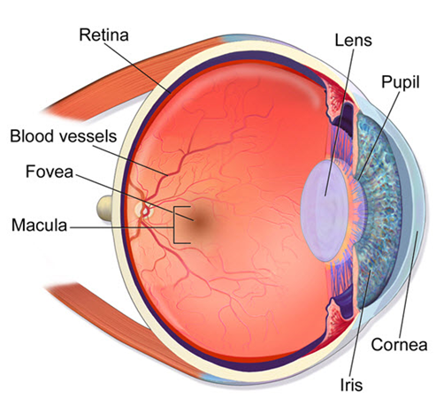

The parts of the ears are as follows:

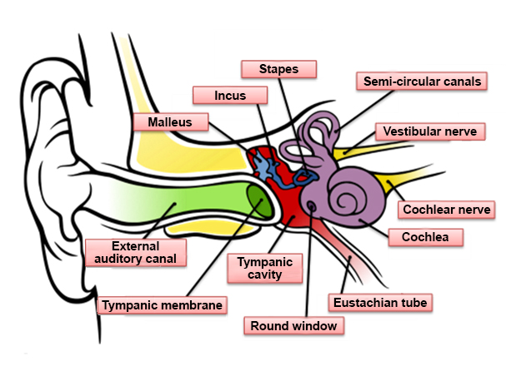

Continue reading Section 1.1.12 to know more about the processes involved in translating information through the senses of the body.

### **1.1.12 Senses of the Body**

The special senses include the functions of the organs such as the nose, tongue, eyes and ears. The eyes and ears have already been discussed in the previous section. Now, it is time to read about how they function in conjunction with other organ systems, such as the nervous system.

The eyes and the ears play a vital role in how people interpret the things around them. The senses and functions that are associated with the eyes and ears are the following:

Light rays enter the eyes. When it reaches the light-sensitive nerve cells, the rods and cones in the retina, light energy is processed into electrical activity or impulses. Electrical impulses are communicated to the brain's visual cortex through the optic nerve. Through this process, people are able to see. This state of being able to see is better known as vision.

For the ears, sound waves enter the inner ear and then into the cochlea. The fluid contained in the cochlea moves in response to the vibration from the oval window. These vibrations are converted into electrical impulses and then sent to the brain via the auditory nerve. Through this process, people can hear. This state of being able to hear is better known as hearing.

Apart from the ability to hear, the ears are normally associated with balance, better known as equilibrium. Equilibrium is the sense that gives humans an idea about the positions of the body. Inside the structures of the inner ear, the balance organ or the vestibular system can be found. It is important to know this as complaints of dizziness and disequilibrium increase with age.

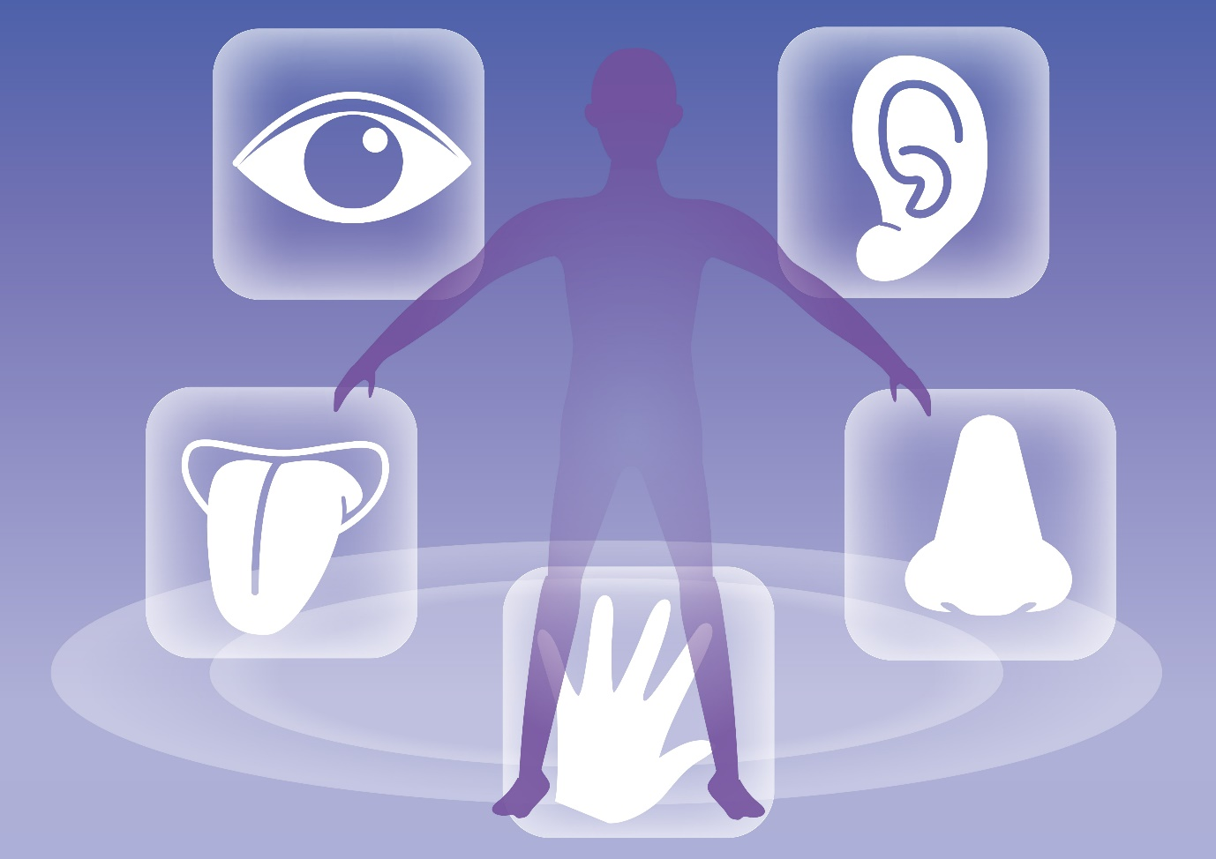

|  |
| --- |
| **Multimedia**  Graphical user interface, application  Description automatically generated  ABC News In-depth offers long-form journalism and explainers to help people across Australia and the world understand various things going on around the globe. In the link below, they tackled how hearing loss is irreversible. They explain how people start losing their hearing as they get older and other factors that may damage our ears long-term. To access the video, click the link below.  [Why your ears could be older than you (hearing test) | Did You Know?](https://www.youtube.com/watch?v=pFG2Xxpx0Cc) |

The other sensory organs include the following:

The senses and functions that are associated with the tongue and nose are the following:

* **Taste**

The tongue is the organ of taste. It is also vital for chewing and swallowing food and speech. The receptors on the tongue detect a variety of tastes, such as sweet, sour, bitter, salty and savoury. The taste buds are responsible for sending messages to the areas in the cortex, a part of the nervous system, in charge of processing taste.

The parts of the tongue include:

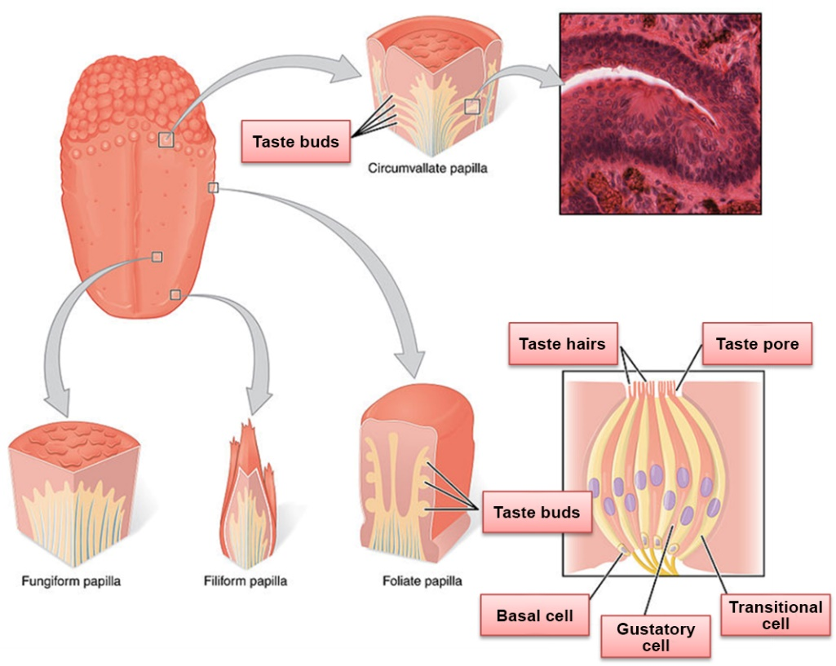

Some people have different conditions relating to their ability to taste:

* **Hypogeusia** –This is the decreased ability to taste.
* **Ageusia** –The person is unable to detect any taste. This is a rare case as a person would most likely lose their sense of smell rather than their sense of taste.
* **Smell**

The nose is the primary organ for the smell. As we smell, signals are sent from the olfactory bulb to the other parts of the brain to be interpreted as a smell we may recognise. Millions of olfactory receptor neurons are located in the mucous membrane on top of the nasal cavity. These receptors detect different scents. Some people have different conditions relating to their ability to smell:

* **Hyposmia** –This is the decreased ability to smell or detect odours.
* **Anosmia** –The person is unable to smell or detect odours.
* **Congenital anosmia** –A person is born with a complete loss of smell.
* **Hyperosmia** –This is the increased ability to smell or detect odours.

The other parts of the nose can be found in the photo below.

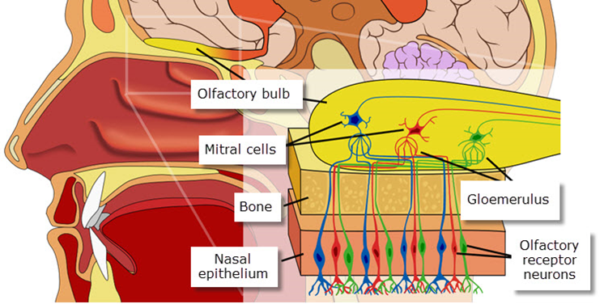

|  |  |
| --- | --- |
|  | **Further Reading**  Various websites cover many more terminologies commonly associated with the human body's five senses. One of them is HearingSol. To access their website, follow the link below.  [The Five Senses of The Human Body: Facts Figure & Functionality](https://www.hearingsol.com/articles/facts-five-sense-organs-of-human-body/) |

## Interpret Information Relevant to the Interrelationship of Body Structures



The saying ‘you are what you eat’ backs up the fact t that the food the digestive system takes in reflects onto the rest of the body. The human body consists of complex interconnected systems. The heart, a part of our circulatory system, does not pump blood unless our brain, which functions under the nervous system, tells it to. The endocrine system coordinates with the other organ systems by releasing hormones that function as chemical signals. The muscular system will not function if the respiratory and circulatory systems do not supply oxygen and nutrients. It takes all the organ systems to work together for a human being to be alive and live well. Each organ systems have different tasks to perform. Therefore, you need to know how each of the body’s organ systems is interrelated to maximise any plans for improving and supporting your client’s overall health. Not knowing how basic organ systems interconnect with each other can lead to grave consequences, including the following:

* Confusion with interpretation
* Injuries
* Expensive mistakes
* Medical malpractice
* Loss of life

To interpret information relevant to the interrelationship of organ systems in the body, access the same documents mentioned in Subchapter 1.1, such as the following:

* Pieces of medical advice to the client given by the doctor
* Changes in the physical, psychological and mental condition of the client or patient
* Indicators of body system issues
* Content of clients’ individualised plans
* Clients’ health conditions

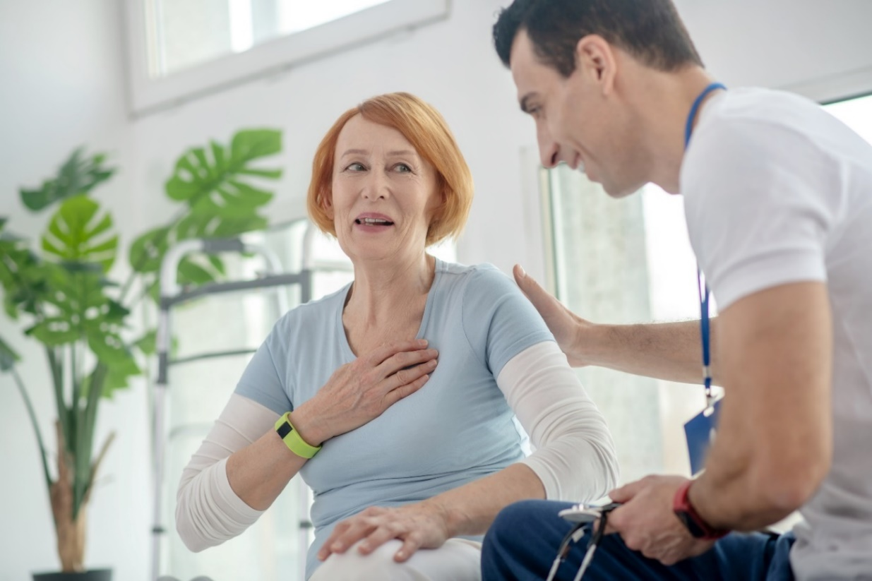

### **1.2.1 Interrelated Major Organ Systems and Relevant Common Body System Issues**

No organ system works in isolation. The main reason you must recognise how the body is structured and how it functions as a single unit is that your client's well-being depends upon the well-being of all the interacting organ systems. A problem within one system generally has consequences for several other organ systems. This is even more important and true in your work role as you work with the older people and people with disability.

The next page summarises how some major organ systems work together closely.

**Cardiovascular System’s Relationship With Other Organ Systems**

One major organ system that is a perfect example of how all organs are interrelated is the cardiovascular system. Below discusses some of the most notable ways the cardiovascular system interacts with the other organs to help the body function.

* **Cardiovascular and respiratory systems**

The circulatory and respiratory systems work together to circulate blood and oxygen throughout the body. Air goes in and out of the lungs through the trachea, bronchi, and bronchioles. Then blood moves in and out of the lungs through the pulmonary arteries and veins that connect to the heart.

* **Cardiovascular and immune systems**

The bone marrow found within the interior walls of bones is crucial for the proper development of the immune system. Most blood cells are made in the bone marrow. The blood cells produced in the bone marrow, such as the white blood cells, are the ones that fight off intruders in the body to prevent infections. The bone marrow ultimately houses stem cells that maintain the immune system.

* **Cardiovascular and digestive systems**

The circulatory system helps distribute the nutrients absorbed in the digestive system. This is completed with the help of the blood, which carries the nutrients such as sugars and essential acids absorbed and processed by the liver. These much-needed nutrients are then transported to the other body parts where they are required.

* **Cardiovascular and urinary systems**

The blood pumps blood filled with oxygen through all parts of our body, including the kidneys. The urinary system, specifically the kidneys, helps the blood be cleansed of waste products and extra water. The urinary system plays a key factor in helping control blood pressure, make red blood cells, and keep the balance of minerals in the blood (e.g. sodium, phosphorous and potassium).

**Other Major Organ Systems’ Relationship With the Rest of the Organ Systems**

The interrelationship of the major body organs involves many great body systems working together so that the body functions at its best. Here are other notable ways the cardiovascular and the other major systems interact with the other organs to help the body function:

* **Lymphatic and immune systems**

The lymphatic system is an important part of the immune system. It produces and releases white blood cells and other immune cells that monitor and then destroy foreign invaders which may enter the body, such as bacteria, viruses, parasites and fungi.

* **Digestive and excretory systems**

The food processed by the stomach is broken down to be used by the body's cells and tissues with the help of the stomach's enzymes. Consumed drugs and alcohol, for example, will be absorbed by the stomach first since absorption is mainly the function of the small intestines. Digestible nutrients pass through the small intestines and their microvilli to capillaries. The liver then goes to work to detoxify and further process our food. The waste collected from them will then be excreted through the excretory system.

* **Endocrine and nervous systems**

The endocrine and nervous systems are linked through the hypothalamus. This organ controls human behaviour, including emotional and stress responses. It is also responsible for basic drives such as sleep, hunger, thirst and libido. Both the endocrine and nervous systems are involved intimately in maintaining homeostasis. Endocrine issues may manifest in various neurologic problems, such as headache, myopathy, and acute encephalopathy, including coma.

* **Endocrine and reproductive systems**

The endocrine glands in the reproductive system produce sex hormones responsible for secondary sex characteristics in men and women.

These sex hormones also contribute to the production of sex cells or gametes. Through this, female sex hormones regulate pregnancy, ovulation, and menstruation or the menstrual cycle.

* **Integumentary and nervous systems**

The skin has different sensory receptors that receive different sensations from the environment, such as pain, pressure, heat, and cold. These sensations are sent to and processed by the nervous system.

* **Nervous and muscular systems**

The system that provides your body's shape is the skeletal system, which comprises cartilage and bone. Movement in the body results from muscle contraction; when muscles combine with the action of joints and bones, obvious movements are performed, such as jumping and walking. The contraction of muscles provides body posture, joint stability, and heat production. The nervous system controls voluntary muscle movements.

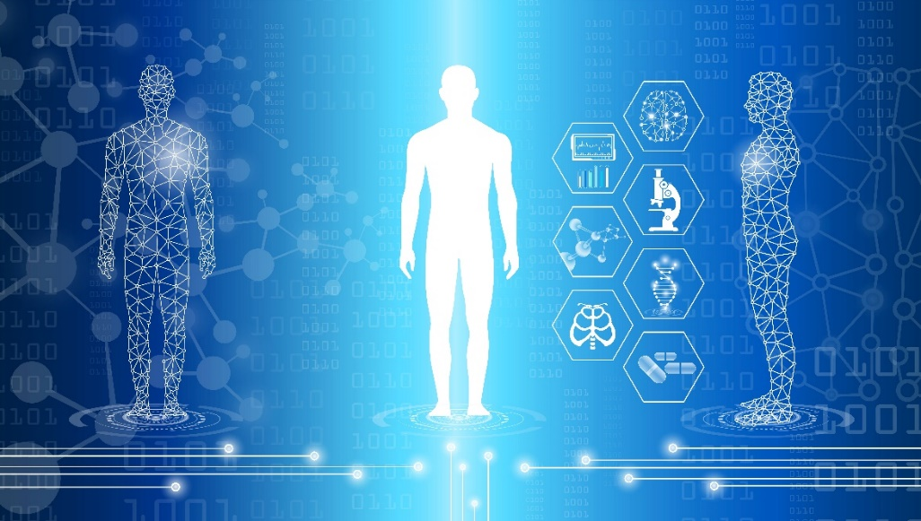

|  |
| --- |
| **Multimedia**  Graphical user interface, application  Description automatically generated  National Geographic, commonly called Nat Geo, is the world's premium destination for science, exploration, and adventure. In the video below, Nat Geo summarises the common roles of the different organ systems and how each system’s complex process helps the body function as a whole.  [Human Body 101 | National Geographic](https://www.youtube.com/watch?v=Ae4MadKPJC0&t=5s) |

As previously mentioned, different body organs are affected even if only one organ fails to function properly. This is especially true with your older people and people with disability.

**Impacts of Ageing and Disability on Client’s Well-Being**

The World Health Organization (WHO) explains that ageing results from accumulating various molecular and cellular damage over time. Like an ageing person’s body, the molecular and cellular structures of the bodies of people with disability change, and an ageing body will experience a decline in its physical and mental capacities.

To perform your work role properly, you must first understand what ageing and disability do to the body. Ageing and specific disabilities affect various areas of life. These include the following:

*Psychological* and *mental* are terms that may be used interchangeably to describe similar issues. However, these terms are often used differently and may affect how your client with specific issues will be treated.

Issues related to mental health conditions are identified based on experience and observation of various symptoms resulting from a psychiatric diagnosis. On the other hand, related psychological problems are clinician-formulated hypotheses founded on symptoms shown by the client, considering social and environmental factors affecting the patient.

* **Impact on physical well-being**

The age of your older clients usually shows in their height, body composition, skin, hair, muscles and bones. In your clients with disability, you will usually notice effects on their body composition. Apart from that, you will observe signs and symptoms commonly associated with the disease or disability they have. For example, a person who is deaf at birth may also not be able to speak.

* **Impact on psychological (emotional) well-being**

It is common for people with physical illnesses and other conditions to experience grief, anger and frustration.

It is common to feel angry about sudden changes in their lifestyle, and they often feel misunderstood by others who do not have the same limitations. While these emotions are normal, physical symptoms and associated emotions can add to a person’s psychological stress.

* **Impact on mental well-being**

People with physical illnesses and other conditions are likely to develop mental health issues because, at times, physical illnesses and conditions are associated with abnormal levels of hormones and neurotransmitters and increased stress. These factors lead to an increased risk for depression, anxiety, and other mental health issues.

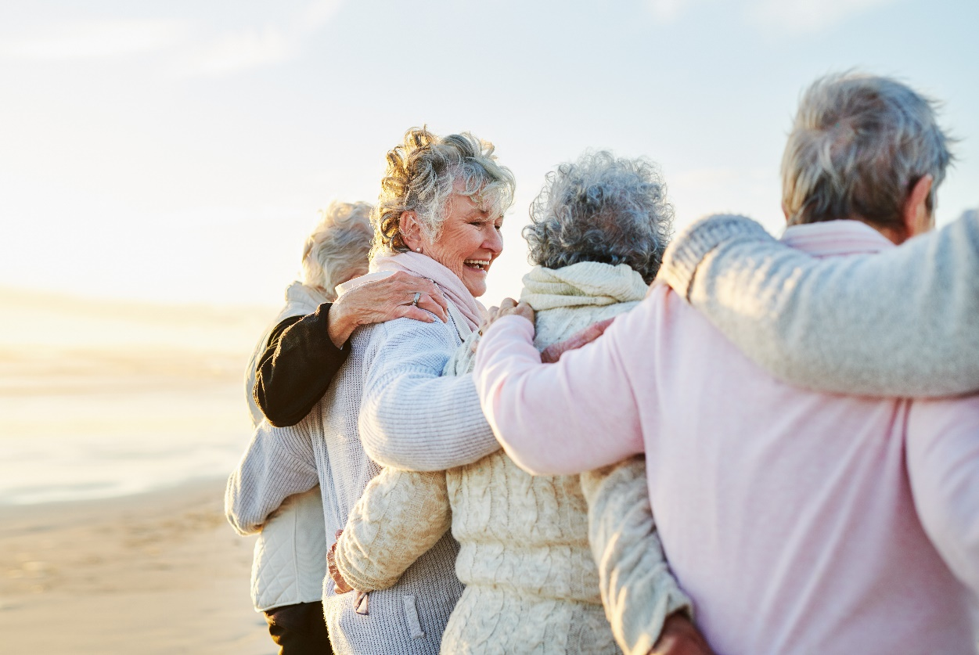

**Using Knowledge About Body Systems to Monitor Client’s Health and Physical Condition**

As a support worker, your primary responsibility is to monitor your client’s physical and overall health. Any problems with their health, may it be concerning their physical health, psychological health or overall well-being, will manifest in changes in the following:

As you monitor your client and observe these changes in their body, your main work responsibilities may include the following:

|  |  |
| --- | --- |
|  | **Lotus Compassionate Care**  Lotus Compassionate Care is the simulated organisation that provides services in disability support, home and community support, and residential care referenced in our learning resources.  Check out their policies and procedures for a better understanding of the work responsibilities your work role entails in a real workplace setting. You can access the link below.  [Policies & Procedures](https://compliantlearningresources.com.au/network/lotus-v2/policies-procedures/)  *(username: newusername password: newpassword)* |

Now that you are familiar with the structures, functions and interactions of the organ systems in the human body, you will be able to use this information to recognise any changes in your client’s health. Monitoring your client’s overall health and well-being often requires these necessary activities to ensure your client’s well-being is given importance and care. Monitoring often involves the following:

1. **Recognising**

This means making rounds to check on your client and following a routine schedule to observe and monitor your client's condition actively. This could also involve reviewing your client’s individualised support or care plan to check the person’s current physical conditions and symptoms. Recognising indicators could also mean consulting with the person’s family or carer to inquire about any changes to the client’s physical health and conditions.

1. **Reporting**

Report changes to your client’s physical, emotional and mental health and conditions to the supervisor, registered nurse, or doctor so they can ascertain whether the changes are normal.

Reporting must be done immediately or as soon as practicable verbally to the supervisor and through documentation in the progress notes. How reporting is done can also depend on the common practices an organisation follows. For example, in other organisations, reports must always be submitted with evidence, such as photos and video recordings. The types of reporting that you may do include the following:

* Hazard reporting
* Incident reporting
* Worksite reporting
* Progress reporting

All of them have different functions as well. Progress reporting is the most common type of reporting you may do daily in your workplace. The step-by-step process for progress reporting may include the following:

1. Fill out the Progress Notes Template with important details about your observations of the client. Remember to do the following:
2. Document any identified concerns, such as risks and changes in the client's physical and psychological conditions and well-being. Remember to do the following:
3. Draw a line through to the end of the page.
4. Complete progress notes and file client records based on the organisation's privacy and confidentiality policy.
5. Report any changes to the client’s physical and psychological conditions and well-being to the supervisor or registered nurse and document them in the progress notes immediately or as soon as practicable.

Reporting can vary on the issues you are to report. As a support worker, how would you know when you already need to report your client's health status and physical condition?

Although other factors commonly affect how and when you report, it is important to consider the type of indicator or symptom you observe. Some symptoms can be eased with simple medication, while others can be life-threatening and may need immediate attention.

Examples of some emergency indicators may include the following:

* Bleeding that will not stop
* Coughing up or vomiting blood
* Fast breathing or trouble breathing
* Severe abdominal pain or pressure
* Feeling like committing suicide or murder

1. **Documenting**

Keeping the data in relevant documents such as a progress report can keep you, the other carers, and the client’s family updated and aware of the client’s current condition. The documentation must be done with accuracy and privacy.

Another document you will likely use in the workplace is an incident report or equivalent form. This document is used mainly to file a report regarding an event that occurred and must be alerted to the appropriate personnel.

|  |  |
| --- | --- |
|  | **Lotus Compassionate Care**  Access and review Lotus Compassionate Care’s Incident Report Form through the link below.  [Incident Report Form](https://compliantlearningresources.com.au/network/lotus-v2/forms/)  *(username: newusername password: newpassword)* |

**Recognising Changes**

There are three areas of your client’s health that you can monitor as you apply what you have learned about body systems in Subchapter 1.1. You will be closely monitoring the following:

Monitoring the abovementioned means paying attention to the following:

* **Indicators of changes in the client’s physical condition**

This is normally checked through constant monitoring and observation.

You can pay attention to any changes in their outward appearance or what they say they feel or experience in specific areas of their body.

Some external and internal indications of noteworthy changes may include the following examples:

* **Indicators of changes in the client’s psychological or mental health condition**

Physical and mood changes of your client can also be recognised through the following procedures:

* Reviewing the person’s individualised support or care plan, including the person’s current physical conditions and symptoms
* Consulting with the person’s family or carer (or people they are living with) and asking them about any changes to the person’s physical health and conditions =
* Consulting with other support workers and asking them about any changes to the person’s physical health and conditions
* Reporting changes to the person’s physical health and conditions to the supervisor, registered nurse, or doctor so they can ascertain whether changes are normal or not

In the next section, examples of common body system issues will be discussed.

### **1.2.2 Common Body System Issues**

The following are body system issues commonly experienced by your clients. Go through each of them to learn more about the problem and how you can deal with it as a support worker for older people and people with disability.

| **Area** | **Indicators of Issues** |
| --- | --- |
| Continence and bowel health issues | * Increased incontinence at night * Soft stools * Sphincter weakness |
| Malnutrition | * Feeling weak or tired * Unplanned weight loss * Eating only small amounts of food at a time (due to lack of ability to chew and swallow) |
| Dehydration | * Not urinating frequently * Dry, sticky mouth * Unexplained tiredness * Dark-coloured urine |
| Weight regulation issues | * Unplanned weight loss * Constipation * Loss of appetite |
| Oral health issues | * Dental infections, cavities or periodontitis * Toothache * Bad breath |
| Appetite regulation issues | * Refusing to eat or having no desire to eat, not feeling hungry at all * Unintentional or unplanned weight loss |
| Dysphagia | * Pain while swallowing or inability to swallow * Regurgitation * Drooling * Hoarseness |

| **Area** | **Indicators of Issues** |
| --- | --- |
| Bone health issues | * Back pain * Stooped posture * Bone breaking more easily than expected * Loss of height over time |
| Food intolerance | * Cramps * Bloating and gas * Stomach pain or nausea |
| Skin integrity issues | * Rashes * Pressure injuries * Wounds from prolonged sitting or lying down * Sustaining pressure injuries and cuts due to pressure on thinning skin around an area where a bone may be protruding |
| Dementia | * Increasing confusion or poor judgement * Greater memory loss * Significant personality and behaviour changes * Wandering |
| Cognitive changes | * Forgetfulness, losing train of thought * Having trouble speaking coherently * Having trouble finding their way around familiar environments |
| Mental health issues | * Spending more time alone * Showing irritability over trivial issues * Starting to have hallucinations * Talking to themselves * Losing interest in interacting with other groups of people |

The following discusses how ageing affects the following areas discussed in previous pages:

| **Area** | **How It Is Affected by Ageing** |
| --- | --- |
| Continence and bowel health issues | Ageing brings about bladder and bowel changes which can affect their functioning. As a person ages, their bladder has increased involuntary bladder contractions and incontinence at night. Their bowel has less anal sensation, and their stool tends to be softer. These can lead to incontinence or loss of bladder and bowel control. |
| Malnutrition | As a person ages, they may become more vulnerable to malnutrition due to loss of appetite, difficulty chewing and swallowing, and intake of more prescription medicines. |
| Dehydration | The kidneys may not work as effectively with age. This could lead to fluid imbalance in the body. Since the body has less water composition as the person ages, they become dehydrated much faster than when they were younger. Diuretic medicines also increase the risk of dehydration in older adults. |
| Oral health issues | As the person ages, the mouth also changes — the nerves in the teeth become smaller, making the teeth not as sensitive to cavities and other problems. Bone and muscle loss are also inevitable with age, leading to gum recession. Severe cases of gum recession can cause teeth to loosen and ultimately fall out. |
| Dysphagia | Age-related changes include changes to the head and neck anatomy and physiology. Muscles for swallowing decrease in strength and mobility, leading to difficulties in chewing, moving food inside the mouth, and swallowing. |
| Bone health issues | As a person ages, their bone structure changes, resulting in the loss of bone tissue. Having low bone mass means the bones are weaker, increasing the risk of breaks from bumps or falls.  Lifestyle and age-related factors, such as decreased physical activity, can also lead to bone wastage. |

| **Area** | **How It Is Affected by Ageing** |
| --- | --- |
| Food intolerance | As the digestive system ages, it becomes more difficult to break down and process foods, and because of this, it is possible to develop food intolerances later in life. |
| Skin integrity issues | As skin ages, it becomes thinner and less elastic, losing its moisture (making it more vulnerable to splitting and cracking). It also loses its cushioning layer of subcutaneous fat. This makes the skin of older people more vulnerable to damage, including wounds, skin tears, and pressure injuries.  Older people who are frail and who spend a lot of their time in bed (hospital beds) become vulnerable to pressure injuries. Since older people have lower skin integrity, when there is prolonged pressure, shear and/or friction to the skin or tissue over a bony prominence, such as the sacrum and spine, they develop pressure injuries or bed ulcers on these sites. |
| Dementia | Even though dementia should not normally be a part of ageing, age is one of the risk factors for dementia. The risk for dementia rises as the person ages, especially after age 65. Other lifestyle-related factors such as diet and exercise, excessive alcohol use, cardiovascular diseases, and smoking over time could also lead to increased risks of dementia. |
| Cognitive changes | Cognition also ages as people get older. This means mental functions become less flexible and quick, and memory slowly worsens. It also takes longer to learn and recall information. |
| Mental health issues | Age-related life stressors such as ongoing loss of capacities and decline in functional abilities, bereavement, and a drop in socioeconomic status (with retirement) can lead to isolation, loneliness, and psychological distress. These can increase the risk of developing mental health illnesses like depression and anxiety. |

Disabilities often share the same effects as ageing in the areas of life discussed previously. Below are examples of other effects of having a disability.

|  |  |
| --- | --- |
| **Area** | **How It Is Affected by Ageing** |
| Weight regulation issues | People with disability find it more difficult to eat healthily and maintain a healthy weight. Reasons may be a lack of healthy food choices, medications that contribute to weight gain, lack of energy, and no access to accessible environments such as physical activities. |
| Appetite regulation issues | People with disability can find it difficult to regulate their appetite. This may be due to a lack of healthy food choices and medications that contribute to changes in appetite. |

### **1.2.3 Common Diseases That Affect Body System Functioning**

Aside from the body system issues, it is also essential to be familiar with the common diseases that impact the body system's functions. Understanding how these diseases affect your clients will guide you in planning and providing better and more appropriate services. It is also best to understand the complications that come with each disease. You may need to coordinate with other health professionals to help ease the pain of your client caused by these complications.

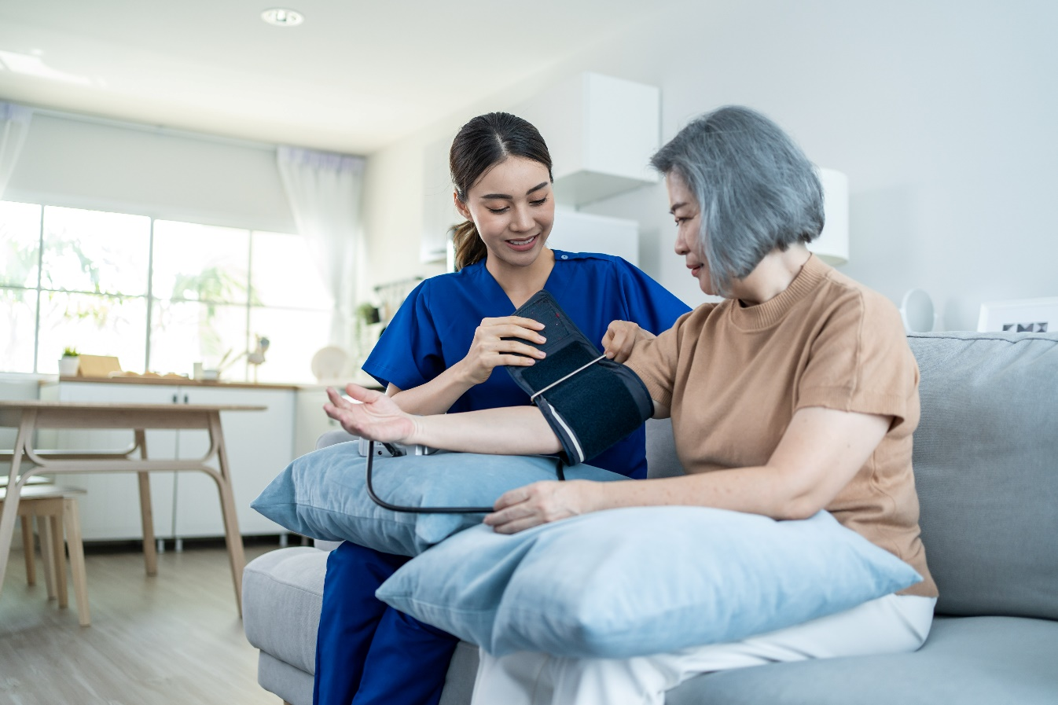

Below are common diseases and how it affects the body system.

* **Cardiovascular system**

|  |  |  |
| --- | --- | --- |
| **Disease** | **Description** | **How It Affects the Body System** |
| Coronary heart disease | It happens when the flow of oxygen-rich blood to the heart is reduced or blocked. It strains the heart and may lead to the following:   * **Angina** or chest pain due to the restricted blood flow * **Heart attack** when the blood flow is suddenly blocked * **Heart failure** where the heart is unable to pump blood around the body | If not addressed immediately, this can lead to impaired body functions. The worst result would be death. |
| Heart arrhythmia | Heart arrhythmia refers to the abnormal rhythm of the heart. The beat may be too slow, too fast, or irregular beat. | Because of the change in rhythm, the heart may not be able to pump enough blood to deliver oxygen and nutrients to other organs, thus affecting how other organs function.  If not addressed immediately and adequately, a heart arrhythmia can lead to a build-up of fluids in the lungs, stroke, heart failure, and death. |

|  |  |
| --- | --- |
|  | **Further Reading**  Click on the link below to learn more about cardiovascular diseases affecting body systems.  [Cardiovascular disease](https://www.nhs.uk/conditions/cardiovascular-disease/) |

* **Respiratory system**

|  |  |  |
| --- | --- | --- |
| **Disease** | **Description** | **How It Affects the Body System** |
| Asthma | It happens when the airways in the lungs are inflamed due to some triggers such as pollen, dust and smoke. This leads to symptoms such as coughing, wheezing, shortness of breath and tightness of the chest. | If not addressed immediately and properly, it can lead to certain complications, which include the following:   * Acid reflux or heartburn * Higher vulnerability to vascular diseases * Coma * Death |
| Pneumonia | Pneumonia is an infection caused by bacteria, viruses and fungi. It affects the air sacs in one or both lungs. The air sacs may be filled with fluid or pus, which leads to coughing with phlegm or pus, accompanied by fever, chills, and difficulty breathing. | Having pneumonia weakens the body system. The bacteria, viruses, or fungi can enter the bloodstream and infect other organs. |

|  |  |
| --- | --- |
|  | **Further Reading**  To know more about respiratory system diseases that affect the body systems, click on the link below.  [The 8 Most Common Types of Respiratory Disease](https://www.verywellhealth.com/respiratory-diseases-5206842) |

* **Musculoskeletal system**

|  |  |  |
| --- | --- | --- |
| **Disease** | **Description** | **How It Affects the Body System** |
| Arthritis | This happens when joint tissues degenerate as people age. The degeneration that happens in the soft tissues and bones is called osteoarthritis. A more serious form of arthritis is called rheumatoid arthritis. It is an autoimmune disease where the body attacks the joint tissues and causes chronic inflammation, severe joint damage, and possible immobility. | The degeneration of tissues leads to certain complications, which include the following:   * Swelling * Pain * Loss of joint mobility   The pain can be so severe that it limits the person’s mobility. |
| Osteoporosis | Osteoporosis is a skeletal disorder. It happens when the bones lose too much calcium. It then loses density and easily gets fractured. | As it affects the muscle surrounding the affected bone, it typically results in the following:   * Bone injury * Stooped posture * Muscle swelling   In severe cases, the ability to walk and maintain balance will be affected when osteoporosis affects the spine. |

|  |  |
| --- | --- |
|  | **Further Reading**  To know more about musculoskeletal system diseases that affect the body systems, click on the link below.  [Muscle and Bone Diseases](https://www.niams.nih.gov/health-topics/muscle-bone-diseases) |

* **Endocrine system**

|  |  |  |
| --- | --- | --- |
| **Disease** | **Description** | **How It Affects the Body System** |
| Diabetes | The body breaks down most of the food consumed into sugar (glucose) and releases it into your bloodstream. The pancreas releases insulin to use glucose as energy when the glucose level goes up. However, with diabetes, the body does not make enough insulin or cannot use it well. Too much glucose in the bloodstream can cause serious health problems.  There are two types of diabetes:   * **Type 1** – The body does not make insulin   Type 1 diabetes is a genetic condition. It shows up early in life. The immune system attacks the cells in the pancreas blocking its ability to make insulin. The way to manage this type is limited to taking insulin to control the blood sugar. Having a healthy and active lifestyle can help strengthen the body, too.   * **Type 2** – The body does not make or use insulin well   Type 2 diabetes is mainly related to the person's lifestyle and develops slowly over time. It is more common in people who are not physically active, people who are overweight, and people who have an unhealthy diet and are often stressed out. Managing this type can be done in more ways than one, such as medication which includes insulin, exercise and a healthy diet. | Depending on the severity, diabetes can cause any or a combination of the following:   * Kidney failure * Blindness * Heart failure * Heart disease * Stroke * Nerve failure   It can also lead to the removal of limbs due to severe complications. |

|  |  |  |
| --- | --- | --- |
| **Disease** | **Description** | **How It Affects the Body System** |
| Thyroid disease | Thyroid disease can be classified into two:   * **Hyperthyroidism** is when the thyroid makes too much thyroid hormone. The body then uses energy too quickly, which makes people easily tired, causing heart palpitations and losing weight without trying. * **Hypothyroidism**, on the other hand, is when the thyroid produces too little thyroid hormone. It makes people easily tired, gain weight quickly and unable to tolerate the cold temperatures. | If the thyroid gland fails to function properly, it can lead to several complications, which include the following:   * Increased level of neurodegeneration * Cardiovascular disease * Weakened immune system * Weakened gastrointestinal system |

|  |  |
| --- | --- |
|  | **Further Reading**  To know more about endocrine system diseases affecting body systems, click on the link below.  [Endocrine Diseases](https://www.niddk.nih.gov/health-information/endocrine-diseases) |

* **Digestive system**

|  |  |  |
| --- | --- | --- |
| **Disease** | **Description** | **How It Affects the Body System** |
| Gastroesophageal Reflux Disease (GERD) | It is a chronic digestive disease accompanied by the following:   * Persistent heartburn * Bad breath * Chest pain * Nausea * Upper abdominal pain * Trouble swallowing or breathing   It happens when the stomach acid moves back up into the oesophagus. | GERD causes throat and stomach problems. It also causes chest pain and lung inflammation, preventing people from doing their everyday activities. |
| Appendicitis | It is the inflammation of the appendix that commonly requires surgery.  The symptoms include abdominal pain, lack of appetite, vomiting, constipation or diarrhoea. | If left untreated for a long, it can lead to peritonitis or an abscess which can cause further complications. If the abscess or pus erupts, it will infect other organs in the digestive system. |

|  |  |
| --- | --- |
|  | **Further Reading**  To know more about digestive system diseases that affect the body systems, click on the link below.  [Gastrointestinal Diseases](https://my.clevelandclinic.org/health/articles/7040-gastrointestinal-diseases) |

* **Urinary or renal system**

|  |  |  |
| --- | --- | --- |
| **Disease** | **Description** | **How It Affects the Body System** |
| Urinary Tract Infection (UTI) | It is an infection that affects the kidneys, ureters, bladder and urethra. UTI is the result of inflammation of the bladder and urethra lining. The symptoms typically include the following:   * Burning or cramping feeling when urinating * Cloudy, bloody or foul-smelling urine * Frequent urge to urinate * Leaking urine * Pressure or pain in the pelvic area | If not treated immediately, UTI can lead to the following:   * Kidney infections * Problems urinating or controlling the urine * Trouble walking or standing properly because of pelvic pain   If the infection is so severe and reaches nearby organs, it can cause further complications and weaken the immune system. |
| Kidney stones | Kidney stones are hard mineral and salt deposits inside the kidneys. If the kidney stones get stuck in the ureters, it will block the flow of urine and cause the kidneys to swell and the ureter to spasm. The severe, sharp pain can be felt from the side and back part of the pelvic area. | The pain can radiate to the lower ribs, lower abdomen and groin. It can cause fever, pain and difficulty standing and sitting normally.  If not addressed properly and immediately, it can lead to chronic kidney disease. |

|  |  |
| --- | --- |
|  | **Further Reading**  To know more about urinary or renal system diseases that affect the body systems, click on the link below.  [Kidneys and Urinary System](https://medlineplus.gov/kidneysandurinarysystem.html) |

* **Reproductive system**

|  |  |  |
| --- | --- | --- |
| **Disease** | **Description** | **How It Affects the Body System** |
| Endometriosis | Endometriosis happens when the tissue that is supposed to grow and line the woman’s uterus grows somewhere else— ovaries, behind the uterus, on the bowels, or the bladder. It can grow on other body parts, but it is rare. | Misplaced or abnormal tissue growth causes pain in the abdomen, lower back, and pelvic areas. It also causes very heavy menstruation and can lead to infertility. |
| Polycystic Ovary Syndrome (PCOS) | PCOS happens when a woman’s ovaries or adrenal glands produce more male hormones than average. It results in cysts (fluid-filled sacs) that develop on the ovaries. | Women with PCOS have a higher risk of developing type 2 diabetes and heart disease. Other complications caused by PCOS include:   * Weight gain * Excessive body hair growth * Acne * Uterine cancer * Infertility |

|  |  |
| --- | --- |
|  | **Further Reading**  To know more about reproductive system diseases that affect the body systems, click on the link below.  [Reproductive System: Facts, Functions & Diseases](https://www.livescience.com/26741-reproductive-system.html) |

* **Integumentary system**

|  |  |  |
| --- | --- | --- |
| **Disease** | **Description** | **How It Affects the Body System** |
| Atopic dermatitis | It is also known as eczema. Atopic dermatitis is a chronic disease that causes inflammation, redness and skin irritation. It causes the skin to be extremely itchy, red, swelling, cracking, crusting and scaling. There are times when the skin experiences flares. | Atopic dermatitis can cause the following concerns:   * Skin infection * Irritation from all the dryness and itchiness * Difficulty sleeping * Difficulty carrying on with daily activities |
| Psoriasis | It is a chronic disease in which the immune system becomes overactive, which causes skin cells to multiply too quickly. Skin becomes scaly and inflamed. This is commonly seen on the scalp, elbows and knees. | Psoriasis can lead to psoriatic arthritis, a form of arthritis that causes pain and stiffness in the joints and parts where tendons and ligaments are attached to the bone.  It can also lead to the following diseases:   * Heart attack * Strokes * Chron’s disease * Diabetes * Osteoporosis * Uveitis * Liver disease * Anxiety * Depression |

|  |  |
| --- | --- |
|  | **Further Reading**  To know more about integumentary system diseases that affect the body systems, click on the link below.  [Skin Diseases](https://www.niams.nih.gov/health-topics/skin-diseases) |

* **Lymphatic system**

|  |  |  |
| --- | --- | --- |
| **Disease** | **Description** | **How It Affects the Body System** |
| Lymphedema | Body parts swell because of the build-up of lymphatic fluid in the tissues. When the lymphatic system gets blocked or damaged, the lymph cannot flow as normal, which causes a build-up. Lymphedema causes infection in the affected area. | Lymphedema prevents wounds from healing faster. It weakens the immune system, making it harder for the body to fight infections.  If left untreated for a long, the infection can become severe and life-threatening. |
| Tonsilitis | Tonsilitis is the inflammation of the tonsils. The tonsils are lymph nodes in the back of the mouth and the top of the throat. They are responsible for filtering out bacteria and other germs to prevent infection in the body. The tonsils can get inflamed from tonsillitis-causing viruses or bacteria. | The inflammation of the tonsils causes the following:   * Sore throat * Earache * Fever * Coughing * Headache   If the infection spreads, it can lead to further complications, including the following:   * Middle ear infection * Peritonsillar abscess * Rheumatic fever * Infection of the filters in the kidneys can lead to vomiting and loss of appetite |

|  |  |
| --- | --- |
|  | **Further Reading**  To know more about lymphatic system diseases that affect the body systems, click on the link below.  [Lymphatic System](https://my.clevelandclinic.org/health/articles/21199-lymphatic-system) |

* **Immune system**

|  |  |  |
| --- | --- | --- |
| **Disease** | **Description** | **How It Affects the Body System** |
| Lupus | Lupus is a chronic disease. It is an autoimmune disease where the body’s immune system attacks healthy tissues and organs. The inflammation can affect different body systems and organs, including joints, kidneys, brain, heart and lungs. | Due to the inflammation, the person might experience joint pain, skin rashes and complications with internal organs.  Lupus also increases the risk of infection, cancer, death of bone tissue and pregnancy complications. |
| Multiple sclerosis | It is a potentially disabling disease of the brain and spinal cord. The immune system damages the nerves and causes communication problems between the brain and other body parts. | Depending on the severity of the nerve damage, the person may lose the ability to walk and other independent body control. It can also affect vision, sensation and clear thinking. |

|  |  |
| --- | --- |
|  | **Further Reading**  Click the link below to learn more about immune system diseases affecting body systems.  [[Disorders of the Immune System](https://www.hopkinsmedicine.org/health/conditions-and-diseases/disorders-of-the-immune-system)](https://my.clevelandclinic.org/health/articles/21199-lymphatic-system) |

* **Nervous system**

|  |  |  |
| --- | --- | --- |
| **Disease** | **Description** | **How It Affects the Body System** |
| Alzheimer’s disease | It is a type of dementia that affects the person’s thinking, behaviour and ability to perform everyday tasks independently. It is common in older people but is not a normal part of the ageing process. | People with Alzheimer’s disease usually have the following complications:   * Impaired thinking * Disturbing memory * Abrupt behaviour changes * Trouble holding up in daily conversation * Lacks enthusiasm for activities * Takes a longer time to do regular, everyday tasks |
| Parkinson’s disease | Parkinson's disease is a brain disorder. It results from damage to the nerve cells that produce the chemical responsible for the smooth control of muscles and movement. It mainly affects older people. | People with Parkinson’s disease experience the following:   * Uncontrolled body movements such as an arm or hand tremor * Muscle stiffness * Freezing movement * Stooped posture * Balancing problems   It also affects handwriting, speech, urinary control, swallowing and mood, to name a few. |

|  |  |
| --- | --- |
|  | **Further Reading**  To know more about nervous system diseases that affect the body systems, click on the link below.  [Nervous system diseases](https://www.healthdirect.gov.au/nervous-system-diseases) |

* **Senses of the body**

|  |  |  |
| --- | --- | --- |
| **Disease** | **Description** | **How It Affects the Body System** |
| Cataracts | A cataract is a cloudy area in the lens of the eye. It can be present in one eye only or in both. It is common in older people. As the cataract progresses, it can make the vision blurry and less colourful. | Doing everyday tasks such as reading and watching television shows becomes hard as your vision becomes impaired. The good thing about this is that it can be removed through surgery. |
| Ear squeeze | The difference in the pressure between internal ear spaces and external ear canals causes it. | Due to the pressure difference, the ears may experience the following:   * Severe pain * Inflammation * Bleeding * Rupture of the eardrum membrane   Aside from the extreme pain that this can cause, if not addressed immediately, this can damage the person’s hearing ability. |

|  |  |
| --- | --- |
|  | **Further Reading**  To learn more about the diseases that affect the body's senses, click on the link below.  [Diseases of the Senses](https://www.britannica.com/browse/Diseases-of-the-Senses) |

### **1.2.4 Pain and Discomfort**

Older adults are more likely to have pain, discomfort, and other comorbidities. Generally, pain is more difficult to manage in older adults, and the presence of cognitive impairments may make it worse. Pain threshold also increases with age, making older adults more sensitive to pain and making pain persist longer.

On the other hand, people with disability, especially physical disabilities, often experience pain and discomfort related to or in addition to their disability condition. As people with physical disability also age, the frequency and severity of their pain and discomfort may also increase.

Pain is the body's way of telling you that something is wrong. Whether from a cut or scrape, trauma from a fall or car accident, or surgery, it disrupts the body's normal processes. When an injury occurs, the body responds by sending signals to the brain interpreted as pain. Discomfort is a lower level of pain that generally does not require medical treatment or medication. For example, sitting in one position for an extended period, your backside gets sore. It is relieved by repositioning yourself.

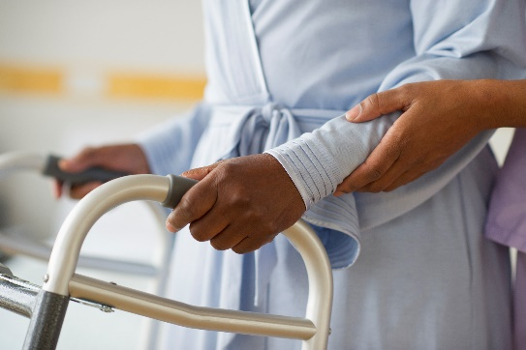Pain can either be acute or chronic. Acute pain starts suddenly due to an injury. In contrast, chronic pain is usually the result of damage to nerves or a psychological disturbance. Chronic pain can be caused by many factors ranging from an old bed mattress to an injury that occurred long ago but left an impression on the brain.

**Categories of Pain and Discomfort**

There are several ways to categorise pain. One is to separate it into acute pain and chronic pain.

|  |
| --- |
| **Multimedia**  Graphical user interface, application  Description automatically generated  For years, people with conditions like fibromyalgia, endometriosis, chronic fatigue or bad back pain have been told the pain is all in their heads. With no obvious physical symptoms, oncoplastic pain can be difficult to diagnose, but its effects are real. Research suggests that the immune system plays a role in neoplastic pain, giving people 'feel bad' symptoms, including anxiety and nausea.  [What is chronic pain and how does it work?](https://www.youtube.com/watch?v=xbSr32OWcX4) |

|  |  |
| --- | --- |
|  | **Further Reading**  New South Wales has chronic pain management information you can use with your clients. You can access the link below to learn more about how pain is managed now.  [Chronic pain management](https://www.health.nsw.gov.au/pharmaceutical/doctors/Pages/chronic-pain-medical-practitioners.aspx) |

People respond to pain differently, but some of the ways people may respond to pain and discomfort are as follows:

* Emotional responses (e.g. anger, anxiety and despair)
* Feeling disempowered for not being able to do certain tasks due to the pain and discomfort
* Feeling isolated
* Behaviours of concern (e.g. self-injury)

Communication is essential in understanding your client’s pain and discomfort. You must use a variety of communication methods that:

* Are reflections of current industry and workplace best practices in individualised support, such as ageing or disability support
* Are relevant to communicating with people in pain and discomfort
* Are within the scope of the support worker’s role and responsibilities

Below are the ways you can effectively communicate with people who are in pain and discomfort:

* Remaining calm and showing empathy
* Using ‘I’ instead of ‘you’ statements (e.g. ‘I would like you to take this medication.’ instead of ‘You need to take this medication.’)
* Reassuring the person that you are there to relieve their pain and discomfort
* Expressing concern for their feelings of pain and discomfort
* Using active listening (e.g. paraphrasing, summarising, and appropriate eye contact

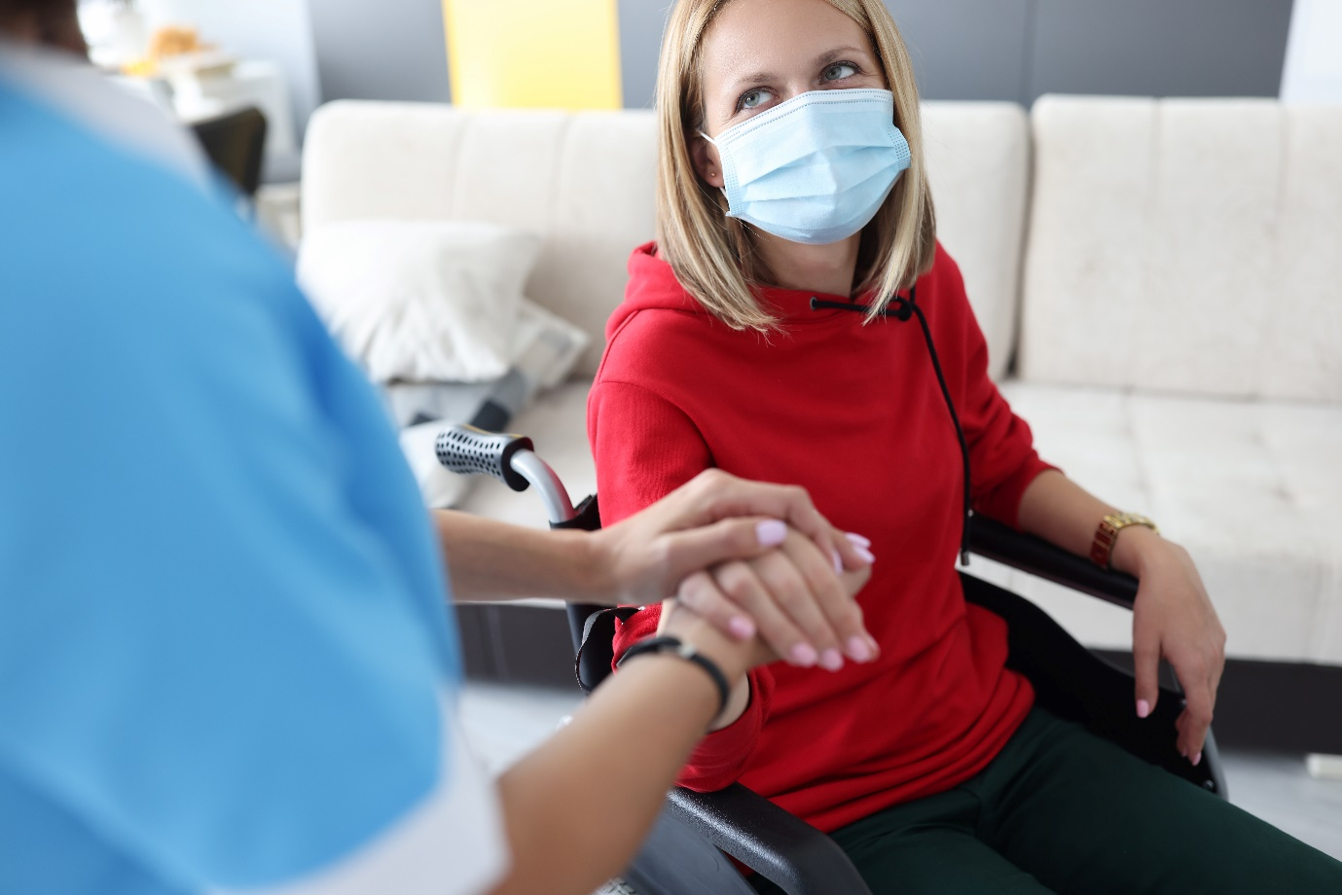

**Common Causes of Pain and Discomfort**

Common causes of pain in older people may include the following:

|  |  |
| --- | --- |
|  | **Further Reading**  Lifeline24 is a dedicated national provider of a low-cost personal alarm service for older people and people with disability. Click the link below to read more about medical conditions affecting older people and contributing to their pain and discomfort.  [20 Most Common Medical Conditions Affecting Older People](https://www.lifeline24.co.uk/medical-conditions/) |

**Assessing Pain and Discomfort**

Unless an obvious injury has occurred, it can be difficult to tell if a patient is experiencing pain. Everyone has different pain tolerance levels, which is why pain rating systems are used. These systems generally use a 0 to 10 scale, where 0 is no pain, and 10 is the worst pain ever experienced. Although there are many other rating systems that you can use to gauge the pain your client feels, discussed on the following pages are a few of them normally present in your workplace setting.

Healthcare professionals will ask patients what pain level is acceptable to them to help figure out when pain medication should be given. Many pain rating scales are available, and a pain scale with faces is frequently used. This tool effectively assesses the pain of anyone over the age of three. Let's say you have two patients who both have a headache. One patient says the pain is tolerable and is a two on a 1 to 10 scale. The patient is watching TV and talking to their spouse. The other patient says the pain is a nine and is experiencing nausea and vomiting and requesting the lights be turned off. The second patient needs more medical attention or additional medication.

So how does it work if the patient is blind or deaf? You can still ask them about their pain if they are blind, but they cannot use a face scale to describe their pain. If they are deaf, they can point at the face that best describes their pain on a face scale.

What if the patient cannot tell you what their pain level is? What if the patient is a child under the age of three? This is when we look at nonverbal signs of pain. Nonverbal signs include vital signs, physical appearance, and other expressions of pain.

**Types of Pain Scales**

At least ten pain scales are being used today. They generally fall into one of the three categories below:

Some of the pain scales used to gauge pain are listed below.

* **Abbey pain scale**

This is used mainly to measure pain for people who cannot verbalise.

* **Wong-Baker FACES pain rating scale**

The Wong-Baker FACES pain rating scale combines pictures and numbers to rate pain. It can be used for children over the age of 3 and adults. The six faces illustrate different expressions, ranging from happy to extremely upset. Each is assigned a numerical rating between 0 (smiling) and 10 (crying).

If your client is experiencing pain, they can point to the picture that best represents the degree and intensity of pain.

|  |  |  |
| --- | --- | --- |
|  |  |  |
| **0** | **2** | **4** |
| No hurt | Hurts a little bit | Hurts a little more |
|  |  |  |
| **6** | **8** | **10** |
| Hurts even more | Hurts a whole lot | Hurts worst |

* **Descriptor differential scale of pain intensity**

This scale has 12 lines, each with a description (e.g. faint, strong, intense, and very intense). A plus sign and a minus sign are placed at the start and end of each line. You can ask your clients to mark each line in the middle of their pain that matches what the descriptor suggests. If their pain is less intense, you instead place their mark on the minus side of the line. Likewise, if their pain is more intense, you can put a mark on the plus side of the line.

|  |  |
| --- | --- |
|  | **Further Reading**  When the client is displaying heart-related discomfort or pain, there are steps that you need to follow to assess the situation. The OPQRST method of assessing pain is a valuable tool to accurately describe, assess and document a patient’s pain, especially with pains experienced in the chest area.  [Medical Patient Assessment for Chest Pain (OPQRST)](https://www.appropedia.org/Medical_Patient_Assessment_for_Chest_Pain_%28OPQRST%29) |

|  |
| --- |
| **Multimedia**  Graphical user interface, application  Description automatically generated  This video is a role-play of a typical scenario a student may experience during clinical practice.  [Pain assessment](https://www.youtube.com/watch?v=_x5-2bLHO1k&t=271s) |

### **1.2.5 Procedures to Follow for Monitoring and Reporting Pain**

You can teach your clients how to observe and report the pain they experience. This report can be given to you or any other worker responsible for the client's well-being in community service. Self-report is one of the most reliable sources of information on pain. Use it with all your clients, including those with a cognitive or communication impairment.Self-report of pain may be obtained by:

* Asking an older person questions about their pain – consider using terms such as ‘hurting’, ‘aching’ and ‘soreness’ and document these if the person uses them
* Using a pain intensity scale
* Using a multidimensional self-report tool

It is important to take self-reports seriously, including those from older people with cognitive impairment. However, consider referring to family or carer reports of pain in an older person, as pain intensity may be overestimated or underestimated.

Another option for reporting issues, pain and discomfort experienced by the client will be done by you through observation and interview.

In older people with severe cognitive impairments or communication difficulties, their behaviour may be the only indication of pain (e.g. grumpiness and irritability).

Pain behaviours are individual, so identifying pain often requires a background in body systems and familiarity with the client. Involving the family and carers can help with identifying and confirming observational pains.

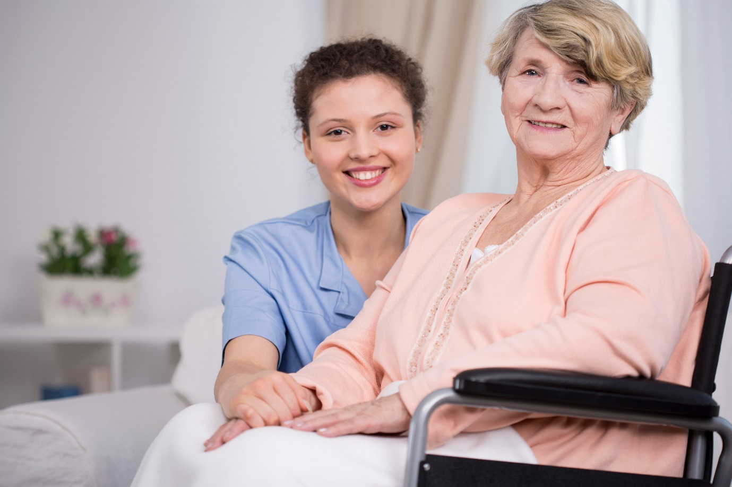

|  |  |
| --- | --- |
|  | **Checkpoint! Let’s Review**   1. Usage and interpretation of specific vocabulary relevant to health and the body are part of standard service delivery. You must be familiar with them for a more accurate recording and reporting of the client’s health status. 2. Each of our body systems is interconnected and dependent on each other. It will be beneficial to remember that any issues affecting one organ system may also affect the other components of the body. |



|  |  |
| --- | --- |
|  | Learning Activity for Chapter 1 Well done completing this chapter. You may now proceed to your **Learning Activity Booklet** (provided along with this Learner Guide)and complete the learning activities associated with this chapter.  Please coordinates with your trainer/training organisation for additional instructions and guidance in completing these practical activities. |

# II. Recognise and Promote Ways to Support Healthy Functioning of the Body

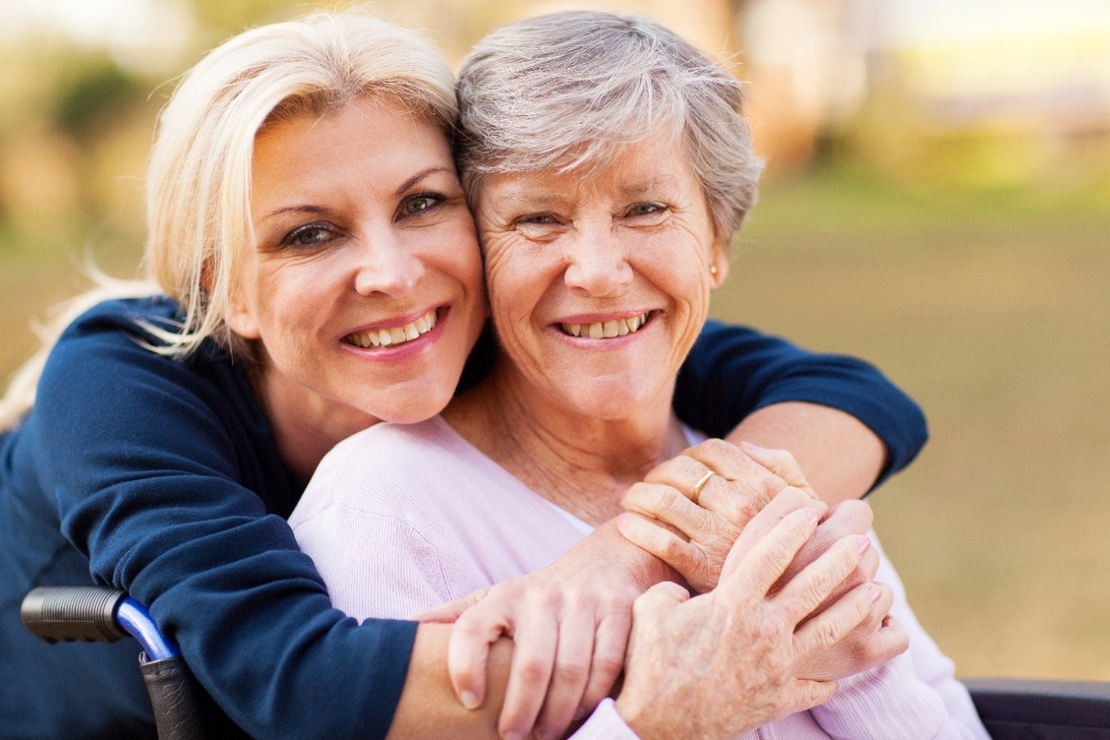

In the previous chapter, you have learnt important facts about the anatomy and physiology of the human body. You also learnt the importance of using correct health-related terminologies so that using and interpreting medical information will be easier and more accurate for you, your clients and other people involved in continuously improving the client’s well-being (e.g. doctors, nurses and carers).

This chapter will focus on ways to keep the body healthy by recognising and promoting activities that encourage healthy habits to maintain the body in its best shape.

There are generally two types of maintenance care that you can consider in helping your clients stay fit and healthy:

Preventive care pertains to the kind of care you provide to keep various diseases at bay. In contrast, diagnostic care happens when the person has already been diagnosed with an illness but needs ongoing care for specific symptoms or risk factors.

As someone who works closely with older people and people with disability, it is your responsibility to do both of the mentioned care practices to maintain your client’s health at their best. You will often coordinate with other stakeholders concerned with your client's medication, monitoring and medical check-ups to ensure their safety.

In this chapter, you will learn how to:

Rewrite the following into shorter phrase:

* Review factors for healthy body maintenance
* Evaluate how body systems affect healthy functioning
* Share information about the healthy body functioning
* Identify and report changes in the person’s health status

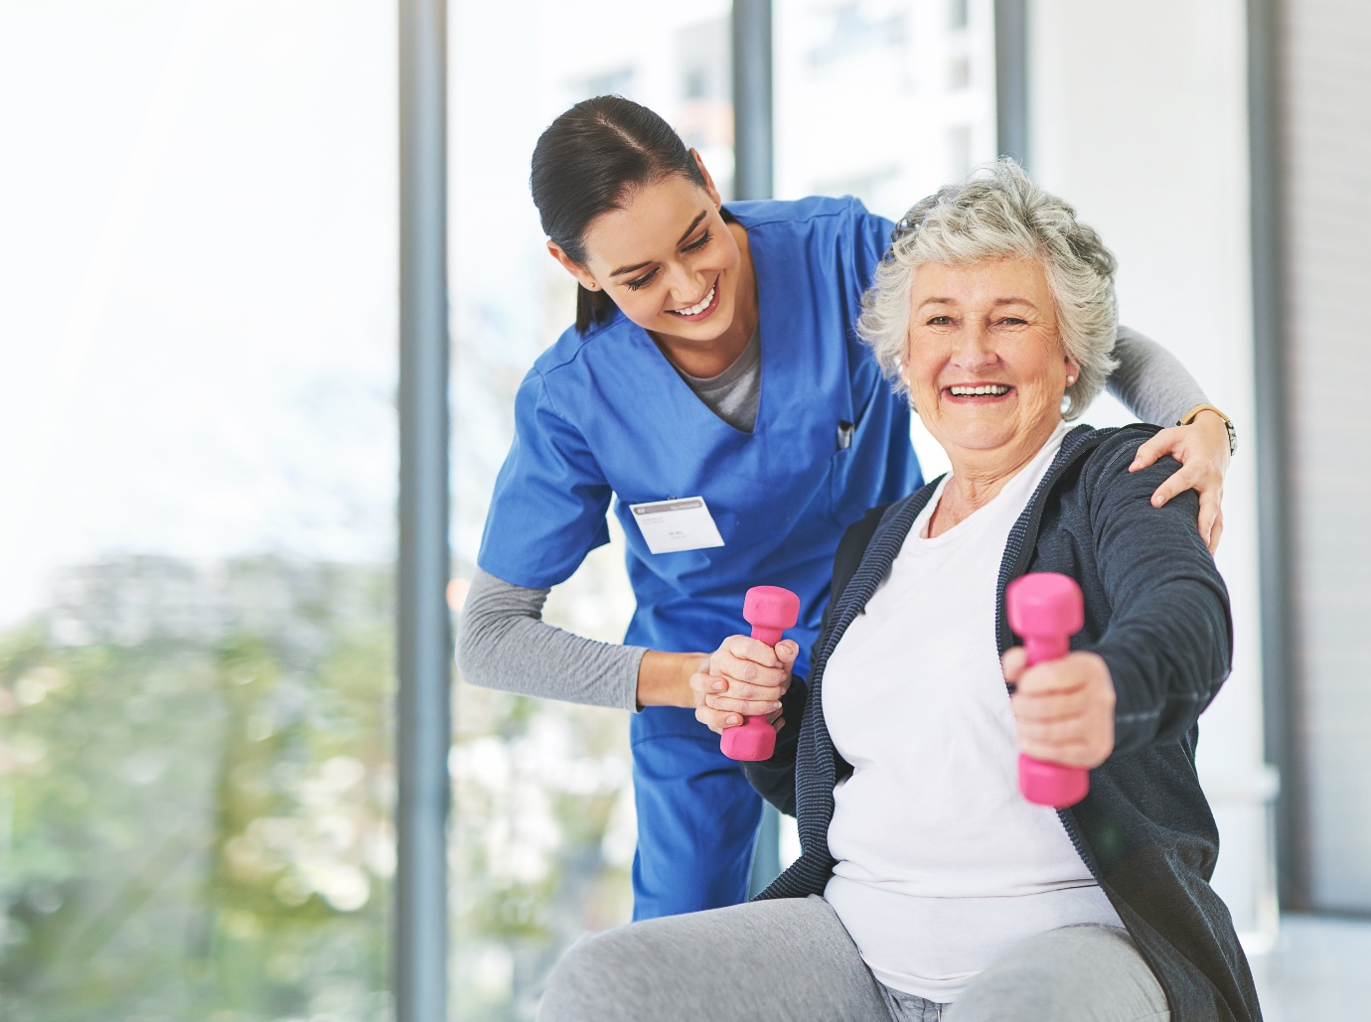

## Review Factors for Healthy Body Maintenance

Different factors contribute to the overall health of a person’s body. To decrease the risk of developing certain conditions such as heart diseases, some cancers, and injuries, you must consider the following factors that impact maintaining a healthy body:

The abovementioned factors are also the areas of life that you must monitor to promote your clients' overall health. Below is each area of life mentioned.

* **Nutrition** – eating the right amount and kind of food
* **Hydration** – drinking enough fluids
* **Skin integrity** – overall health or function of your skin
* **Movement** – the ability of the body to move various body parts as part of a whole mechanism
* **Social interaction** – ability to interact with the people around you

How these areas contribute to maintaining a healthy body can be seen in how they interact with each other and how they affect the older people and people with disability.

**Nutrition and Hydration**

Older individuals and people with disability go through many physical changes that also come with changing nutrition and hydration requirements. Certain conditions associated with ageing or some disabilities require specific dietary restrictions, affecting the older individual’s nutrition and hydration.

In monitoring your client’s meals, you may keep the following in mind:

* Use less salt.
* Limit intake of foods containing saturated fats and trans fats.
* Avoid alcohol.
* Take recommended vitamins and minerals.

As for their water intake, they must not neglect drinking water as it is easier for them to become dehydrated due to the changes in their bodies. The signs that they may need to drink more water include the following:

Below are ways to promote your client’s health and well-being in terms of hydration:

* Aim to drink at least six times a day (more during warmer weather or after exercising)
* Avoid drinking caffeinated drinks and alcohol, as they can dehydrate
* Eat water-rich foods (e.g. cucumber, tomato and spinach)

**Nutrition and Hygiene**

Another important factor that affects the nutrition of the client is hygiene. Not having proper, clean hygiene can make the client sick, limiting their ability to consume food and fluids. For example, if a client eats using their dirty hands daily and the dirt enters their body through the food, it can result in stomach flu. The flu can weaken their body, make them lose their appetite and vomit whatever enters their mouth.

Remember that hygiene is not limited to the cleanliness of one’s body. There are different classifications of hygiene. They are as follows:

* **Personal hygiene** – involves the cleanliness of one’s body, clothing, healthy diet, rest and exercise.
* **Environmental hygiene** – involves safe and clean spaces to prevent the spread of diseases and infections caused by the dirty and harmful environment (e.g. pollution, rodent infestation, piles of trash everywhere).
* **Domestic hygiene** – involves clean and sanitary preparation of food. It also involves clean and safe preparation of the person’s bedding, clothes, and dishes before and after a meal and all spaces at home that the person uses.
* **Food hygiene** – involves clean and safe preparation, storage and serving of food to avoid contamination. Contaminated food can lead to disease outbreaks and transmission.

Ensuring cleanliness and safety of all types of hygiene contributes to the client’s safety and well-being. The food must be prepared and stored in a clean environment, free from all infestations and infection, and later served in a clean meal set. This will allow the client to enjoy their meal without getting sick.

Maintaining all types of hygiene is critical. However, personal hygiene can greatly affect the client’s nutrition. Aside from keeping hands clean, body, and clothes, good oral health is also important.

Oral hygiene falls under the category of personal hygiene.

**Consequences of Poor Oral Hygiene on Nutrition**

Poor oral health can lead to impaired oral health (e.g. missing teeth due to tooth decay and dental cavities) and gum diseases. Impaired oral health can affect the client’s ability to chew or swallow food. This can negatively impact their nutritional intake. They may consume fewer meals or meals with lower nutritional value, leading to poor nutritional status and an increased risk of malnutrition.

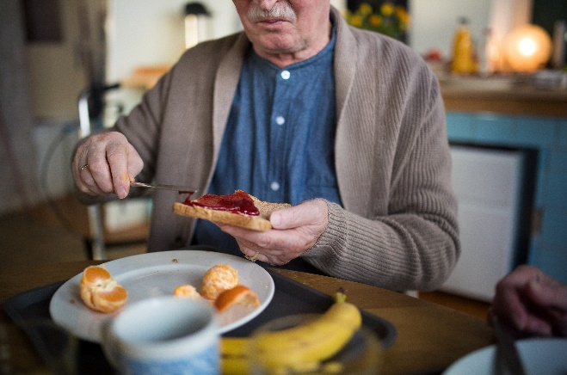

**Impact of Poor Oral Hygiene on Quality of Life**

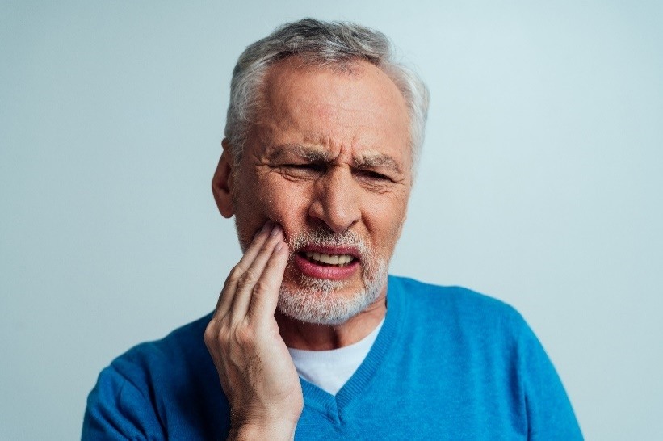*Quality of life* refers to the client’s satisfaction and general positive view of their status. If the client is healthy, comfortable, and able to do and enjoy daily activities, it reflects a good quality of life. However, when the person experiences pain and other effects of poor oral hygiene, it hinders them from enjoying a good quality of life.

Tooth decay, missing teeth, foul breath, bleeding gums and oral pain are all physical effects of poor oral hygiene. These effects further lead to more serious problems such as, but not limited to, the following:

* Oral infection
* Trouble swallowing and eating the food
* Difficulty consuming liquid
* Decrease in appetite due to the pain and difficulty in eating

All these affect the nutritional intake of the person. When the person cannot eat and drink well, the body cannot get the right amount of nutrition it needs. Although many supplements are available, they cannot replace the number of nutrients from the food we consume.

Having poor nutritional intake leads to more severe problems such as, but not limited to, the following:

* Weakened body
* Stress
* Easily getting sick
* Loss of energy to carry out daily tasks

Simply put, poor oral hygiene's impact is serious and alarming as it extends to different aspects of the client’s life. It limits their ability to engage in some daily life activities. These activities include enjoying their food, socialising with others, and laughing. For example, if the client has many missing teeth due to poor oral hygiene, it would be hard for them to consume certain food, thus affecting food intake. Also, bad breath or halitosis can embarrass a person and cause a loss of confidence and self-esteem.

**Recognising Signs of Oral Pain**

Now that you understand how poor oral hygiene and its results (e.g. tooth decay, tooth pain and foul breath) affect your client’s life, you need to know how to help them. One way is by recognising signs of oral pain or oral difficulties. Recognising signs at an early stage allows you to help the client faster.

If you notice any of the signs below, check your client’s condition and coordinate immediately with a health professional, specifically a dentist, to address the concern.

Check on your client regularly to see if these signs are present. As discussed in Section 1.2.5, there are different ways how you can encourage your client to report the pain and difficulty they are experiencing. It can be through any of the following:

**Exercise and Movement**

Age-related changes, conditions and illnesses can limit the older adult’s exercise and movement. The decline of their health, including vision and bone health (e.g. joints becoming stiffer and less flexible), can make exercise and movement difficult. At the same time, people with disability may find it more difficult to do regular exercise and movement. Lack of accessible physical environments, assistive technology, and attitudes and perception of people toward disability are some of the factors limiting people with disability from exercise and movement.

People with illnesses and other conditions may also frequently experience barriers and restrictions to daily life. Some illnesses and conditions may cause the person to stay indoors or in their beds. They are likely unable to do activities independently or without the help of others, such as doing the groceries, going out for social activities, outdoor activities, and taking a holiday trip.

Due to these restrictions, people are likely to do less exercise and movement. Insufficient physical activities can lead to issues such as heart disease and increased risk factors for obesity, high blood pressure and cholesterol, and type 2 diabetes.

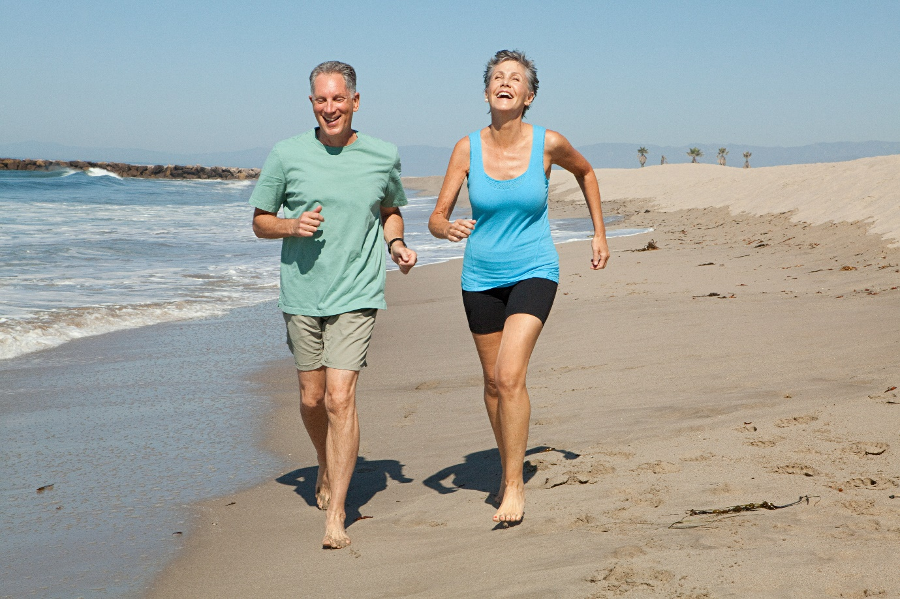

**Reviewing Resources to Plan Strategies**

As someone who works closely with the older people and people with disability, it is important to develop strategies to promote and maintain their health and well-being. However, before promoting and maintaining your clients' health, you must first review the factors that affect their overall health and well-being.

Often, this is done by accessing assessment resources that may provide useful insights into your client’s medical history and current clinical status. The table below lists the resources you can review and what you can learn from reviewing these resources.

|  |  |  |
| --- | --- | --- |
| **Area** | **Resources to Review** | **What You Can Learn From Reviewing the Resource** |
| Nutrition | Nutrition assessments and food diary | Understand your client’s nutrition status and eating habits. Discover food allergies. |
| Hydration | Vital signs, fluid balance chart, daily weight chart, fluid prescription chart, and surgical documentation | Understand whether your client is dehydrated or well-hydrated. |
| Skin integrity | Pressure ulcers clinical data collection form or other similar documents | Check the client’s skin for cracks, openings, bruises, rashes, and lesions. |
| Movement | Physical therapy assessment documentation and medical history (for previous injuries) | Assure the current state of your client's ability and capacity to move. |
| Social interaction | Psychological reports and geriatric functional assessment documentation | Clarify your client’s psychological state to check for neglect or trauma. |

Below are ways to promote and maintain your client’s health.

|  |  |
| --- | --- |
| **Area** | **Ways of Promoting and Maintaining Health and Well-Being** |
| Nutrition | * Follow healthy eating habits. * Minimise intake of salt, saturated fats, and trans fats. * Take vitamins and minerals as recommended. * Eat a wide variety of foods from the five food groups. |
| Hydration | * Aim to drink at least six times a day (more during warmer weather or after exercising). * Avoid drinking caffeinated drinks and alcohol. * Eat water-rich foods (e.g. cucumber and spinach). |
| Skin integrity | * Ensure skin is cleansed, dried thoroughly, and moisturised daily. * Use pressure redistributing seating cushions for people with limited mobility to reduce prolonged exposure to pressure. * Use non-soap cleansers with a pH close to 5.5. |
| Movement | * Encourage incidental or physical activities that occur as part of the person’s regular daily activities (e.g. walking to the toilet, dressing, and eating meals out of bed). * Follow an exercise program recommended by the doctor that includes strength, balance, and aerobic exercises. |
| Social interaction | * Incorporate social interaction into activities (e.g. walking group exercise activities). * Plan regular visits with family. * Join communities and hobby or interest groups (e.g. book club and volunteering at an animal shelter). |

**Programs to Support Client’s Health**

There are many ways to implement the previously mentioned practices in the client’s routine or treatment plan. There are already initiatives and programs the government has put in place for older people and people with disability.

|  |  |
| --- | --- |
| **Initiative or Program** | **Description** |
| Advance Care Planning Australia | Promotes advanced care planning, involving resources and national curriculum and learning |
| Commonwealth Home Support Programme (CHSP) | Provides support for older people who need some help to stay at home — service providers work with them to maintain their independence |
| Dementia, Ageing and Aged Care Mission | Supports older people to maintain health and quality of life as they age — they aim for them to live independently longer and access quality care when needed |

|  |  |
| --- | --- |
|  | **Further Reading**  The Commonwealth’s Department of Social Services offers various information on more programs relevant to promoting the health of the older people and people with disability. Access the link below to learn more.  [Communities and Vulnerable People](https://www.dss.gov.au/communities-and-vulnerable-people-programs-services/seniors-connected-program) |

## Evaluate How Body Systems Affect Health Functioning

As a support worker, it is your job to maintain your client's health. However, apart from you, there is one that works twice as hard to keep your client’s body healthy and functioning. This is none other than their body itself. In addition to the amazing structure and function of the human body’s organ systems, the body can also regulate itself to maintain a stable internal environment despite the changes it experiences in the external environment. This process is commonly referred to as homeostasis. Check the succeeding discussion to find out how the body keeps the different organ systems functioning to sustain life.

### **2.2.1 Body Regulation**

Below are the various ways the body regulates itself and the body systems mainly responsible for each role in keeping the body in good shape:

* + **Temperature**

To function properly, the body’s temperature must be maintained at an ideal range or close to the core body temperature of 37 °C. Extremes of body temperature are dangerous mainly because high temperatures can cause the following:

However, low temperatures can cause hypothermia that may also result in the demise of a client if left untreated. The hypothalamus is the processing centre in the brain that controls body temperature. It does this by triggering changes to effectors, such as sweat glands and muscles controlling body hair.

Below are some of the responses of the body to changes in temperature. You can use these to check if your client is feeling too hot or too cold:

* Skin hairs trap more warm air if they are standing up and less if they lie flat. Tiny muscles in the hair follicles pull these hairs upright to reduce heat loss or lay them down flat to increase heat loss.
* Sweating is one of your body's primary methods of maintaining its temperature. The sweat glands under the skin push out sweat if the body is too hot. As the sweat evaporates from the skin, the heat leaves the body. Sweating then stops when body temperature returns close to 37 °C. Use a thermometer to measure a client’s temperature.
* Blood vessels supplying blood to the skin's capillaries can widen, decreasing blood pressure. This can cause more heat to be carried by the blood to the skin, which can be lost to the air. During this process, the client's skin may appear red.
* Blood vessels can narrow or constrict, which increases blood pressure. This reduces heat loss through the skin. The person's skin appears pale.

Normal body temperature does not change much with ageing. However, as one ages, it becomes harder for the body to control its temperature. A decrease in fat below the skin makes it harder to stay warm.

Ageing decreases the body’s ability to sweat. Older people may have difficulty telling when they are overheating, which puts them at high risk of overheating (heatstroke).

A condition that can affect the proper regulation of body temperature includes *anhidrosis*. This is the inability to sweat normally when sweat glands do not function properly. The factors which may cause this condition are as follows:

* + **Fluid and electrolyte balance**

The kidneys are a pair of bean-shaped organs. They are essential for regulating the fluid and electrolyte composition of the body. The kidneys are responsible for maintaining fluid and electrolyte balance. They go hand in hand, which is why failing to keep them at their ideal state would lead to various body systems failing to function at their normal capacity.

Electrolyte balance is all about the combined levels of the different electrolytes found in the blood. In a older person, the factors that may affect the body’s ability to maintain fluid and electrolyte balance include the following:

The ways the kidneys maintain fluids and electrolytes and keep the pH at 7.35–7.45, which is the normal pH level, may include the following:

* + **Body waste elimination**

The excretory system is a passive biological system that removes excess and unnecessary materials from the body to help maintain homeostasis and prevent damage.

Several parts of the body are involved in this process. Some include the following:

Older people find it more difficult to eliminate wastes from their body due to the changes in their body as they age and the various illnesses they have that directly affect the abovementioned parts of the body. One example of a condition that may prevent a client from eliminating body waste is *respiratory acidosis.* This condition is caused by the lungs' inability to remove enough carbon when the individual exhales.

Examples of conditions that may lead to respiratory acidosis include the following:

* Asthma
* Emphysema and chronic bronchitis
* Pneumonia (severe)
* Obesity
* Sleep apnoea
  + **Blood pressure**

The body tries to stabilise blood pressure through the process of homeostasis. The body must maintain blood pressure at its ideal range to avoid concerning conditions. To know the ideal blood pressure range, you must be familiar with systolic and diastolic pressure.

|  |  |
| --- | --- |
| **Pressure** | **Explanation** |
| Systolic | The pressure of the blood during the heart contraction (systole) |
| Diastolic | The pressure of the blood when the heart is at rest between heartbeats (diastole) |

People are more likely to have elevated blood pressure as they get older. This is because blood vessels become stiffer as we age, increasing blood pressure.

The factors that can affect blood pressure include the following:

It is important to keep track of your client’s blood pressure and ensure that you know when they need assistance and monitoring the most. To do that, refer to the table below for the systolic and diastolic numbers you need to interpret from your sphygmomanometer or the tool commonly used to gauge blood pressure.

|  |  |  |  |
| --- | --- | --- | --- |
| **Blood Pressure Category** | **Systolic** | **and/or** | **Diastolic** |
| Normal | Less than 120 | and | Less than 80 |
| Prehypertension | 120–139 | or | 80–89 |
| Stage 1 Hypertension  (High blood pressure) | 140–159 | or | 90–99 |
| Stage 2 Hypertension  (High blood pressure) | 160 or higher | or | 100 or higher |
| Hypertensive Crisis  (Emergency care needed) | Higher than 180 | or | Higher than 110 |

### **2.2.2 Protection From Infection**

Infection and sepsis are responsible for nearly one-third of all-cause mortalities in clients aged 65 years and older. Nearly 90% of deaths from pneumonia are in this patient population. Sepsis is a life-threatening organ dysfunction. This is associated with old age, and chronic complex comorbidities influence and increase risk.

The effects of old age on the body have been established earlier. Due to the client’s advanced age, significant changes to homeostasis in all organ systems have already occurred, and the immune system is no exception. The immune system is impaired quantitatively and qualitatively, which is reflected by an increased susceptibility to infection and delayed or ineffective recovery.

**Common Infections**

|  |  |
| --- | --- |
| **Infection** | **Description** |
| Pneumococcal disease | Includes pneumonia, bronchitis, bacteraemia, and meningitis caused by any one of the 83 serotypes of *Streptococcus pneumoniae* |
| Influenza | Respiratory infection caused by any of the strains of the antigenically variable influenza A and B viruses |
| Nosocomial infections | Infections of any type that are not present on admission to a hospital but develop after the third hospital day |
| Tuberculosis | Can present as a pneumonia |
| COVID-19 | An infectious disease caused by the SARS-CoV-2 virus |

Infections are caused by the overgrowth of microorganisms in the body (e.g. bacteria, viruses and fungi). The body’s natural barriers and the immune system are responsible for fighting off infections. To recall how the immune system works, refer to Subchapter 1.1.10. The body’s natural barriers include the skin, tears, earwax, mucus, stomach acid and mucous membranes. The skin is usually responsible for preventing the invasion of microorganisms unless there is damage. Keratin, a protein inside skin cells, makes up the skin cells and sticks together with other proteins to form the epidermis. The epidermis keeps bacteria and germs from entering the body and causing infections. If the skin is damaged and the microorganisms enter the body, the white blood cells (WBC) start to work by attaching themselves to the microorganisms. The WBC produce antibodies that latch onto these germs.

Depending on the type of infection, treatments can differ. Some are treated with antibiotics such as amoxicillin, erythromycin and ciprofloxacin. However, most treatments for viral infections focus on symptom relief, not fighting the virus. For example, cold medicine helps alleviate the pain and congestion associated with the cold but does not act directly on the cold virus. Meanwhile, many viral infections resolve on their own without treatment. However, with clients who are often immunocompromised due to their age, treatment of infections becomes typically trickier.

**Signs of Infection**

* + Fever

Fever is a natural response of the immune system wherein a person may experience a rise in temperature so that the body can kill the microbes within the body.

* + Feeling tired or fatigued
  + Swollen lymph nodes in the neck, armpits or groin
  + Headache
  + Nausea or vomiting

**Ways to Prevent Infections**

Most of your clients may already be immunocompromised due to their age. This makes them susceptible to various diseases and infections. It is only right that you follow good infection control practices to avoid infecting older people and people with disability.

For maintaining proper hygiene, cleaning and washing are essential things to consider. A clean surrounding is less likely to be contaminated. Use disinfecting wipes, toilet seat sanitiser, and other cleaning supplies to clean every room efficiently. Some high-contact places which need the utmost attention and cleaning are as follows:

### **2.2.3 Physical Activities**

There are no standard procedures or guidelines for selecting the physical activities that people with disability or chronic conditions will have to engage in. These physical activities depend on various factors, such as the person’s abilities, preferences and age.

Adults aged 65 years and above, with the advice of a health professional, should do at least 150 minutes of moderate-intensity physical activity or at least 75 minutes of vigorous-intensity physical activity throughout the week.

*Materials developed by* [*CDC*](https://www.cdc.gov/)*.* [*Based on How much physical activity do older adults need?*](https://www.cdc.gov/physicalactivity/basics/older_adults/index.htm)

*Reference to specific commercial products, manufacturers, companies, or trademarks does not constitute its endorsement or recommendation by the U.S. Government, Department of Health and Human Services, or Centers for Disease Control and Prevention.*

*The material is otherwise available on the agency website for no charge.*

People with mobility challenges should perform physical activity to enhance balance and prevent falls three or more days per week. Muscle-strengthening activities involving major muscle groups should be done two or more days a week (World Health Organization, n.d.).

There are two types of exercises that your client can do to keep their bodies healthy depending on their situation:

Active exercises are normally for clients with the physical capability to perform active exercises, while passive exercises are normally for clients who may be stroke survivors left with mild to severe paralysation or paresis. Examples of passive exercises include the following:

* + Passive range of motion (ROM) exercises
  + Functional neuromuscular stimulation (FNS)
  + Facilitated electrical stimulated (FES) exercises
  + Technician-assisted exercises
  + Use of leg extension or leg-cycling equipment
  + Hydrotherapy or swimming in a warm pool

|  |  |
| --- | --- |
|  | **Further Reading**  For older people and people with disability, there are specific recommended hours of exercise and types of exercises to do. For more information on the recommended exercises, refer to the link below.  [For people with disability or chronic conditions](https://www.health.gov.au/health-topics/physical-activity-and-exercise/physical-activity-and-exercise-guidelines-for-all-australians/for-people-with-disability-or-chronic-conditions) |

Just a slight increase in daily activity can improve your health and well-being. It can help with the following:

|  |
| --- |
| **Multimedia**  Graphical user interface, application  Description automatically generated  The risk of falling is a challenge your client may face when doing physical exercises. You must take precautions to avoid complications that may stem from falls. Below is a video about fall prevention in an Australian residential aged care setup from the Australian Physiotherapy Association (APA), the peak body representing the interests of Australian physiotherapists.  [Falls prevention in Australian Residential Aged Care – SUNBEAM Trial](https://www.youtube.com/watch?v=4ENhYufGacI) |

## Share Information About Healthy Body Functioning

When supporting your client, there are many ways to use and share information about the body's healthy functioning. Often, information about your client's health can be used or disclosed for the following:

* The primary purpose for which you collected it (e.g. monitoring, reporting or documenting the client's health status).
* A secondary purpose in certain circumstances — any purpose other than the primary purpose is a secondary purpose. You can only use or disclose a patient’s health information for a secondary purpose in certain circumstances (e.g. referral to a specialist and registration for government programs).

Depending on the purpose and receiver, you must remember that you can only use or disclose your client’s health information for a secondary purpose if you have your client’s consent. Below are scenarios wherein you can use or disclose a patient’s health information:

* The client would reasonably expect you to use or disclose the information for that purpose
* The purpose is directly related to the primary purpose of the collection

*Based on* [*Chapter 3: Using or disclosing health information*](https://www.oaic.gov.au/privacy/guidance-and-advice/guide-to-health-privacy/chapter-3-using-or-disclosing-health-information)*, used under* [*CC BY 3.0 AU*](https://creativecommons.org/licenses/by/3.0/au/deed.en)*. Office of the Australian Information Commissioner website —* [*www.oaic.gov.au*](https://www.oaic.gov.au/)

Information is shared through different methods with different types of people in your workplace. Some examples of the methods may include sharing through the following:

In your workplace, you commonly share information with your colleagues. There may be two or more of you who work with one client. To better support your client's health, you must be in constant contact and share information about your client’s health as often as possible. For example, during your separate shifts, each support worker will fill out a document, such as a client’s progress notes, at the end of the workday. Through this, each of you can monitor if there are any changes in your client’s situation.

Carrying out work tasks can also mean working with a multidisciplinary health team. A multidisciplinary health team is composed of different health professionals that have their own fields of specialization. They can also be addressed as allied health teams or multidisciplinary health care. They are a group of medical practitioners with specialist knowledge in identifying, assessing, diagnosing, treating and preventing disabilities and disorders. Below are some examples of people who are part of the multidisciplinary health team you can work with, especially when implementing a client’s individualised plan.

| **Multidisciplinary Health Team Specialist** | **Possible Role in Providing Service Delivery** |
| --- | --- |
| Physical therapists | They help improve or restore physical functioning, such as strength or movement. They also evaluate and develop treatment plans to improve range of motion, balance, coordination, posture, endurance, and mobility, such as getting out of a chair or walking. |
| Occupational therapists | They help improve a client’s ability to perform tasks associated with daily living. Patients recovering from a condition such as a stroke may benefit from a referral for occupational therapy. |
| Speech pathologists | They help improve or restore the speech of clients who have had illnesses that affected their speech. Examples of diseases that may cause speech problems requiring speech pathologists' expertise include stroke and trauma. |
| Respiratory therapists | They assess and treat patients who are having difficulty breathing. Therapists administer medication, set up and monitor life support equipment such as ventilators, and teach patients how to manage chronic lung disorders. |
| Recreational therapists | They evaluate the patient to determine the patient’s needs and the activities they enjoy. Recreational therapy may be helpful with patients of all ages, but it may be especially beneficial for children. Participating in recreational activities may be fun for a child, and they may not resist as they would with physical or occupational therapy. |

|  |  |
| --- | --- |
| **Multidisciplinary Health Team Specialist** | **Possible Role in Providing Service Delivery** |
| Clinical nutritionists | They work with individual patients to ensure they get proper nutrition based on their medical condition. |
| Chaplain services | Hospital chaplains can help patients deal with the stress of being hospitalised through counselling and prayer.  Chaplains may also help family members deal with grief and difficult situations.  On admission to the hospitals, patients are often asked if they have spiritual needs and would like a visit from the hospital chaplain. |
| Rehabilitation counsellors | Rehabilitation counsellors provide assistance following the onset of illness or injury and for people with life-long, acquired or developing disability.  They work with both physical and mental health conditions and disabilities. |
| Pharmacists | They provide advice on how to use medicine safely. They also offer a range of services, including healthcare advice, vaccinations, self-care and lifestyle assessments, and provide medical certificates. |
| Social workers | They provide counselling, information and referrals to other services.  They must meet certain professional standards and be accredited by the[*Australian Association of Social Workers (AASW).*](https://www.aasw.asn.au/)  Some social workers have additional training in mental health issues. |

Since the medical field is vast and the choices for support care are also wide. What you should do to help a client or a person who needs to connect with a multidisciplinary health professional is to refer to their individualised plan. The client’s individualised plan will tell you everything they need and preferences regarding the kind of support they want to receive.

Below are the steps to follow when working with multidisciplinary health professionals to implement individualised plans.

1. **Review the client’s individualised care plan.**

Refer to the individualised care plan of the client to ensure assistance from multidisciplinary health teams would match the client’s.

1. **Seek the client’s doctor’s referral.**

Doctors usually are the ones who help in deciding which multidisciplinary service best fits the client's needs. So, as a community service worker, you may need to reach out to the client’s doctor first to review the client’s individualised plan. They can either give a referral or go over the list of multidisciplinary professionals.

1. **Reach out to a multidisciplinary health professional.**

Contact the multidisciplinary professional referred by the doctor of the client. Arrange necessary documents and other processes to provide your client's multidisciplinary professional care.

1. **Implement service delivery according to the help of a multidisciplinary health professional.**

Execute the planned service according to the multidisciplinary health professional’s care plan. Sometimes, you will have to work directly with a multidisciplinary health professional. Sometimes, you will not be with them throughout the plan's implementation. Instead, you will refer to their plans from a document containing the client’s medical and care needs.

|  |  |
| --- | --- |
|  | **Further Reading**  Healthdirect Australia lists the other multidisciplinary health professionals you can seek help from when implementing service delivery. Access the link below to learn more.  [Allied health](https://www.healthdirect.gov.au/allied-health) |

Procedures for coordinating with multidisciplinary professionals may vary in different organisations. You must check your organisation’s handbook to check how your organisation deals with multidisciplinary professionals.

|  |  |
| --- | --- |
|  | **Lotus Compassionate Care**  Access and review Lotus Compassionate Care’s Staff Handbook for its policies, procedures, and code of conduct through the link below.  [Lotus Compassionate Care – Staff Handbook](https://compliantlearningresources.com.au/network/lotus-v2/policies-procedures/)  *(username: newusername password: newpassword)* |

Below lists an example procedure to be followed for coordinating that you can use as a reference.

1. When support services and activities require tasks outside the scope of the support worker's role, knowledge and expertise, these services and activities may be sourced outside the organisation.
2. Before availing of the services of a health professional, check that they are a registered or accredited member of their profession by checking the Australian Health Practitioner Regulation Agency register of practitioners.
3. Check that outsourced services and activities come from a registered business with a reputable business record.
4. The following personnel and services must be consulted for the concerns indicated below:

* 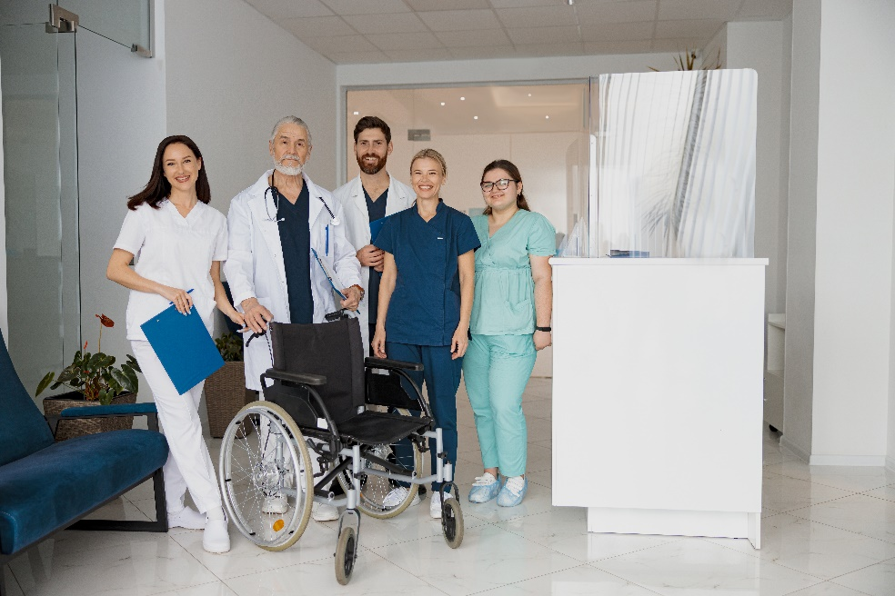**Physiotherapist –** for clients in need of physical therapy
* **Psychologist –** for clients with mental health problems
* **Meals on Wheels –** for clients who would like to avail of meal delivery services
* **National Auslan Interpreter Booking and Payment Service –** for people with hearing impairment who need interpreters for their medical appointments

1. Support workers may ask their supervisor for references to other health professionals and service providers who can help them deliver client support.

**Escalating Concerns**

Should there be changes in the client’s status, such as worsening or improvement of the condition, reaction to medications and additional treatment requests, you have to relay this to the responsible multidisciplinary health professional.

Below are some examples of the concerns that need escalation:

* Vomiting after receiving medicines
* Refusal to take medications or other treatment
* Slower body movement
* Decreased appetite
* Bruises in the body
* Fever

The concerns that need immediate escalation are those that can affect or worsen the client’s status. Examples of the concerns are listed above. Good judgment as a support worker and understanding your organisation’s policy and procedures are critical. You have to immediately act on things you can resolve and inform the medical professional afterwards. An example is when the client refuses to take another medication because they believe they are not getting better.

During your shift, reflect this on the client’s chart or progress notes so that other health professionals can check this during their shift. Ensure that your notes are detailed and accurate. Here is some important information that you can include in your notes:

If the concern is urgent, reflect this in the client’s chart and communicate immediately to the concerned health professional. You may give them a call, message or report to their office. The procedure varies per organisation. Check how your organisation’s instruction on escalating concerns with other health professionals.

|  |  |
| --- | --- |
|  | **Checkpoint! Let’s Review**   1. People with illnesses and other conditions may more frequently experience barriers and restrictions to daily life. Insufficient physical activities can lead to issues such as heart disease and increased risk factors for obesity, high blood pressure and cholesterol, and type 2 diabetes. 2. As a support worker, it is your job to maintain your client's health. You must develop strategies to promote and maintain their health and well-being. This can be done by accessing assessment resources that may provide useful insights into your client’s medical history or current clinical status and referring to various programs to keep clients healthy. |

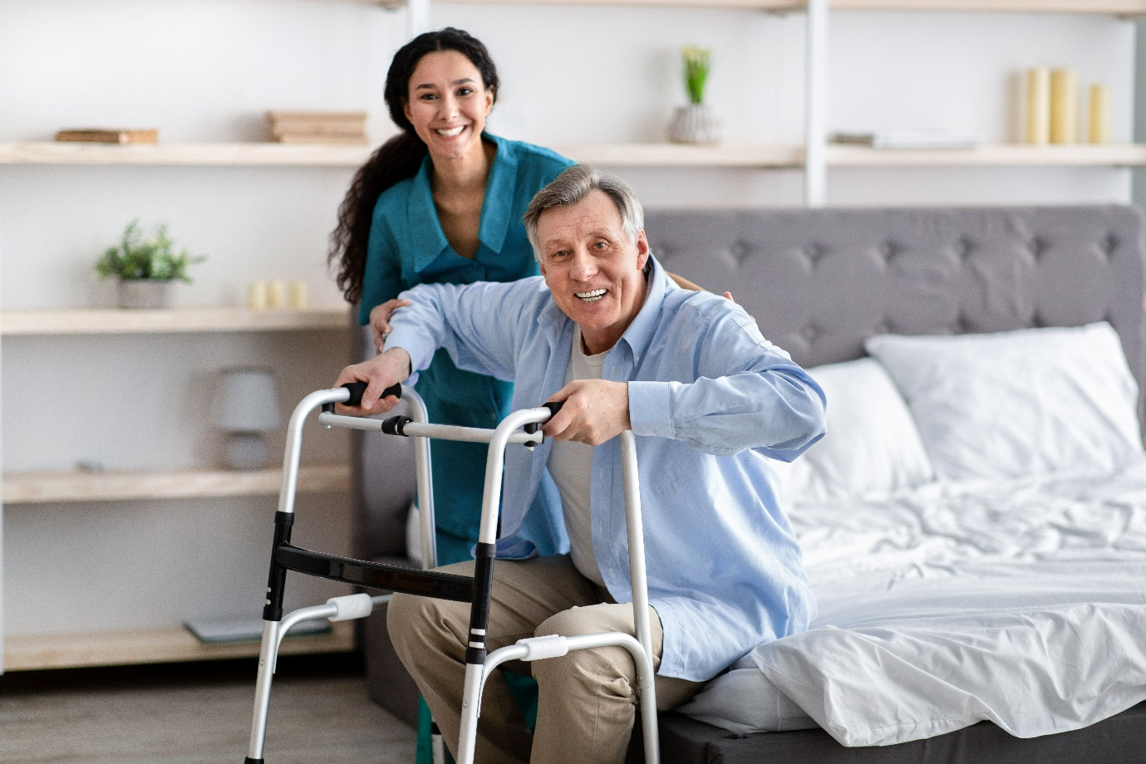

## Identify and Report Changes in the Person’s Health Status



You learnt from Chapter 1 the following about the body systems:

* The way they function
* The way they interact with one another
* The common issues and diseases that affect each system
* The complications that come with each disease

You now understand that the body functions of older people and people with disability differ from younger, healthier ones. Do note that even though their body functions are different, there are still specific indicators that their body systems are healthily functioning based on their current condition.

As a support worker, staying up to date with the client’s status is important. This way, it will be easier for you to recognise if there are changes. If there are changes, they should be documented and reported immediately to your supervisor or concerning multidisciplinary health professional.

### **2.4.1 Changes in the Client’s Health Status and Physical Condition**

Keeping track of the client’s condition can help you recognise if there are changes. Knowing about healthy body systems and relevant issues can help you determine whether the changes are positive. However, take note that individuals have different healthy body indicators based on their body system’s issues or health status. Factors such as age and underlying conditions greatly affect one’s indicator of a healthy body system.

In recognising changes, note that you should not only focus on the negative or ones that imply worsening conditions. Changes can also be positive. For example, the client has been eating more lately. It can also be that the client can walk independently for longer distances. Whatever the category of the changes, it is important to recognise, record, and report it to your supervisor or other health professionals.

Although the changes you might observe may vary per client, the samples below can give you an idea of these changes.

|  |
| --- |
| **Multimedia**  Graphical user interface, application  Description automatically generated  The video below provides information to understand the normal aging process. It will give you insights into identifying common indications of what is normal and what is not in the body system functioning that comes with ageing.  [Understanding the Normal Aging Process](https://www.youtube.com/watch?v=aLY4NTfAfcg) |

Aside from knowing the examples provided in the previous graphic, it is also critical for you to be aware of the client’s health condition and current status and to monitor their daily condition. This can help you determine if your current observation is something new or unusual- if it is really a change.

As mentioned in Chapter 1, you can find the information about the client’s status by reviewing the following documents:

**Recognising Changes in the Client’s Status**

As mentioned, clients may have different health status and physical condition, which depends on the following:

* Age
* Presence of a disability or disabilities
* Presence of diseases or medical conditions

Despite the differences, below are general steps you can follow to check for changes in the client’s health status and physical condition. These are as follows:

* 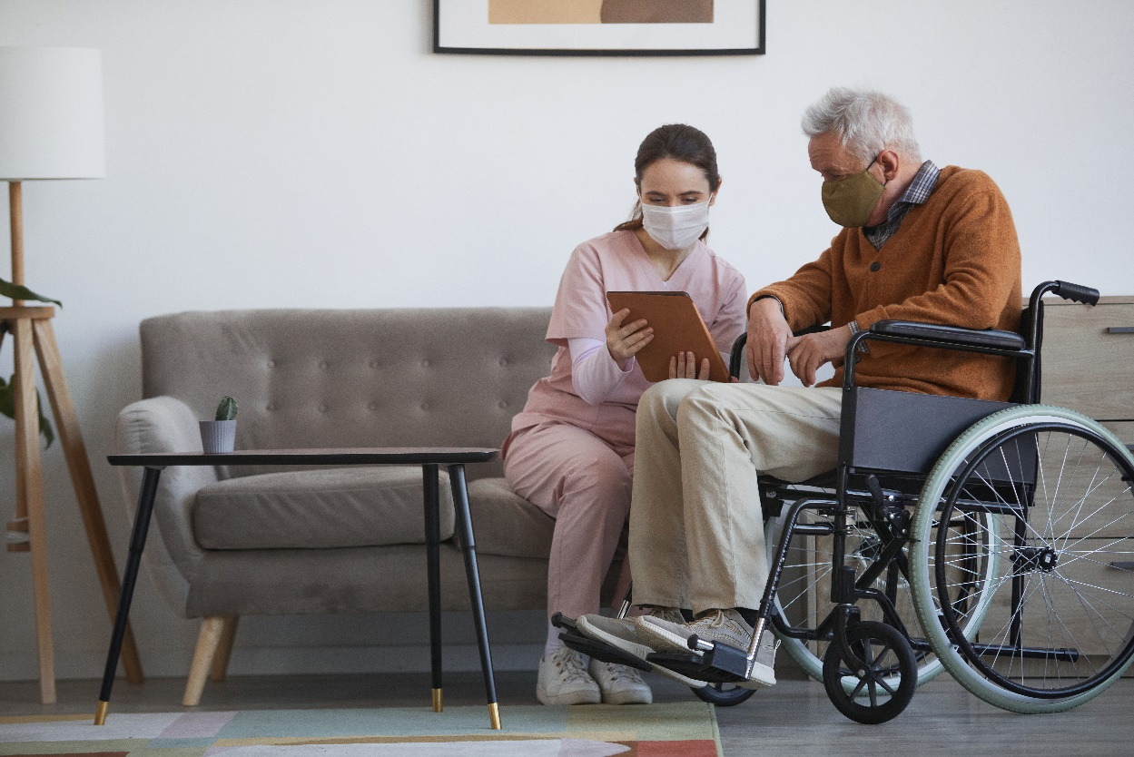**Regularly check the client’s care chart or progress notes.**

Check the observation logs of the nurses, other staff or health professionals. Compare the current log with the previous one and see if there were changes. For example, after checking the log from yesterday, you saw that the other care worker wrote down that your client did not finish their food, which is unusual.

* **Regularly check your client’s physical body.**

When you assist your client in daily activities such as bathing, changing clothes, walking or eating, check their body. In checking, see if they have bruises or sores on the skin. Press some body parts and ask if it hurts. Ask your client if a body part is aching or itchy.

* **Talk to your client and ask them to share what they feel.**

While assisting your clients, you can ask them simple questions such as ‘how are you feeling today?’ and ‘is anything hurting or uncomfortable?’

See the sample scenario showing changes in your client’s status.

|  |
| --- |
| **Marge**  You work as a support worker in Lotus Compassionate Care. Marge, a senior with no health condition besides the weakness caused by ageing, has been under your care for one year. She prefers walking with a cane because she feels like she moves slowly without it.  In the morning, Marge usually takes her morning walk for 30 minutes and does some stretches. After this, Marge takes her breakfast. She has a good appetite and always finishes her food serving. After eating, Marge continues with whatever activity she wants. Sometimes she reads, crochets, socialises with her friends and roams around the facility.  **18 January 2022**  Marge goes through her morning walk and activities without issue. She does not raise any concerns throughout the day. You ask how she feels throughout the day. Her reply is always ‘great’.  In the afternoon, after her walk, she chats with other seniors before returning to her room.  At the end of your shift, you update the progress note and report no abnormalities with Marge’s condition.  **19 January 2022**  At 3:30 pm, during her afternoon walk, you notice that Marge stops now and then to knead her calves.  Upon asking Marge, she mentioned that she felt a tingling sensation around her calves that started 30 minutes ago. You ask her if she wants to continue the walk, but she would rather take a break. You conclude the walk and return Marge to her room.  You notify the nurse about what Marge felt. She gives Marge a 10-minute TENS therapy. After treatment, Marge notes that the sensation goes away.  Before the end of your shift, you go to see your supervisor. You inform her about Marge’s condition and the interventions given. Your supervisor asks you to monitor Marge’s condition closely.  **20 January 2022**  At 8:00 am, you check Marge’s chart and find out about the following events:   1. The tingling sensation around her knees and calves feels like needles poking through her muscles starting around 7:00 am. She is given breakfast, but she barely touches it. 2. The nurse provides prescription medication and a 10-minute TENS therapy to relieve the pain. 3. Marge falls asleep after treatment.   Marge requests to rest for the day due to the pain.  Marge is still fiddling with her legs. She mentions that the pain started increasing just before you arrived. Her complexion also looks quite pale.  After doing routine checks, you find out that the pain is isolated to her knees and calves. You report this to the nurse in charge.  The nurse arrives at 8:30 am with Marge’s medicine for pain and a hot compress. The nurse instructs you to apply a hot compress for 30 minutes and monitor her condition. She also requests you give her hourly reports until noon.  These are the events that transpire:   * 11:00 am   1. Marge wakes up and says that the pain has returned. She still looks pale.   2. After reporting to the nurse, she calls the doctor to report Marge’s condition.   3. You apply a hot compress to her knees and calves while waiting. You also try to serve her lunch, but like breakfast, she does not touch the food. * 11:40 am  1. The doctor arrives and checks on Marge’s condition. 2. The doctor informs that Marge will need to take additional tests before they can come up with a conclusive diagnosis; however, her current condition points towards osteoarthritis. 3. In the meantime, he prescribes a different set of medications to treat the pain. In addition, the doctor leaves you with the following instructions:    * 1. Marge needs to be assisted with lifting her legs and moving them left and right until she can stand.      2. Monitor her pain levels for the rest of the day. If the condition persists until tomorrow, Marge needs to be brought to the hospital.   You leave Marge to rest as you prepare the update on the progress note. You proceed to the supervisor’s office to report events with Marge.  After reporting to your supervisor, you check back on Marge. She is already awake and informs you that she feels a bit better. |

The scenario above shows the importance of regularly observing and checking your client’s physical condition. It also shows why it is essential to be aware of your client’s status from the beginning so that it is easier to notice if there have been changes.

In this case, Marge has no abnormal health conditions, but for the past two days, she has been experiencing sensation and pain accompanied by paleness, weakness and a decreased appetite. Immediately coordinating with the nurse after your observations was a good move. Immediately recognising the changes in Marge’s condition helped address the concerns faster.

As mentioned, it has to be recorded in the client’s progress notes or chart whenever you recognise changes. Reporting first the changes to your supervisor or health professional before recording is acceptable if:

* The client is in pain
* The client shows other indicators of a problem (e.g. looks pale, weak, decreased appetite)
* The client needs immediate attention (e.g. having trouble breathing, chest pain, uncommon sensations such as tingling and vomiting)

However, you must ensure that your observations, actions taken and update on the client’s condition will be reflected in the records as soon as possible within the day.

**Completing Reports According to Organisational Policies and Procedures**

Part of your responsibilities is completing reports about the clients in your care. *Reports* are written accounts of the client’s diagnosis, condition, and progress. As a care worker, examples of reports you may encounter include the following:

* Progress reports (health or behavioural)
* Incident reports (accidents, fighting, complaints)
* Critical incident reports (accidents, serious injuries)
* Mandatory reports (reportable incidents like abuse)

Reports can be physically written or typewritten in their digitalised format. Regardless of its form, you need to prepare the report with the following in mind:

* **Accuracy**

Your report should contain factual information about your client, the event or the incident. Stating the date, time, place where it occurred, and names of people involved can add to the accuracy of your report. Gather all the necessary information first before making the report.

* **Objectivity**

To support the requirement of accuracy, the details on your report should be according to what exactly happened. You should not include your insights and interpretation. Terms such as ‘I think’, ‘I believe’ and others that suggest subjective opinion should be avoided.

* **Essential details**

Your organisation might require additional details in making reports. However, you can still use the general information on the next page to understand what to include.

Essential details to include in the report:

Remember to do the following:

* Use formal but easily understandable language.
* Use the appropriate terms relevant to the event or observation.
* Focus on objective information.
* Provide a clear picture of the incident using terms that clearly describe what happened.
* Always review the report before submitting it. Ensuring its accuracy, objectivity and relevance are all part of your accountability.
* Maintain confidentiality in all reports and documentation.
* Secure the report to make sure that unauthorised individuals will not access it.
* Always sign your reports and put the exact date and time when it was prepared.



On the next page is a sample template of progress notes where you can record your observations. Your organisation may have their template and procedure for using it. However, you can use the sample as a reference.

The scenario with your client, Marge, will be used for the sample entry.

Before inputting the information, you have already recalled what happened, the actions taken and an update on Marge’s condition.

See how the discussions on the previous page are reflected in the progress notes.

**Progress Notes**

**Client Information**

|  |  |  |  |  |  |
| --- | --- | --- | --- | --- | --- |
| **Name** | | Marge L. Dawson | | | |
| **Address** | | Lotus Compassionate Care, Sydney, Australia | | | |
| **Date** | **Status** | | | **Action Points** | **Achievements** |
| 18 January 2022 | Marge did her usual morning-to-afternoon routine. Everything went fine. | | | Provided the usual morning to afternoon assistance. | Marge is in good condition today. |
| **Reviewer/Health Professional Name and Signature** | | | **Rebecca Jay**  Support caseworker | | |
| **Date** | **Status** | | | **Action Points** | **Achievements** |
| 19 January 2022 | Marge did her usual morning-to-afternoon routine. However, Marge had several stops during her afternoon walk and kneaded her calves. She said she had been experiencing a tingling sensation from her knees down to her lower legs for about 30 minutes. | | | Marge took a break and then concluded her walk.  Upon return, I informed the nurse on duty. She gave Marge a 10-minute TENS therapy.  Five minutes after the therapy, Marge confirmed that the tingling sensation was gone.  I informed the supervisor before the end of the shift and was asked to monitor Marge’s condition closely. | Marge got relieved of the tingling sensation.  No other parts are experiencing tingling sensation, pain or any unusual feeling. |
| **Reviewer/Health Professional Name and Signature** | | | **Rebecca Jay**  Support caseworker | | |

|  |  |  |  |  |
| --- | --- | --- | --- | --- |
| **Date** | **Status** | | **Action Points** | **Achievements** |
| 20 January 2022 | According to the chart, at 7:00 a.m., Marge experienced a tingling sensation around her knees and calves. The nurse gave her a 10-minute TENS therapy. She did not touch her food.  Marge requested to rest for the day due to the pain.  Marge kept fiddling with her legs and mentioned that the pain had started to increase before I arrived.  Marge woke up at 11:00 am. She looked pale and informed me that the pain has returned.  Marge did not touch her food.  Marge continued resting after the doctor's visit.  Marge felt better when she woke up. | | I reviewed the chart upon arrival to check on Marge’s current condition.  Marge was still feeling pain, so I performed routine checks and found out that the pain was isolated to her knees and calves.  I reported Marge’s condition to the nurse in charge.  Per the nurse’s instruction, I applied a hot compress for 30 minutes and gave hourly reports until 12:00 PM.  After Marge mentioned that she was feeling pain again around 11:00 AM, I called the nurse. The nurse called a doctor. I applied a hot compress to her knees and calves and served lunch while waiting for the doctor.  The doctor gave a different set of medications but needed additional tests.  The doctor instructed me to assist Marge with her movements and to monitor her pain levels for the rest of the day.  I reported the events to the supervisor. | Marge felt better at the end of the day. |
| **Reviewer/Health Professional Name and Signature** | | **Rebecca Jay**  Support caseworker | | |

The progress note used on the previous page is an example of a well-written report. It contains factual information. It refrains from using personal opinions. It also includes essential information such as the following:

* What happened to the client
* What the given interventions were
* Who gave the interventions
* What time the event happened
* What happened after the interventions

Always refer to your organisation’s report template and procedure before making the report. Progress notes are great for immediate recording of observation and intervention about the client. However, if you need a more detailed report about your observation and intervention, you should submit a detailed observation report.

|  |  |
| --- | --- |
|  | **Lotus Compassionate Care**  Lotus Compassionate Care is the simulated organisation that provides services in disability support, home and community support, and residential care referenced in our learning resources.  You can see relevant policies and procedures for assisting the client and recording observations and interventions by accessing the link below.  [Policies & Procedures](https://compliantlearningresources.com.au/network/lotus/policies-procedures/)  *(username: newusername password: newpassword)* |



### **2.4.2 Reporting to Supervisor or Health Professional**

Any observed or reported changes in the client’s health status and physical condition must be reported to your supervisor or concerned health professional. This is to ensure that they can address the changes properly and immediately. Reporting the client’s condition is also part of your compliance with your organisation’s policy.

Keeping an up-to-date and accurate record of the client’s status is part of your organisation’s and concerned health professional’s compliance with the state laws and regulations regarding care services and the client’s health.

Procedures for reporting vary per organisation. It is best to be familiar with your organisation’s policy and procedures for reporting.

|  |  |
| --- | --- |
|  | **Lotus Compassionate Care**  Access and review Lotus Compassionate Care’s Staff Handbook for its policies and procedures in reporting changes in the person’s status.  [Lotus Compassionate Care – Staff Handbook](https://compliantlearningresources.com.au/network/lotus-v2/policies-procedures/)  *(username: newusername password: newpassword)* |

Going back to your report about Marge’s condition, you have already gathered the necessary information and updated the progress note. Based on your organisation’s policy, it is correct that you immediately informed the nurse on duty about your observations. After reporting the changes or your observations, ensure that written records are available.

Updated daily progress notes and other client health records are important. This is because your supervisor or health professional that overlooks the client’s case has to check it and stay informed of what is happening. They usually check it during their rounds and ask you questions if needed. However, suppose the supervisor or health professional is not doing rounds daily and asks for end-of-the-day or important updates instead in their offices. In that case, you must hand over an updated progress note and prepare to discuss your report about the client’s condition.

In reporting changes, remember the following:

* Consider the hierarchical organisation for reporting and the different kinds of changes to report (e.g. support care supervisor, nurse, doctor or other health professionals).
* Identify if the changes need to be addressed immediately (within minutes or hours) or can hold off for a day.
* Report critical changes (e.g. pain, swelling, open wounds, difficulty breathing, unusual sensations such as tingling and vomiting) immediately to the concerned person. Reporting can be through the communication medium set in place (e.g. verbally reporting to the nurse or case worker supervisor).
* Update the record before reporting verbally to your supervisor or concerned health professional if the changes are not critical.
* Regularly update the progress notes or client’s records as soon as possible and before the day ends.

If your supervisor holds a one-on-one or team daily or weekly report, prepare the client’s updated record and hand it over. Prepare to discuss essential details about the client’s condition and interventions or additional care given if there is any.

|  |
| --- |
| **Multimedia**  Graphical user interface, application  Description automatically generated  The video below provides a general guide on how to write good incident reports.  [Incident Report Writing](https://youtu.be/2zYZDdD0w9c) |

|  |  |
| --- | --- |
|  | **Checkpoint! Let’s Review**   1. Understanding indicators of healthy body systems for older people and people with disability will help you easily identify the changes in their health status and physical condition. 2. Review your client’s individualised plan, medical records and physical body regularly to recognise and take note of the changes easily. 3. In reporting changes to your supervisor and other health professionals, you must ensure that you have updated and accurate records to support your report. 4. If you notice that the person’s health status or condition is in a bad state, it requires immediate reporting to your supervisor and other health professionals. |



|  |  |
| --- | --- |
|  | Learning Activity for Chapter 2 Well done completing this chapter. You may now proceed to your **Learning Activity Booklet** (provided along with this Learner Guide)and complete the learning activities associated with this chapter.  Please coordinate with your trainer/training organisation for additional instructions and guidance in completing these practical activities. |

# References

ABC News In-depth. (2018, July 20). *Why your ears could be older than you (hearing test) | Did you know?* [Video]. YouTube. <https://www.youtube.com/watch?v=pFG2Xxpx0Cc>

Australian Institute of Health and Welfare. (2022, August 12). *Older people*. AIHW. <https://www.aihw.gov.au/reports-data/population-groups/older-people/overview>

Australian Physiotherapy Association. (2020, March 17). *Falls prevention in Australian residential aged care – SUNBEAM trial* [Video]. YouTube. <https://www.youtube.com/watch?v=4ENhYufGacI&t=10s>

CareChannel. (2019, August 30). *Understanding the normal aging process*. [Video]. YouTube. <https://www.youtube.com/watch?v=aLY4NTfAfcg>

CrashCourse. (2015, February 10). *The integumentary system, part 1 - Skin deep: Crash course anatomy & physiology #6* [Video]. YouTube. <https://www.youtube.com/watch?v=Orumw-PyNjw&t=2s>

Guardian Australia. (2021, June 28). *What is chronic pain and how does it work?* [Video]. YouTube. <https://www.youtube.com/watch?v=xbSr32OWcX4>

Healthdirect. (2018, November 26). *Nervous system diseases*. <https://www.healthdirect.gov.au/nervous-system-diseases>

Mohr, C. (2020). *Medical patient assessment for chest pain (OPQRST)*. Appropedia. https://www.appropedia.org/Medical_Patient_Assessment_for_Chest_Pain_%28OPQRST%29

National Geographic. (2017, December 1). *Human body 101 | National Geographic* [Video]. YouTube. https://www.youtube.com/watch?v=Ae4MadKPJC0&t=5s

Office of the Australian Information Commissioner. (2019, September). *Chapter 3: Using or disclosing health information*. OAIC. <https://www.oaic.gov.au/privacy/guidance-and-advice/guide-to-health-privacy/chapter-3-using-or-disclosing-health-information>

State of New South Wales NSW Ministry of Health. (2018, August 17). *Mental health and the NDIS (psychosocial disability)*. NSW Health. https://www.health.nsw.gov.au/disability/Pages/ndis-and-mental-health.aspx?msclkid=a9c963ead0cd11ec83d79557db212090

Residential Life. (2020, August 14). *Incident report writing* [Video]. YouTube. https://www.youtube.com/watch?v=2zYZDdD0w9c&feature=youtu.be

State of New South Wales NSW Ministry of Health. (2021, March 23). *Chronic pain management*. NSW Health. <https://www.health.nsw.gov.au/pharmaceutical/doctors/Pages/chronic-pain-medical-practitioners.aspx>

University of Technology Sydney. (2014, April 14). *Pain assessment* [Video]. YouTube. https://www.youtube.com/watch?v=_x5-2bLHO1k

Visible Body. (n.d.-a). *Digestive system | Learn anatomy*. Retrieved January 12, 2023 from <https://www.visiblebody.com/learn/digestive>

Visible Body. (n.d.-b). *Endocrine system | Learn anatomy*. Retrieved January 12, 2023 from <https://www.visiblebody.com/learn/endocrine>

Visible Body. (n.d.-c). *Lymphatic system*. Retrieved January 12, 2023 from <https://www.visiblebody.com/learn/lymphatic>

Visible Body. (n.d.-d). *Nervous system | Learn anatomy*. Retrieved January 12, 2023 from <https://www.visiblebody.com/learn/nervous>

Visible Body. (n.d.-e). *Reproductive system | Learn anatomy*. Retrieved January 12, 2023 from <https://www.visiblebody.com/learn/reproductive>

Visible Body. (n.d.-f). *Skeletal system | Learn skeletal anatomy*. Retrieved January 12, 2023 from <https://www.visiblebody.com/learn/skeleton>

Visible Body. (2007). *Circulatory system | Learn anatomy.* <https://www.visiblebody.com/learn/circulatory>

Visible Body. (2018). *Respiratory system | Learn respiratory anatomy*. https://www.visiblebody.com/learn/respiratory

Visible Body. (2019a). *Muscular system | Learn muscular anatomy*. <https://www.visiblebody.com/learn/muscular>

Visible Body. (2019b). *Sight, sound, smell, taste, and touch: How the human body receives sensory information*. <https://www.visiblebody.com/learn/nervous/five-senses>

**End of Document**